Graad 8 Wiskunde  Toets/Opdrag-Memo  Kwartaal 2-2022 | Grade 8 Mathematics  Test/Assignment-Memo  Term 2-2022
Eksaminator:  Moderator:  Totaal : 50  Tyd: 60 min | Examiner:  Moderator:  Total: 50  Time: 60 min
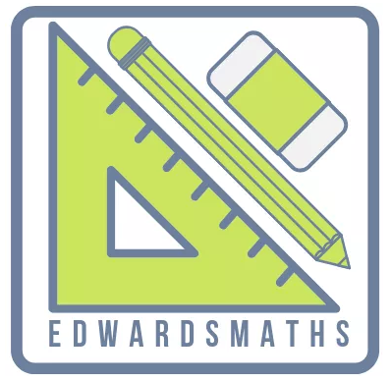

Vraag 1/Question 1

1.1 | $$-2(9)=-18$$ | $$✓ 9$$  $$✓-18$$ | (2)
1.2 | $${13}^{13}÷{13}^{14}$$  $$=\frac{1}{{13}^{14-13}}$$  $$=\frac{1}{13}$$ | $$✓\frac{1}{{13}^{14-13}}$$  $$✓\frac{1}{13}$$ | (2)
1.3 | $$\left(1\right)\left(-8\right)=-8$$ | $$✓ 1$$  $$✓-8$$ | (2)
1.4 | $$\sqrt{2^{6}}=2^{3}=8$$ | $$✓ \sqrt{2^{6}}$$  $$✓ 8$$ | (2)
1.5 | $$(-2)^{6}=64$$ | $$✓$$ | (1)
1.6 | $$81-64=17$$ | $$✓$$ | (1)
1.7 | $$\sqrt{169-25}$$  $$=\sqrt{144}=12$$ | $$✓$$  $$✓ 12$$ | (2)
1.8 | $$3^{8}÷3^{4}$$  $$=3^{4}=81$$ | $$✓ 3^{8}÷3^{4}$$  $$✓ 81$$ | (2)
1.9 | $$\sqrt{4+5}$$  $$=\sqrt{9}=3$$ | $$✓\sqrt{4+5}$$  $$✓ 3$$ | (2)
 |  |  | [16]

Vraag 2/Question 2
2.1.1 | $$\sqrt{1764}=\sqrt{2^{2}×3^{2}×7^{2}}$$  $$=2×3×7$$  $$=42$$ | $$✓$$  $$✓$$ | (2)
2.1.2 | $\sqrt[3]{2744}$= $\sqrt[3]{2^{3}×7^{3}}$  $$=2×7$$  = 14 | $$✓$$  $$✓$$ | (2)
2.2.1 | $$3^{2}×5^{2}$$ | $$✓ 5$$ | (1)
2.2.2 | $$3×3×3×5×5×5=3375$$  $$\sqrt[3]{3375=15}$$ | $$✓$$  $$✓$$ | (2)
2.3.1 | $$1 s→300 000km$$  $$60 s→60×300 000km$$  $$1 min→18 000 000km$$  $$1min→1,8×{10}^{7}km$$ | $$✓$$  $$✓$$ | (2)
2.3.2 | $$1h→60×1,8×{10}^{7}km$$  $$1h→10,8×{10}^{8}km$$  $$1h→1,08×{10}^{9}km$$ | $$✓$$  $$✓$$ | (2)
 |  |  | [11]
Vraag 3/Question 3

3.1.1 | $$-7 ; -12$$ | $$✓✓$$ | (2)
3.1.2 | $$1 ; -\frac{1}{2}$$ | $$✓✓$$ | (2)
3.1.3 | $$10 ;11$$ | $$✓✓$$ | (2)
3.1.4 | $$30 ;42$$ | $$✓✓$$ | (2)
3.2.1 |  | $$✓✓$$ | (2)
  1 | 2 | 3 | 4 | $$n$$
  1 | 3 | 5 | 7 | $$2n-1$$
3.2.2 |  | $$✓✓$$ | (2)
  1 | 2 | 3 | 4 | $$n$$
  4 | 7 | 10 | 13 | $$3n+1$$
3.3 | $$y=x^{3}+1$$ | $$✓✓$$ | (2)
3.4.1 | 2,5 liters | $$✓$$ | (1)
3.4.2 |  | $$✓✓$$ | (2)
  $$t$$ | Time (in hours) | 2 | 12 | 24
  $$v$$ | Volume (in litres) | 5 | 30 | 60
3.4.3 | $$v=2,5t$$ | $$✓✓$$ | (2)
3.4.4 | 40 liters | $$✓✓$$ | (2)
3.4.5 | $$2,5t=175 liter$$  $$t=70 hours$$ | $$✓$$  $$✓$$ | (2)  [23]

