WISKUNDE/MATHEMATICS JUNIE

GRAAD 10/GRADE 10 PUNTE/MARKS: 100
EKSAMEN/EXAMINATION TYD/TIME: 2 uur/hours
EKSAMINATOR: MODERATOR :

INSTRUKSIES EN INLIGTING

Lees die volgende instruksies aandagtig deur voordat u die vrae beantwoord:

1. Beantwoord AL die vrae in hierdie vraestel.

2. Dui AL die berekeninge, diagramme, grafieke, ensovoorts, wat u gebruik het om die antwoord te bepaal, duidelik aan.

3. ’n Goedgekeurde wetenskaplike sakrekenaar (nie-programmeerbare en nie-grafiese) mag gebruik word tensy anders vermeld.

4. Indien noodsaaklik moet antwoorde tot TWEE desimale plekke afgerond word, tensy anders vermeld.

5. Nommer die antwoorde korrek volgens die nommeringsisteem wat in hierdie vraestel gebruik word.

6. Diagramme is NIE noodwendig volgens skaal geteken nie.

7. Dit is tot u eie voordeel om leesbaar te skryf en u werk netjies aan te bied.

INSTRUCTIONS AND INFORMATION

Read the following instructions carefully before answering the questions:

1. Answer ALL the questions in this question paper.

2. Clearly show ALL calculations, diagrams, graphs, et cetera, which you have used in determining the answers.

3. An approved scientific calculator (non-programmable and non-graphical) may be used, unless stated otherwise.

4. If necessary, answers should be rounded off to TWO decimal places, unless stated otherwise.

5. Number the answers correctly according to the numbering system used in this question paper.

6. Diagrams are NOT necessarily drawn to scale.

7. It is in your own interest to write legibly and to present the work neatly.

Vraag 1/Question 1

Kies uit die volgende lys/Choose from the following list:

$$0; -\sqrt{1\frac{9}{16}}; 4π+1; \sqrt{-9}; \frac{48}{6}; (\sqrt[3]{10} )^{3}; 3,14$$

1.1 ‘n Positiewe rasionale getal, maar nie ‘n heelgetal nie.
A positive rational number, but not an integer. (1)
1.2 ‘n Telgetal kleiner as 8.
A counting number smaller than 8. (1)
1.3 Al die irrasionale getalle.
All the irrational numbers. (1)
1.4 ‘n Nie-reële getal.
A non-real number. (1)
1.5 ‘n Heelgetal wat ‘n veelvoud van 4 is.
An integer that is a multiple of 4. (1)
[5]

Vraag 2/Question 2

2.1 Die volgende ry word gegee:
The following sequence is given:

$5;1; -3; -7;……$

2.1.1 Gee die volgende twee waardes in die ry.
Give the following two values in the sequence. (1)
2.1.2 Bepaal die formule vir die n^{de} term van die ry.
Determine the formula for the n^{th} term of the sequence. (2)
2.1.3 Wat is die waarde van die twintigste term van die ry?
What is the value of the twentieth term of the sequence? (2)
2.1.4 Watter term van die ry sal -387 wees?
Which term of the sequence will be -387? (2)

2.2 Natuurlike getalle word in ‘n piramiede vorm gestapel.
Natural numbers are stacked in a pyramid form.

Ry/Row 1 1
Ry/Row 2 2 3 4
Ry/Row 3 5 6 7 8 9
Ry/Row 4 10 11 12 13 14 15 16

2.2.1 Hoeveel getalle is in die 7de ry?
How many numbers are in the 7th row? (1)
2.2.2 Wat is die laaste nommer in ry 7?
What is the last number in row 7? (1)
2.2.3 Wat is die eerste getal in ry 7?
What is the first number in row 7? (1)
2.2.4 Hoeveel getalle is in die n^{de} ry?
How many numbers are in the n^{th} row? (2)
2.3 Beskou die volgende getalpatroon/Consider the following sequence:

$3;6;11;…;…;38;51$

Die algemene term van die getalpatroon is $T_{n}=n^{2}+2$
The general term for the sequence is $T_{n}=n^{2}+2$
2.3.1 Vind die waarde van die twee ontbrekende terme.
Determine the value of the missing two terms. (2)
2.3.2 Watter term in die getalpatroon het ‘n waarde van 291?
Which term in the sequence will be equal to 291? (2)
[16]

Vraag 3/Question 3

3.1 Bepaal die volgende produkte/Determine the following products:

3.1.1 $(3x^{2}+4y)(2x^{2}-5y)$ (3)

3.1.2 $(\frac{1}{2}a^{2}-\frac{1}{3a^{2}})^{2}$ (3)

3.2 Faktoriseer volledig/Factorise fully:

3.2.1 $2x^{2}-10x+12$ (3)

3.2.2 $18y^{2}+12y-30ay-20a$ (3)

3.2.3 $2(a-b)^{2}-3a+3b$ (3)

3.2.4 $24x^{4}+3xy^{3}$ (3)

3.3 Vereenvoudig/Simplify:

$\sqrt{36x^{2}-24xy+4y^{2}}$ (3)
[21]

Vraag 4/ Question 4

Vereenvoudig volledig/Simplify fully:

4.1 $\frac{8x^{2}+12x}{4x^{2}-9}×\frac{2x^{2}-11x+12}{16x^{-1}}$ (4)

4.2 $\frac{a}{b}÷(\frac{1}{c}-\frac{1}{b})$ (3)

4.3 $\frac{3}{x+1}+\frac{2}{1-x^{2}}$ (4)
[11]

Vraag 5/Question 5

5.1 Los op vir x/Solve for x:

5.1.1 $2x^{2}-x=1$ (3)

5.1.2 $\frac{m}{x}+\frac{n}{2x}=3m$ (2)

5.1.3 $2^{3x}+2^{3x+2}=40$ (3)

5.1.4 $-3<2-5x≤7$ (3)

5.2 Maak vir $a$ die onderwerp in:
Make $a$ the subject of the formula:

$K=\frac{a+1}{a+2}$ (3)

5.3 Los op vir x en y in/Solve for x and y in:

$2x+3y=8$ en/and $3x+4y=11$ (4)
[18]

Vraag 6/Question 6

Gegee: $f\left(x\right)=-x^{2}+16$ en/and $g\left(x\right)=x+4$

6.1 Skets die grafieke van f en g op dieselfde assestelsel. Dui alle snypunte met die asse en draaipunte aan.
Sketch the graphs of f and g on the same set of axes. Show all the turning points and intercepts with the axes. (5)

6.2 Gebruik jou grafiek om die volgende te bepaal/Use your graph to determine the following:

6.2.1 die waardes van $x$ waarvoor $f(x)<0$ / the values of $x$ if $f(x)<0$. (2)
6.2.2 die waardes van $x$ waarvoor albei grafieke toeneem soos $x$ toeneem.
the values of $x$ for which both graphs increase as $x$ increases. (1)
6.2.3 $f\left(0\right)-g(0)$ (1)

6.3 Bepaal die koördinate van die snypunte van $f(x)$ en $g(x)$.
Determine the coordinates of the intercepts of $f(x)$ and $g(x)$. (5)

6.4 As $g(x)$ 5 eenhede afwaarts transleer, wat is die vergelyking van die nuwe grafiek?
If $g(x)$ is translated 5 units down, what will the equation of the new graph be? (1)

[15]

Vraag 7/Question 7

7.1 Die sketse hieronder is die grafieke van $f\left(x\right)=\frac{a}{x}+q$ en $g\left(x\right)=nb^{x}+t.$
Die horisontale asimptoot vir albei grafieke is die lyn $y=1.$
Bepaal die waardes van $a, b, n, q en t.$
Sketched below are graphs of $f\left(x\right)=\frac{a}{x}+q$ and $g\left(x\right)=nb^{x}+t.$ The horizontal asymptote of both graphs is the line of $y=1.$
Determine the values of $a, b, n, q and t.$

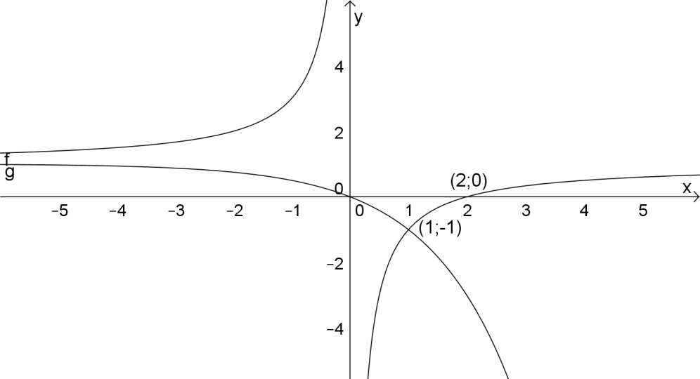 (8)

7.2

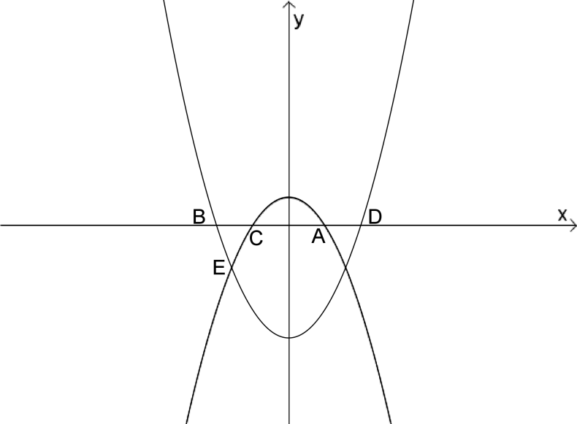

Die grafieke van $y=x^{2}-4$ en $y=-x^{2}+1$ word gegee:
The graphs of $y=x^{2}-4$ and $y=-x^{2}+1$ are given:

7.2.1 Bepaal die afstand van DC/Determine the length of DC. (3)

7.2.2 Bepaal die koördinaat van E/Determine the coordinate of E. (4)
[15]

