WISKUNDE/MATHEMATICS V2/P2 NOVEMBER

GRAAD 10/GRADE 10 PUNTE/MARKS: 100
EKSAMEN/EXAMINATION TYD/TIME: 2 uur/hours
EKSAMINATOR: MODERATOR :

INSTRUKSIES EN INLIGTING

Lees die volgende instruksies aandagtig deur voordat u die vrae beantwoord:

1. Beantwoord AL die vrae in hierdie vraestel.

2. Dui AL die berekeninge, diagramme, grafieke, ensovoorts, wat u gebruik het om die antwoord te bepaal, duidelik aan.

3. ’n Goedgekeurde wetenskaplike sakrekenaar (nie-programmeerbare en nie-grafiese) mag gebruik word tensy anders vermeld.

4. Indien noodsaaklik moet antwoorde tot TWEE desimale plekke afgerond word, tensy anders vermeld.

5. Nommer die antwoorde korrek volgens die nommeringsisteem wat in hierdie vraestel gebruik word.

6. Diagramme is NIE noodwendig volgens skaal geteken nie.

7. Dit is tot u eie voordeel om leesbaar te skryf en u werk netjies aan te bied.

INSTRUCTIONS AND INFORMATION

Read the following instructions carefully before answering the questions:

1. Answer ALL the questions in this question paper.

2. Clearly show ALL calculations, diagrams, graphs, et cetera, which you have used in determining the answers.

3. An approved scientific calculator (non-programmable and non-graphical) may be used, unless stated otherwise.

4. If necessary, answers should be rounded off to TWO decimal places, unless stated otherwise.

5. Number the answers correctly according to the numbering system used in this question paper.

6. Diagrams are NOT necessarily drawn to scale.

7. It is in your own interest to write legibly and to present the work neatly.

Vraag 1/Question 1
1.1 Die afwesigheid van die graad 10’s in Hoërskool Overberg is vir die eerste kwartaal aangeteken. Die data is as volg:
The number of absent learners in grade 10 in Overberg High School for the first term was recorded and is shown in the table below:
Dae afwesig/Days absent | Frekwensie/Frequency
$$0≤x<4$$ | 37
$$4≤x<8$$ | 23
$$8≤x<12$$ | 9
$$12≤x<16$$ | 17
$$16≤x<20$$ | 5
$$20≤x<24$$ | 1

1.1.1 Hoeveel graad 10’s is daar in Hoërskool Overberg?
How many grade 10’s are at Overberg High? (1)
1.1.2 Bereken die benaderde gemiddelde aantal dae wat die graad 10’s gedurende die eerste kwartaal afwesig was.
Calculate the average of the number of days during which the grade 10’s were absent during the first term. (3)
1.1.3 Gee die modale interval.
Give the modal interval. (1)
1.1.4 In watter interval lê die 70ste persentiel?
In which interval is the 70th percentile? (1)

1.2 Ovielicious se bestellings vir kollewyntjies (per dosyn) gedurende Februarie was daagliks soos volg:
Ovielicious’s order for muffins (per dozen) during February was as follow:
14 3 10 13 36 20 17
15 21 6 5 17 15 9
8 20 23 8 12 16 18
1.2.1 Bepaal die mediaan van die data.
Determine the median of the data. (2)

1.2.2 Bereken die semi-interkwartiel variasiewydte van die data. Wys alle bewerkings.
Calculate the semi-interquartile range of the data. Show all calculations. (4)

1.3 ‘n Tweedehandse motorhandelaar se motorverkope per maand vir Maart 2013 tot Februarie 2014 word deur die mond-en-snordiagram voorgestel.
A secondhand car dealer’s sales per month for March 2013 to February 2014 is given by the box and whiskers diagram below.
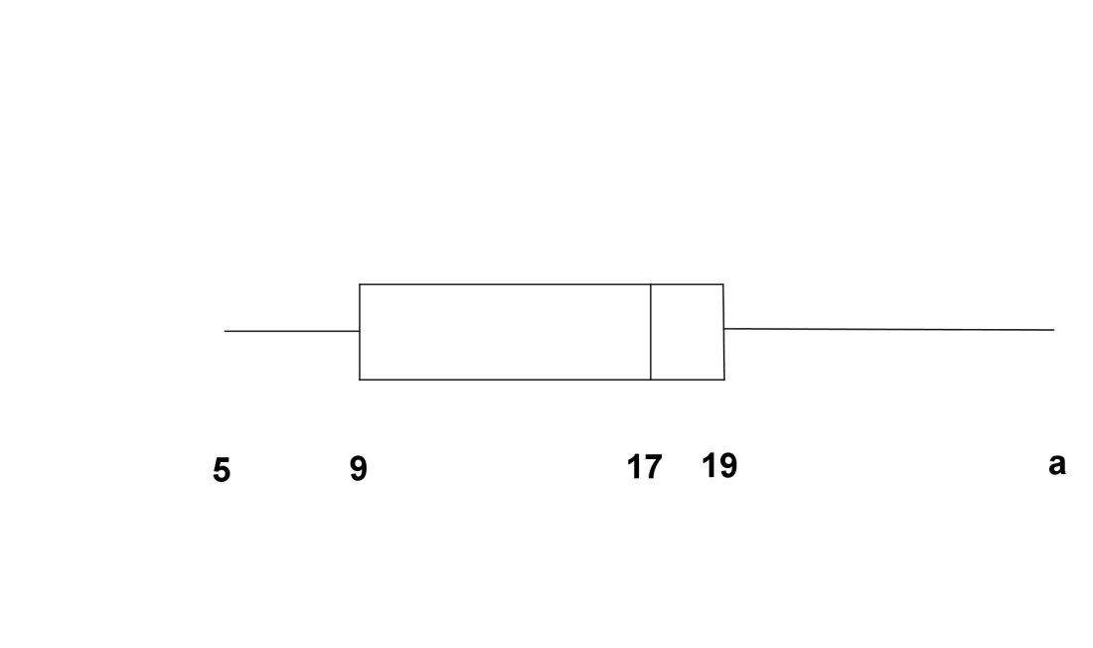
1.3.1 As die omvang van die verkope 25 is, bereken die waarde van a.
If the range of the sales is 25, calculate the value of a. (1)
1.3.2 Indien hy minder as 9 motors per maand verkoop, dek sy wins nie al sy finansiële verpligtinge vir die maand nie. Hoeveel maande was sy wins nie voldoende nie?
If he sells less than 9 cars per month, his profit is not enough to cover all his expenses. How many months was his profit not enough? (2)
1.3.3 Ongeveer watter persentasie van die jaar het hy meer as 19 motors per maand verkoop?
Approximately which percentage of the year did he sell more than 19 cars a month? (1)
[16]

Vraag 2/Question 2
2.1 In die figuur is ABCD ‘n reghoek met A(-8;0) en B(2;5). M is die punt waar die 2 hoeklyne mekaar sny.
In the figure ABCD is a rectangle with A(-8;0) and B(2;5). M is the point where the 2 diagonals intercept.
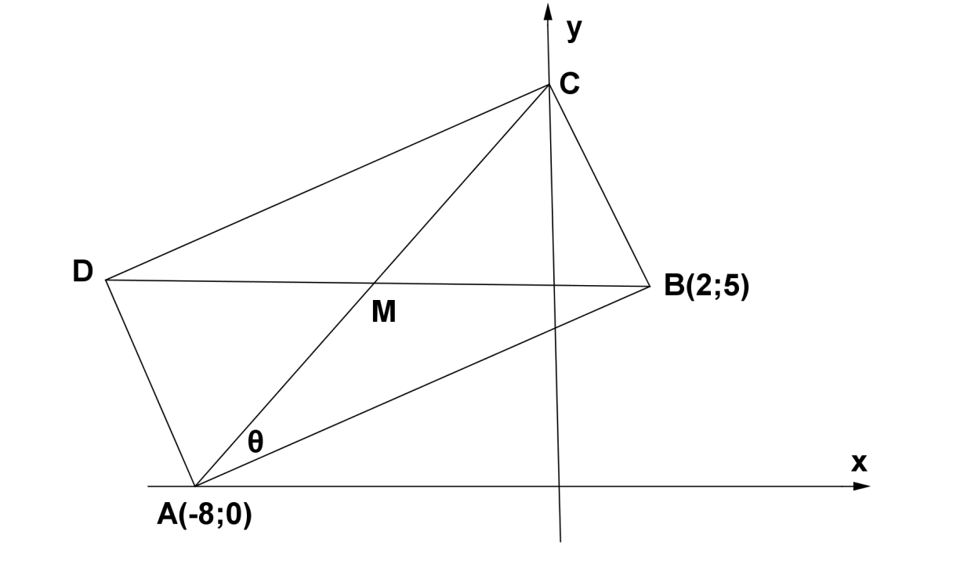

2.1.1 Bepaal die gradiënt van AB/Determine the gradient of AB. (2)
2.1.2 Bepaal die vergelyking van BC/Determine the equation of BC. (3)
2.1.3 As die vergelyking van BC $y+2x=9$ is, bepaal die koördinate van punt M.
If the equation of BC is $y+2x=9$ determine the coordinates of M. (2)
2.1.4 Bepaal die vergelyking van die lyn ewewydig aan AB en deur M.
Determine the equation of the line parallel to AB and through M. (3)
2.1.5 Bepaal die koördinate van E as AC met sy eie lengte verleng word om AE te vorm.
Determine the coordinates of E if AC is extended with its own length to form AE. (2)
2.1.6 Bereken die lengte van hoeklyn BD/Calculate the length of BD. (3)
2.1.7 Indien verder gegee word dat $BC=2\sqrt{5}$ eenhede, bepaal die grootte van $θ$, as $∠BAC=θ,$ tot 1 desimale syfer.
If given that $BC=2\sqrt{5}$ units, calculate, to one decimal number, the size of $θ$ if $∠BAC=θ.$ (2)

2.2 Bepaal die waarde van $y$ indien P(-1;0); Q(1;2) en R(3;$y$) kolinêer is.
Determine the value of $y$ if P(-1;0); Q(1;2) and R(3;$y$) are collinear. (3)
[20]
Vraag 3/Question 3
3.1 As $A=38,6° en B=14,1°$, bepaal $cos^{2}3A-2sinB$.
If $A=38,6° and B=14,1°$, calculate $cos^{2}3A-2sinB.$ (2)
3.2 Bepaal die waarde van $θ$ as/Determine the value of $θ$ if:
3.2.1 $4\cos{θ-1=0}$ (2)
3.2.2 $\frac{tan⁡(2θ-13°)}{2}=6,5$ (3)
[7]
Vraag 4/Question 4
4.1 Vereenvoudig sonder ‘n sakrekenaar/Simplify without a calculator:
$8sin^{2}60°+tan^{4}30°$ (3)
4.2
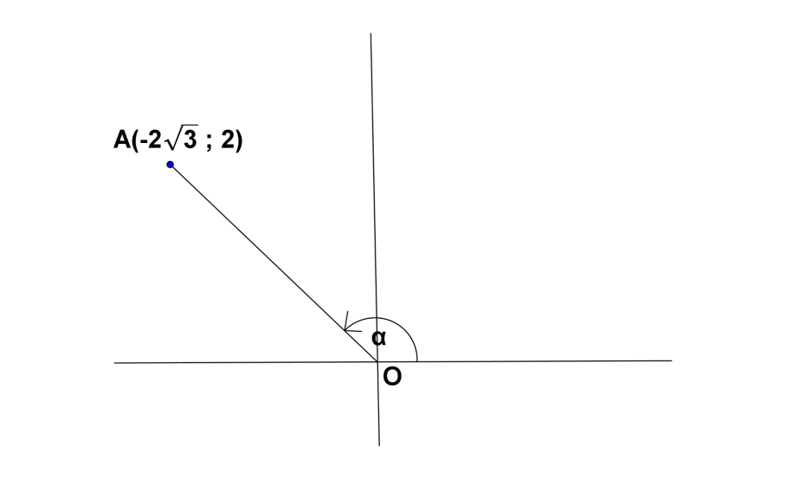
Gebruik die figuur en beantwoord die vrae sonder om ‘n sakrekenaar te gebruik.
Use the figure to answer the questions without using a calculator.
Bereken/Calculate:
4.2.1 OA (2)
4.2.2 $\sin^{2}{α-2\cos^{2}α}$ (3)
[8]
Vraag 5/Question 5
Gegee/Given:
$$f\left(x\right)=\operatorname{asin}{x+p}$$
$$g\left(x\right)=bcos x$$
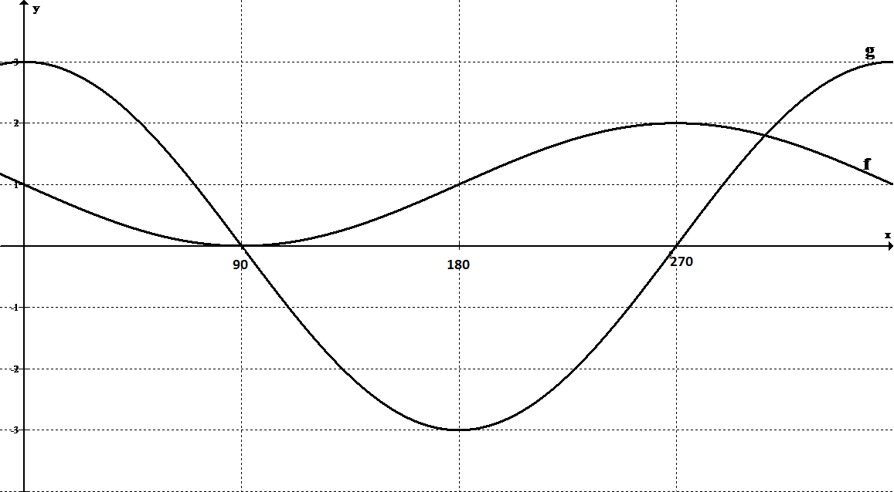

5.1 Bepaal die waardes van $a, b en p$/Determine the values of $a, b and p.$ (3)
5.2 Gee die amplitude van $f(x)$/Give the amplitude of $f\left(x\right).$ (1)
5.3 Gee die periode van $g(x)$/Give the period of $g\left(x\right).$ (1)
5.4 Bepaal die waardeversameling van $f$/Give the range of $f.$ (2)
5.5 Vir watter waardes van $x$sal/For which values of $x$ will:
5.5.1 $f\left(x\right)-g\left(x\right)=4$ (1)
5.5.2 $f\left(x\right)=1$ (2)
5.5.3 $g(x)≥0$ (2)
[12]

Vraag 6/Question 6
In die figuur is $∆ABC met ∠A=90°.$ AD sny BC loodreg met BD = 4 eenhede en DC = 16 eenhede.
In the figure is $∆ABC with ∠A=90°.$ AD is perpendicular with BC and BD = 4 units and DC = 16 units.
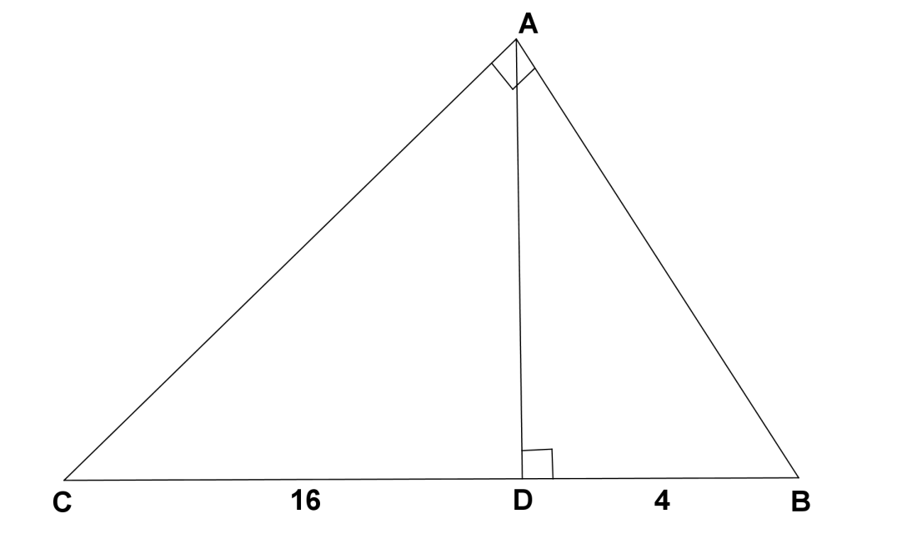

6.1 Voltooi/Complete:
$\cos{C=\frac{6.1.1}{AC}=\frac{AC}{6.1.2}}$ (2)
6.2 Bepaal vervolgens die lengte van AC in wortelvorm.
Hence, calculate the length of AC in surd form. (3)
6.3 Bepaal die grootte van $∠B$/Determine $∠B.$ (2)
6.4 Bepaal die lengte van AD/Determine the length of AD. (2)
[9]

Vraag 7/Question 7
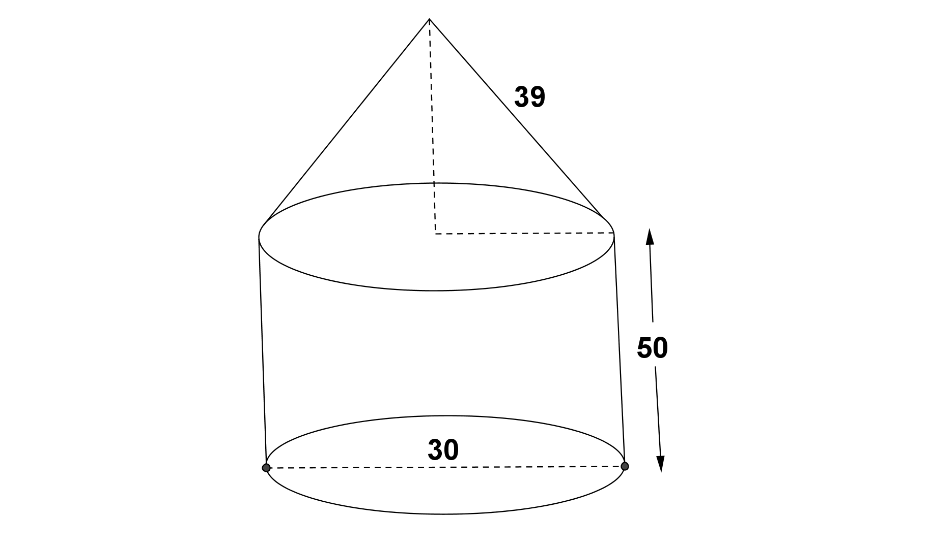
‘n Regte sirkelvormige keël met skuinshoogte 39 cm word bo-op ‘n soliede silinder met ‘n basisdeursnee van 30 cm en ‘n hoogte van 50 cm geplaas soos in die figuur getoon.
A cone with slantheight of 39 cm is fixed on top of a solid cylinder with a diameter of 30 cm and a height of 50 cm as shown in the figure.
7.1 Bereken die buite-oppervlakte van die keël.
Calculate the surface area of the cone. (3)
7.2 Bereken die volume materiaal wat benodig word om die figuur te vorm.
Calculate the volume of the material needed to form the figure. (5)
7.3 Indien die keël in die figuur met ‘n hemisfeer(met dieselfde hoogte) vervang moet word, sal daar meer of minder materiaal benodig word? Toon berekeninge om jou antwoord te staaf.
If the cone must be replaced with a hemisphere (with the same height), will more or less material be needed? Show calculations to prove your answer. (4)
[12]

Vraag 8/Question 8
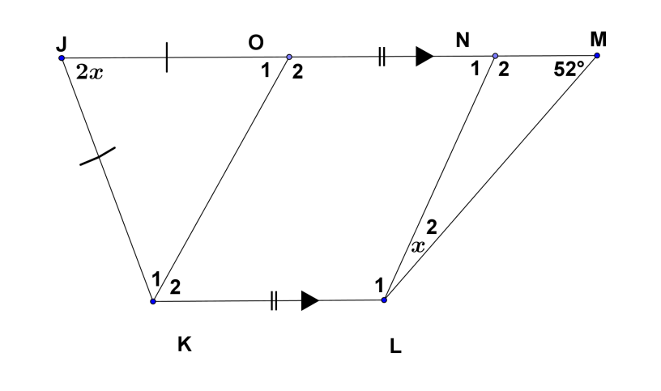
8.1 In die diagram/In the diagram is:
$$JM∥KL, JK=JO, ON=KL, ∠J=2x, ∠M=52° en ∠L_{2}=x.$$
8.1.1 Identifiseer die vierhoek ONLK en gee ‘n rede.
Identify the quadrilateral ONLK and give a reason. (2)
8.1.2 Bereken, met redes, die waarde van $x.$
Calculate, with reasons, the value of $x.$ (4)
8.2 ABCD is ‘n parallelogram. Die halveerlyn BQ, van $∠B$ ontmoet AD in Q en die halveerlyn AP van $∠A$, ontmoet BC in P. AP en BQ sny by O.
ABCD is a parallelogram. The bisector BQ, of $∠B$ meets AD in Q and the bisector AP of $∠A,$ meets BC in P. AP and BQ intersect at O.
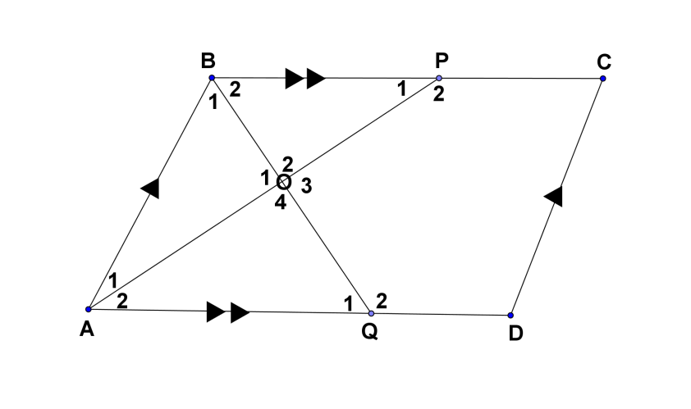
Bewys dat/Prove that:
8.2.1 $AO⊥BQ$ (4)
8.2.2 ABPQ is ‘n ruit/ABPQ is a rhombus. (6)
8.2.3 As $AQ=2\sqrt{10,}$ bepaal die lengte van DC. If $AQ=2\sqrt{10,}$ determine the length of DC. (2)
[18]

