Naam van leerling: ………………………………………………
Hoërskool November
Graad 10 Punte: 100
Wiskunde Eerste Vraestel Tyd: 2 uur

INSTRUKSIES / INSTRUCTIONS
- Hierdie vraestel bestaan uit 6 vrae. Beantwoord AL die vrae. /
This question paper consists of 6 questions. Answer ALL the questions.
- Trek ‘n lyn onder elke vraag. Begin elke vraag op ‘n nuwe bladsy. /
Rule off each question. Start each question on a new page.
- Vraag 5.2.1 moet op die DIAGRAMVEL beantwoord word./
Question 5.2.1 must be answered on the DIAGRAM SHEET.
- Indien nodig, moet anwoorde tot TWEE desimale plekke afgerond word,
tensy anders vermeld. /
If necessary, answers should be rounded off to TWO decimal places, unless
stated otherwise.
- Diagramme is NIE noodwendig op skaal geteken nie. /
Diagrams are NOT necessarlily drawn to scale.

VRAAG 1 / QUESTION 1
  - Vereenvoudig / Simplify
1.1.1 ${(3p+2q)}^{2}$ (3)
1.1.2 $\frac{5^{m+n}.5^{m}}{5^{n}}$ (1)
1.1.3 $\frac{4^{0}{(p}^{2})^{3}}{p^{4}.p^{-2}}$ (2) [6]
1.2 As / If $3^{x}=13$
Bepaal die getalwaarde van / Determine the numerical value of
$3^{x+3}$ [2]
  - Faktoriseer volledig / Factorise fully
1.3.1 $x\left(a-b\right)+(b-a)$ (2)
1.3.2 $8px-6py+12x-9y$ (3)
1.3.3 $12x-35x^{2}+{25x}^{3}$ (3)
1.3.4 ${8x}^{6}y^{9}-1$ (2) [10]
/18/
VRAAG 2 / QUESTION 2
2.1 Los op vir $x$ / Solve for $x$
2.1.1$\left(x-7\right)\left(x+2\right)=10$ (3)
2.1.2 $\frac{2x-1}{3}-\frac{x}{6}=\frac{2x-4}{6}$ (3)
2.1.3 ${2.5}^{x+1}-250=0$ (4)
2.1.4 ${9x}^{\frac{2}{3}}-4=0$ (3)
2.1.5 $5≤1-2x≤11$ (2) [15]

2.2 Los op vir $x$ in terme van $t$ en $r$ / Solve for $x$ in terms of $t$ and $r$
$\frac{x}{t}-4=\frac{t+x}{r}$ [4]

2.3 Die afmetings van ‘n reghoek word in die volgende skets in terme van $x$ en $y$
aangedui. Bepaal die waardes van $x$ en $y$. /
The measurements of a rectangle are given in terms of $x$ and $y$. Determine the
values of $x$ and $y$.

$18$

$y+2$ $x$

$3x+y$ [4]
/23/

VRAAG 3 / QUESTION 3

3.1 Gegee: / Given: $24 ;19 ;14 ;9 ;$

3.1.1 Bepaal die algemene term ${(T}_{n})$. /
Determine the general term ${(T}_{n}).$ (2)

3.1.2 Vervolgens, watter term is gelyk aan $-106?$ /
Hence, determine which term equals $-106?$ (2) [4]

3.2 Vir watter waarde van $x$ sal die volgende linêere getallery ‘n konstante verskil
van 7 hê? /
For which value of $x$ will the following linear sequence have a constant difference
of 7?

$x+1 ;2x+3 ;4x ;…$ [2]
/6/

VRAAG 4 / QUESTION 4

4.1 Ek wissel $347 vir R2 169 na my toer in Amerika. Bereken die wisselkoers waarteen
ek die dollars gewissel het. /
I exchange $347 for R2 169 after a Journey to America. Calculate the exchange rate
at which I exchanged the dollars. [2]

4.2 ‘n Trollie kruideniersware kos R520 in Januarie 2003. Bereken die verwagte prys
van die trollie met dieselfde kruideniersware in Januarie 2010 as die inflasiekoers
9 % per jaar is. /
A trolley of groceries amounted to R520 in January 2003. Determine the expected
price of a trolley with the same amount of groceries in January 2010 if the inflation
rate is 9 % per year. [5]

4.3 Frieda spaar vir ‘n oorsese vakansie oor 5 jaar. Sy open ‘n spaarrekening waarin
sy dadelik R4 000 belê. Twee jaar nadat sy die rekening oopgemaak het,
deponeer sy R3 000, gevolg deur nog ‘n deposito van R3 800 ‘n jaar later.
Bereken die totale bedrag geld wat sy gespaar het aan die einde van vyf jaar as die
rentekoers 12 % p.j jaarliks saamgestel is. /
Frieda saves for an overseas holiday in 5 years time. She opens a savings account
and deposits R4 000 immediately. Two years after she had opened the savings
account, she deposits R3 000, followed by another payment of R3 800 one year later.
Calculate the total amount of money saved at the end of five years if the interest rate
was 12 % p.a compounded annually. [4]
/11/

VRAAG 5 / QUESTION 5

5.1 Gegee: / Given: ${f\left(x\right)=x}^{2}-4$ en / and $g\left(x\right)$

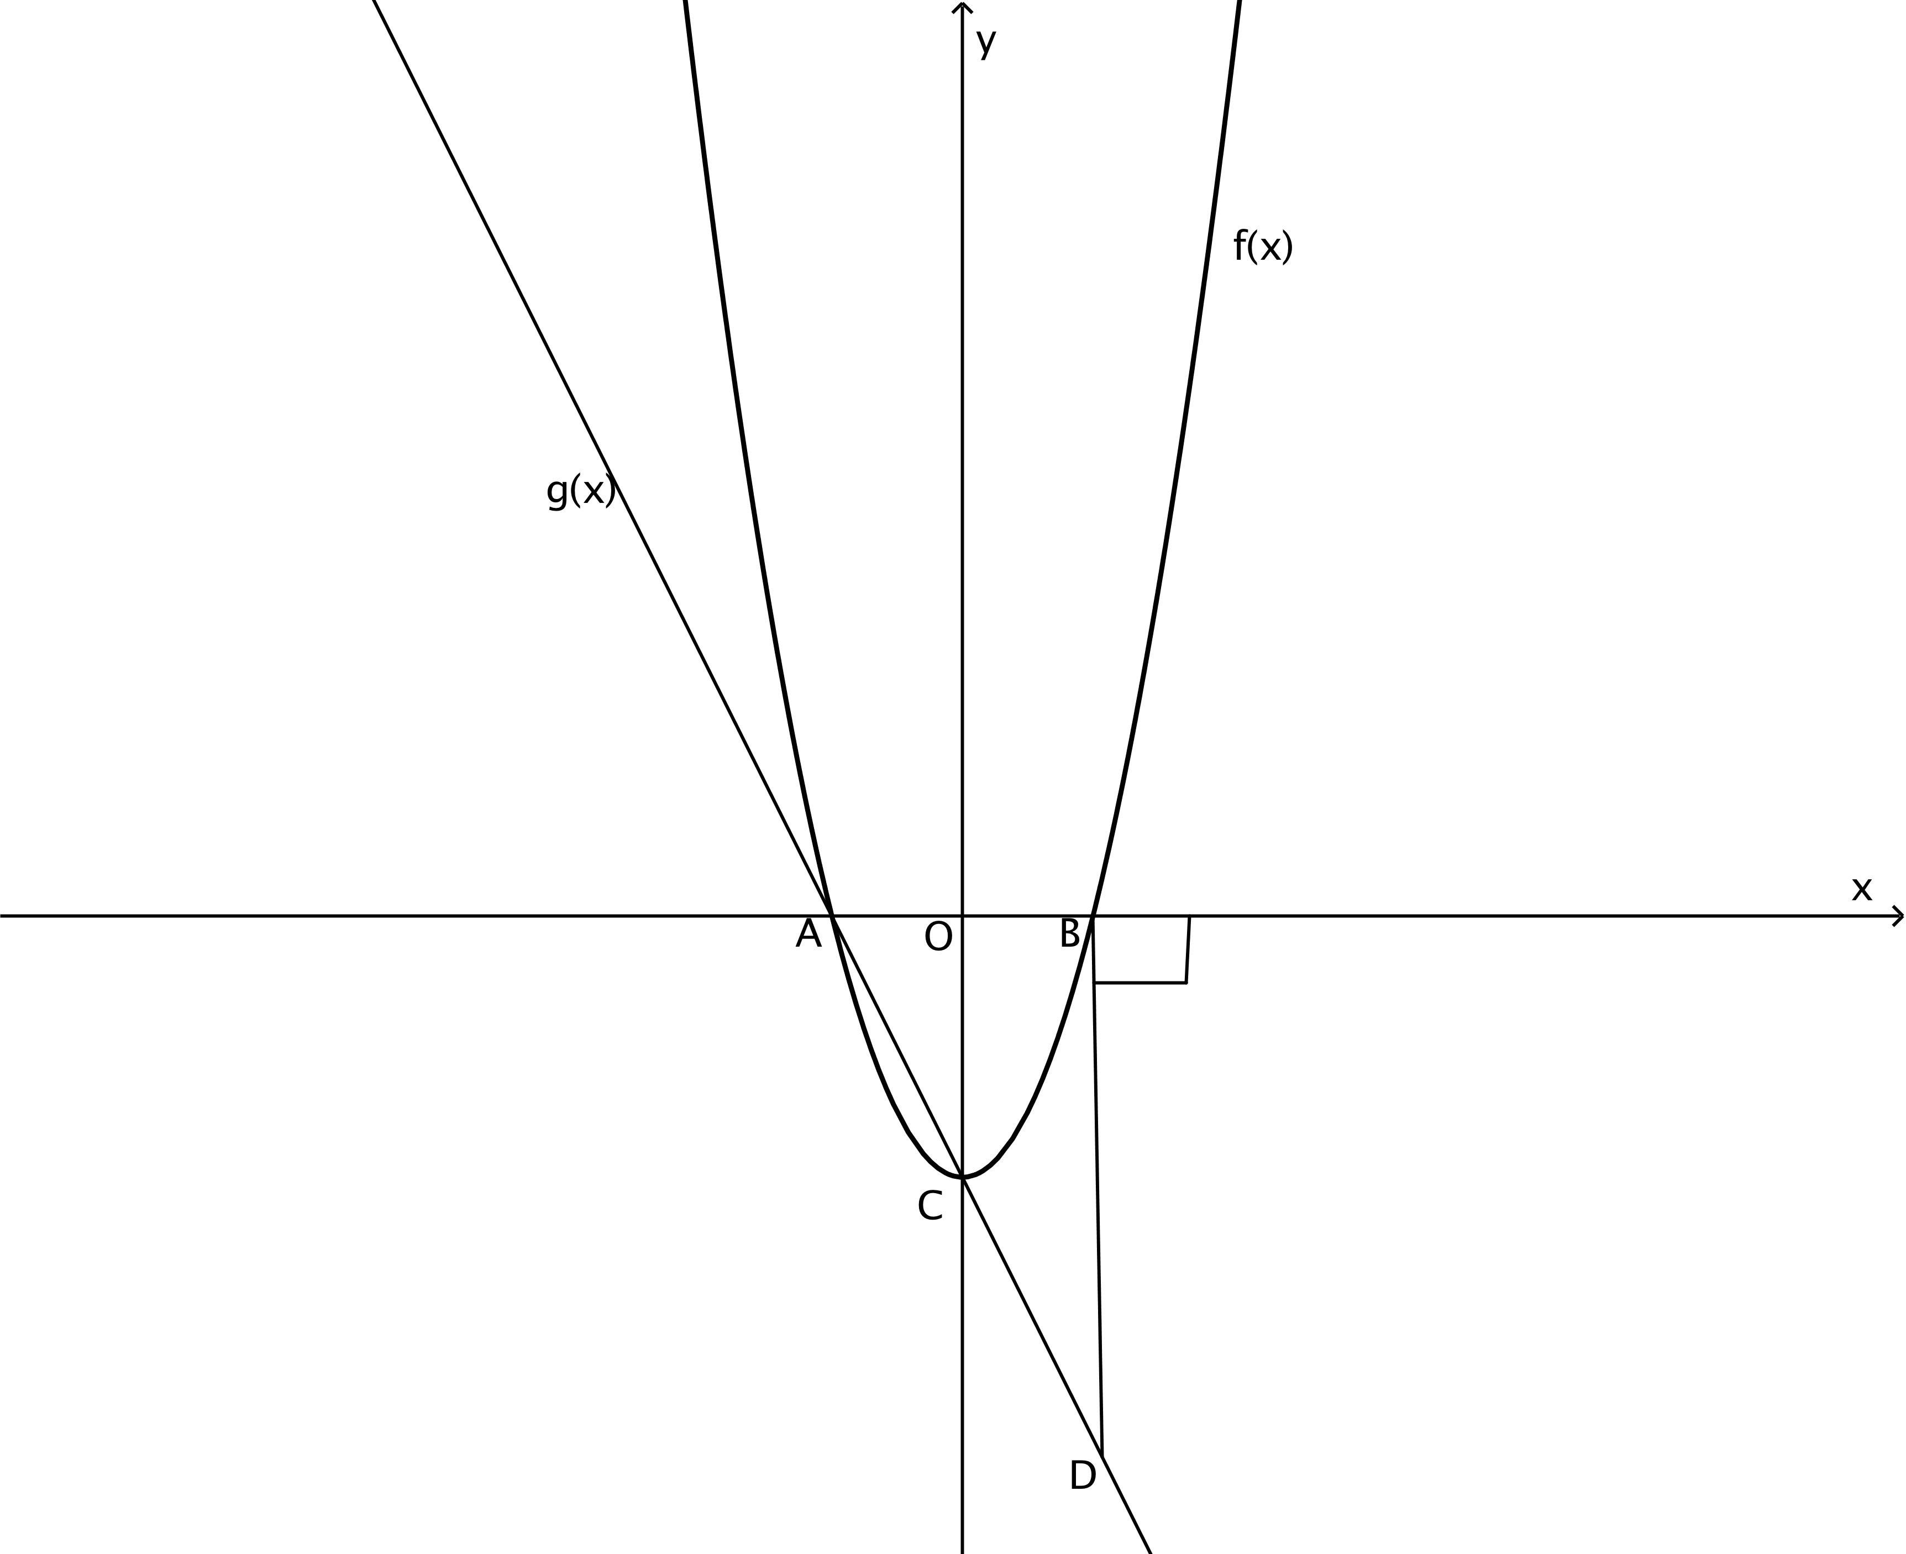

5.1.1 Bepaal die koördinate van A, B en C /
Determine the coordinates of A, B and C. (5)

5.1.2 Bepaal die vergelyking van die reguit lyn AC. /
Determine the equation of the straight line AC. (2)

5.1.3 Bepaal die vergelyking van die reguit lyn wat ewewydig is aan $g(x)$ en
wat deur $B$ gaan. /
Determine the equation of the straight line parallel to $g(x)$ passing
through$B$. (4)

5.1.4 Bepaal die lengte van BD. /
Determine the length of BD. (3)

5.1.5 Vir watter waarde(s) van $x$ is:/
For which value(s) of $x$is:

5.1.5.1 $f(x)≤0$ (2)
5.1.5.2 $f(x)>g(x)$ (2)

5.1.6 Gee die waardeversameling van $f(x)$/
Give the range of $f(x)$ (1)

5.1.7 Vir watter waarde(s) van $x$ is $f(x)$ stygend? /
For which value(s) of $x$ is $f(x)$ increasing? (1) [20]

5.2 Gegee: / Given: $f\left(x\right)=3.2^{x}$ en / and $g\left(x\right)=\frac{3}{x}+1$

5.2.1 Trek netjiese sketse van $f\left(x\right)$ en $g(x)$ op dieselfde assestelsel.
Gebruik die gegewe diagramblad.
Dui alle afsnitte met die asse asook die asimptote aan. /
Draw neat graphs of $f\left(x\right)$ and $g(x)$on the same set of axes.
Use the given diagram sheet.
Indicate clearly all intercepts with the axes and also asymptotes. (4)

5.2.2 Bepaal: / Determine:
5.2.2.1 $g(-2)$ (2)

5.2.2.2 $f\left(x\right)=24$ (2)

5.2.3 Gee die vergelyking van die asimptoot van $f(x)$ /
Give the equation of the asymptote of $f(x)$ (1)

5.2.4 Gee die definisieversameling van $g(x)$ /
Give the domain of $g(x)$ (2)

5.2.5 Bepaal die vergelyking van $h(x)$ as $f(x)$ gereflekteer word rondom die $y-as.$ /
Determine the equation of $h(x)$ if $f(x)$ are reflected about the $y-axis.$ (1) [12]
/32/
VRAAG 6 / QUESTION 6

6.1 In ‘n klas van 30 leerders neem 15 leerders Biologie, 18 neem Wiskunde en
5 leerders neem nie Wiskunde of Biologie nie. /
In a class of 30 learners 15 takes Biology, 18 takes Mathematics and 5 learners
does not do Mathematics or Biology.

6.1.1 Stel bogenoemde inligting in ‘n Venn-diagram voor. /
Represent the given data in a Venn diagram. (5)

6.1.2 Bepaal die waarskynlikheid dat ‘n leerder net Wiskunde neem. /
Determine the probability that a learner will only take Mathematics. (1)

6.1.3 Wat is die waarskynlikheid dat ‘n leerder Wiskunde en Biologie sal neem? /
What is the probability that a learner will take Mathematics and Biology? (1) [7]

6.2 Daar is 4 rooi lekkers (R), 6 groen (G) lekkers en 5 blou (B) lekkers in ‘n sak.
Indien daar ‘n lekker uit die sak gehaal word, bereken /
There are 4 red (R) sweets, 6 green (G) sweets and 5 blue (B) sweets in a bag.
If a sweet is taken out of the bag, determine

6.2.1 $P(B)$ (1)
6.2.2 $P(B)'$ (1)
6.2.3 $n(R∪G)$ (1) [3]
/10/
[TOTAAL: 100]

DIAGRAMVEL / DIAGRAM SHEET

HEG AGTER AAN JOU VRAESTEL VAS. / ATTACH TO BACK OF ANSWER SHEET

NAAM / NAME ……………………………………………………………………………………….

5.2.1

