
Gr. 11 Wiskunde Gr.11 Mathematics
HOËRSKOOL BREDASDORP HIGH SCHOOL
Vraestel 1 Paper 1
Tyd: 2 ure Time: 2 hours
Totaal: 100 Total: 100
Datum: 28 Mei 2015 Date: 28 May 2015
Eksaminator: Me C du Toit Examiner: Mrs C du Toit
Moderator: Mnr K Meyer Moderator: Mr Mnr K Meyer

NAAM/ NAME: ___________________________________________________________________
Instruksies:  - Skryf jou naam, van, graad en groep bo-aan jou antwoordstel en vraestel.  - Trek ‘n lyn na elke vraag.  - Laat ‘n reël oop tussen opeenvolgende antwoorde (1.1 , 1.2 ens.).  - Begin elke vraag op ‘n nuwe bladsy.  - Alle afronding moet tot 2 desimale gedoen word.  - Sakrekenaars mag gebruik word, tensy anders vermeld.  - Alle formules, substitusie en berekeninge moet getoon word.  - Sterkte!! | Instructions:  - Write your name, surname, grade and group on your question paper and answer sheet.  - Draw a line after each question.  - Leave open a line between consecutive answers (1.1 and 1.2, etc.)  - Start every question on a new page.  - All rounding must be done to 2 decimal places.  - Calculators may be used, unless stated otherwise.  - All formulae, substitution and calculations must be shown.  - Good luck!!

Vraag 1 |  | Question 1 |  | [36]
1.1. | Los op vir $x$ in elk van die volgende vergelykings: | 1.1. | Solve for $x$in each of the following calculations:
1.1.1. | $$x^{2}+5x-6=0$$ | 1.1.1. | $$x^{2}+5x-6=0$$ | (3)
1.1.2. | ${3x}^{2}-4x=5$ (korrek tot 2 desimale) | 1.1.2. | ${3x}^{2}-4x=5$ (correct to 2 decimals) | (4)
1.1.3. | $$\frac{x}{x-1}-\frac{2x+4}{3x+1}=-4$$ | 1.1.3. | $$\frac{x}{x-1}-\frac{2x+4}{3x+1}=-4$$ | (6)
1.1.4. | $$\sqrt{x-1}=2$$ | 1.1.4. | $$\sqrt{x-1}=2$$ | (2)
1.1.5. | $$2.5^{x}=50$$ | 1.1.5. | $$2.5^{x}=50$$ | (3)
1.1.6. | $${(x-3)}^{2}≤16$$ | 1.1.6. | $${(x-3)}^{2}≤16$$ | (4)
1.2. | Los vir $x$ en $y$ gelyktydig op in die volgende twee vergelykings:  $x-2y=2$ en $x^{2}-y^{2}+1=0$ | 1.2. | Solve $x$ and $y$ simultaneously in the following two equations:  $x-2y=2$ and $x^{2}-y^{2}+1=0$ | (8)
1.3. | Gebruik kwadraatsvoltooiing en los vir $x$ in die onderstaande vergelyking op:  $${2x}^{2}+8x-10=0$$ | 1.3. | Solve $x$ in the equation below by completing the square:  $${2x}^{2}+8x-10=0$$ | (6)

Vraag 2 (Nuwe bladsy) |  | Question 2 (New page) |  | [17]
Vereenvoudig elk van die volgende sonder die gebruik van ‘n sakrekenaar. Toon ook ALLE berekeninge. |  | Simplify each of the following without using a calculator. Show ALL calculations.
2.1. | $${\left(\frac{{8a}^{4}}{a}\right)}^{\frac{2}{3}}$$ | 2.1. | $${\left(\frac{{8a}^{4}}{a}\right)}^{\frac{2}{3}}$$ | (4)
2.2. | $${\left(27\right)}^{\frac{2}{3}}+{\left(\frac{1}{2}\right)}^{-2}-5^{0}$$ | 2.2. | $${\left(27\right)}^{\frac{2}{3}}+{\left(\frac{1}{2}\right)}^{-2}-5^{0}$$ | (5)
2.3. | $$\sqrt{32}-\sqrt{18}+2\sqrt{50}$$ | 2.3. | $$\sqrt{32}-\sqrt{18}+2\sqrt{50}$$ | (4)
2.4. | $$\frac{2^{p+4}-{6.2}^{p+1}}{{5.2}^{p+2}}$$ | 2.4. | $$\frac{2^{p+4}-{6.2}^{p+1}}{{5.2}^{p+2}}$$ | (4)

Vraag 3 (Nuwe bladsy) |  | Question 3 (New page) |  | [9]
3.1. | Bepaal die aard van die wortels van die vergelyking $x^{2}-3x-5=0$, sonder om ‘n skets te gebruik. | 3.1. | Determine the nature of the roots for the equation${ x}^{2}-3x-5=0$, without drawing a sketch. | (5)
3.2. | Vir watter waarde(s) van $m$ sal die onderstaande vergelyking gelyke wortels hê?  $${2mx}^{2}+10x=25$$ | 3.2. | For what value(s) of $m$ will the equation given below have equal roots?  $${2mx}^{2}+10x=25$$ | (4)

Vraag 4 (Nuwe bladsy) |  | Question 4 (New page) |  | [14]
4.1. | Bepaal die algemene term (T_{n}) vir elk van die volgende patrone: | 4.1. | Determine the general term (T_{n}) for each of the following patterns:
4.1.1. | $$4; 7; 10; 13; …$$ | 4.1.1. | $$4; 7; 10; 13; …$$ | (2)
4.1.2. | $$8;18;30;44;…$$ | 4.1.2. | $$8;18;30;44;…$$ | (4)
4.2. | Beskou die onderstaande patroon. Teken die gegewe tabel oor op jou antwoordstel en voltooi dit. Toon steeds alle berekeninge. | 4.2. | Study the pattern below. Redraw the given table on your answer sheet and complete it. Show all your calculations. | (8)
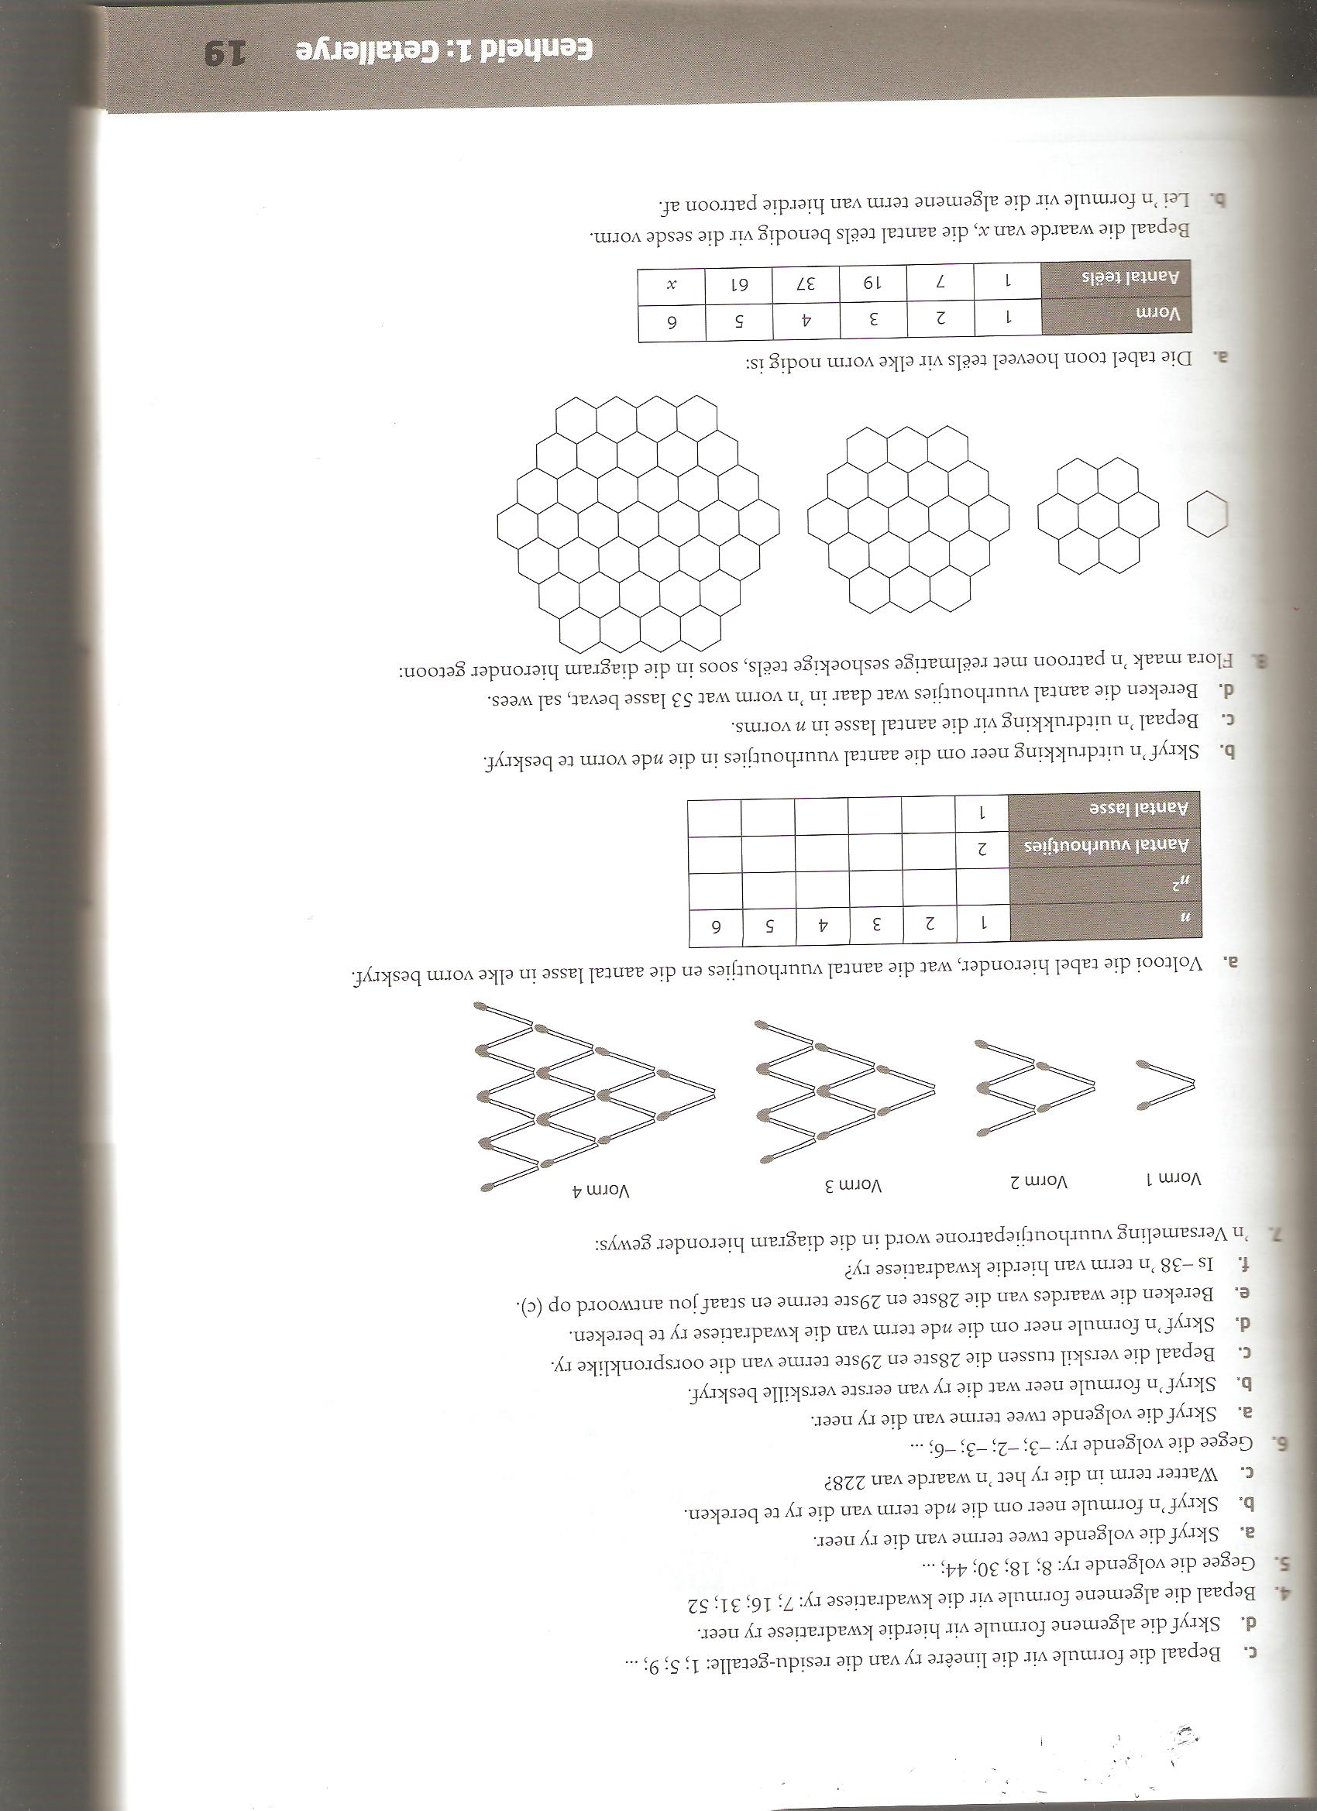

Fig. 3
Fig. 4
Fig. 2
Fig. 1
Figuur/ Figure | 1 | 2 | 3 | 4 | … | 10 | n
Aantal vuurhoutjies/
Number of matches

Vraag 5 (Nuwe bladsy) |  | Question 5 (New page) |  | [24]
5.1. | Skets die grafiek van $y=\frac{-3}{x-1}+2$, toon alle asimptote en afsnitte met asse. | 5.1. | Sketch the graph of $y=\frac{-3}{x-1}+2$, show all asymptotes as well as intercepts with axis. | (5)
5.2. | Gegee: $h\left(x\right)={2x}^{2}-8x+8$. Beantwoord die vrae wat volg. | 5.2. | Given: $h\left(x\right)={2x}^{2}-8x+8$. Answer the questions that follow.
5.2.1. | Gee die koördinate van die y – afsnit van $h.$ | 5.2.1. | Give the coordinates of the y – intercept of $h.$ | (1)
5.2.2. | Bereken die koördinate van die draaipunt van $h$. | 5.2.2. | Calculate the coordinates of the turning point of $h$. | (4)
5.3. | Gegee die funksies $f\left(x\right)={ax}^{2}+bx+c$ en $g\left(x\right)=p^{x}+q$. Beantwoord die vrae wat volg. | 5.3. | Given the functions $f\left(x\right)={ax}^{2}+bx+c$ and $g\left(x\right)=p^{x}+q$. Answer the questions that follow.
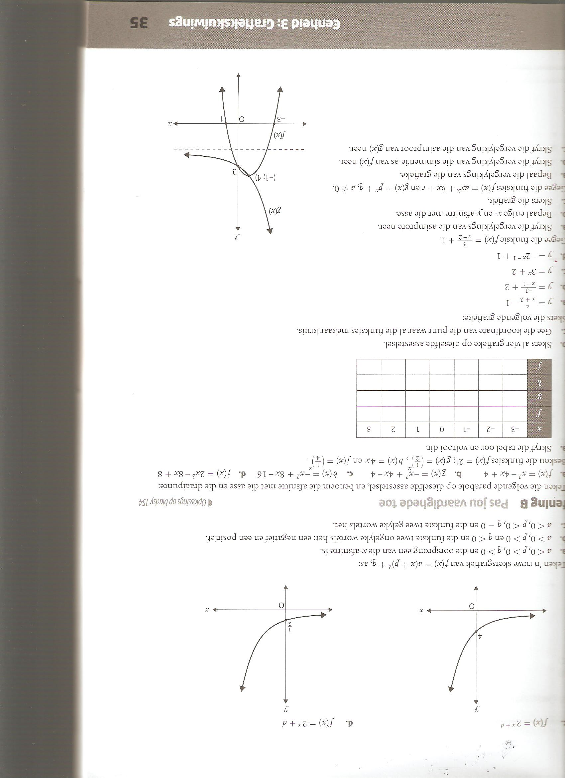

5.3.1. | Bepaal die vergelyking van $f(x)$. | 5.3.1. |  | Determine the calculations of $f(x)$. | (5)
5.3.2. | Gestel die vergelyking is vir $f$ is  $f\left(x\right)={-x}^{2}-2x+3$, gee die vergelyking van die simmetrie-as van $f.$ | 5.3.2. |  | Assume that the equation for $f$ is  $f\left(x\right)={-x}^{2}-2x+3$, give the equation of the axis of symmetry. | (2)
5.3.3. | Bepaal die waardes van $p$ en $q$ in die vergelyking van $g(x)$. | 5.3.3. |  | Determine the values of $p$ and $q$ in the equation of $g(x)$. | (5)
5.3.4. | Gee die definisieversameling vir $g\left(x\right).$ | 5.3.4. |  | Give the domain of $g(x)$. | (2)
TOTAAL: 100 |  |  | TOTAL: 100

