
Gr. 11 Wiskunde Gr.11 Mathematics
HOËRSKOOL BREDASDORP HIGH SCHOOL
Vraestel 2 Paper 2
Tyd: 2 ure Time: 2 hours
Totaal: 100 Total: 100
Datum: 5 Junie 2015 Date: 5 June 2015
Eksaminator: Me C du Toit Examiner: Mrs C du Toit
Moderator: Mnr K Meyer Moderator: Mr Mnr K Meyer

NAAM/ NAME: ___________________________________________________________________
Instruksies:  - Skryf jou naam, van, graad en groep bo-aan jou antwoordstel en vraestel.  - Trek ‘n lyn na elke vraag.  - Laat ‘n reël oop tussen opeenvolgende antwoorde (1.1 , 1.2 ens.).  - Begin elke vraag op ‘n nuwe bladsy.  - Alle afronding moet tot 2 desimale gedoen word.  - Sakrekenaars mag gebruik word, tensy anders vermeld.  - Alle formules, substitusie en berekeninge moet getoon word.  - Sketse en grafieke is nie noodwendig volgens skaal geteken nie.  - Sterkte!! | Instructions:  - Write your name, surname, grade and group on your question paper and answer sheet.  - Draw a line after each question.  - Leave open a line between consecutive answers (1.1 and 1.2, etc.)  - Start every question on a new page.  - All rounding must be done to 2 decimal places.  - Calculators may be used, unless stated otherwise.  - All formulae, substitution and calculations must be shown.  - Graphs and sketches are not necessarily drawn to scale.  - Good luck!!

Vraag 1 |  | Question 1 |  | [15]
1.1. | Gee een woord/ term/ formule vir elk van die volgende stellings: | 1.1. | Give one word/ term/ formula for each of the following: | (5)
1.1.1. | Die periode van die funksie $y=tanx$. | 1.1.1. | The period of the function $y=tanx$.
1.1.2. | Die lyn wat ‘n hoekpunt van enige driehoek met die middelpunt van die teenoorstaande sy verbind. | 1.1.2. | The line segment joining a vertex of a triangle to the midpoint of the opposing side.
1.1.3. | Die identiteit: $\frac{\sin{x}}{\cos{x}}$ . | 1.1.3. | The identity: $\frac{\sin{x}}{\cos{x}}$.
1.1.4. | Die hoek wat enige reguit lyn met die positiewe $x$-as van die kartesiese vlak maak. | 1.1.4. | The angle that any straight line forms with the positive $x$-axis of the Cartesian plane.
1.1.5. | Die formule waarmee die middelpunt van lynstuk AB bereken kan word. | 1.1.5. | The formula that can be used to determine the midpoint of line AB.
1.2. | Sê of die volgende stellings waar of onwaar is. Indien onwaar, verander die onderstreepte term(e) om die stelling waar te maak. | 1.2. | Say whether the following statements are true or false. If false, change the underlined term(s) to make the statement true. | (5x2 =10)
1.2.1. | Parallelle lyne se gradiënte is gelyk. | 1.2.1. | Parallel lines have equal gradients.
1.2.2. | $\sin{θ}+\cos{θ}$= 1 | 1.2.2. | $\sin{θ}+\cos{θ}$= 1
1.2.3. | $\cos{110°=}$ $\sin{20°}$ | 1.2.3. | $\cos{110°=}$ $\sin{20°}$
1.2.4. | Die formule om die lengte van ‘n lynstuk, in die kartesiese vlak, te bereken is afgelei vanaf Pythagoras se stelling. | 1.2.4. | The formula that is used to calculate the length of a line segment in the Cartesian plane, is derived from Pythagoras’ theorem.
1.2.5. | Die amplitude van die funksie $y=-2\cos{x}$is $-2$. | 1.2.5. | The amplitude of the function $y=-2\cos{x}$is $-2$.

Vraag 2 [Nuwe bladsy] | Question 2 [New page] | [23]
Die volgende punte word gegee: $P\left(-2; 5\right), Q\left(-6; -3\right), R\left(7; -1\right), M(9; 2)$ en $T$ die middelpunt van $QR$. Hierdie punte word verbind soos getoon in die onderstaande diagram. $β$ is die inklinasie van $PR$ en $θ$ is die inklinasie van $QP$. Beantwoord die vrae wat volg. | The following points are given: $P\left(-2; 5\right), Q\left(-6; -3\right), R\left(7; -1\right), M(9; 2)$ and $T$the midpoint of$QR$. These points are connected as shown in the diagram below. $β$ is the inclination of $PR$ and $θ$ is the inclination of $QP$. Answer the questions that follow.
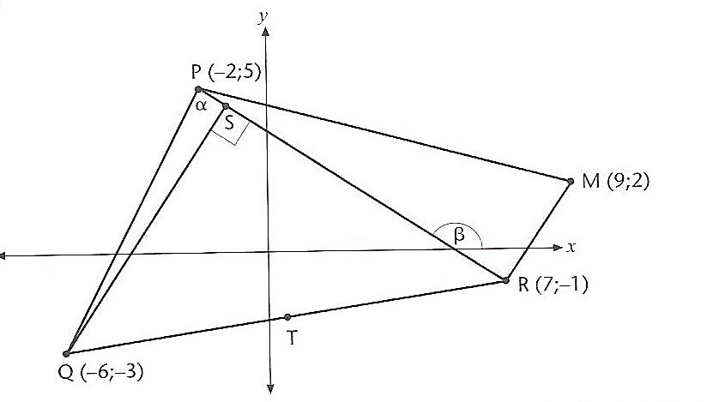
$$θ$$

2.1. | Bereken die koördinate van T, die middelpunt van QR. | 2.1. | Calculate the coordinates of T, the midpoint of QR. | (3)
2.2. | Bereken die lengte van PR, gee jou antwoord in eenvoudigste wortelvorm. | 2.2. | Calculate the length of PR, give your answer as a surd. | (2)
2.3. | Bereken die gradiënt van PR. | 2.3. | Calculate the gradient of PR. | (2)
2.4. | Bereken die grootte van $β$. | 2.4. | Calculate the size of $β$. | (3)
2.5. | Bewys dat PR loodreg is op RM. | 2.7. | Prove that PR is perpendicular to RM. | (4)
2.6. | Gestel $β=146,31°,$bereken die grootte van $α$. | 2.5. | If $β=146,31°$, calculate the size of $α.$ | (4)
2.7. | Gestel T is die punt $\left(\frac{1}{2};-2\right)$ en PQ het ‘n helling van $2$. Bereken die vergelyking van die lyn parallel aan PQ wat deur punt T gaan. | 2.6. | If T is the point $\left(\frac{1}{2};-2\right)$ and PQ has a gradient of $2$. Determine the equation of the line parallel to PQ that passes through point T. | (3)
2.8. | Gee die koördinate van N, sodat PRMN ‘n reghoek vorm. | 2.8. | Give the coordinates of N, so that PRMN forms a rectangle. | (2)

Vraag 3 [Nuwe bladsy] |  | Question 3 [New page] |  | [23]
3.1. | Vereenvoudig die volgende sonder die gebruik van ‘n sakrekenaar. Toon alle berekeninge. | 3.1. | Simplify the following without using a calculator. Show all your calculations.
3.1.1. | $$\sin{60°}.\cos{30°}+\cos{60°.}\sin{30°}+\sin{90°}$$ |  |  | (6)
3.1.2. | $$\frac{\sin\left(180°-x\right).\tan{(360°-x)}}{\cos{(90°-x)}}+\frac{2\tan\left(180°+x\right).\sin{(90°-x)}}{\cos{(-x)}}$$ |  |  | (7)
3.1.3. | $$\frac{4\cos{10°}.\cos{240°}}{\sin{100°}.\sin{150°}}$$ |  |  | (4)
3.2. | Bewys die volgende trigonometriese identiteite: | 3.2. | Prove the following trigonometric identities:
3.2.1. | $$\cos^{2}x.\sin{x}+\sin^{3}x=\sin{x}$$ |  |  | (3)
3.2.2. | $$\cos{θ}+\sin{θ}.\tan{θ}=\frac{1}{\cos{θ}}$$ |  |  | (3)
Vraag 4 [Nuwe bladsy] |  | Question 4 [New page] |  | [19]
4.1. | As $3\sin{θ}-2=0$ en $θ ϵ [90°;360°]$; gebruik ‘n skets en bereken die waarde van $\tan^{2}θ-3\sin{θ}$, sonder om die grootte van $θ$ te bereken. | 4.1. | If $3\sin{θ}-2=0$ and $θ ϵ [90°;360°]$ use a sketch to determine the value of  $\tan^{2}θ-3\sin{θ}$ without calculating the size of $θ$. | (6)
4.2. | Los op vir $x, x∈\left[0°;360°\right],$ in elk van die volgende vergelykings. | 4.2. | Solve for $x, x∈\left[0°;360°\right],$ in each of the following equations.
4.2.1. | $$5\cos{x}-1=0$$ |  |  | (4)
4.2.2. | $$3\sin{2x}=0,487$$ |  |  | (5)
4.3. | Bereken die algemene oplossing van $\tan{x}=-0,563.$ | 4.3. | Calculate the general solution for  $\tan{x}=-0,563.$ | (4)

Vraag 5 [Nuwe bladsy] |  | Question 5 [New page] |  | [20]
5.1. | Skets die grafiek van $y=\tan{(x-45°)}$ vir die interval $x ∈[-45°;315°]$. Toon alle afsnitte met asse sowel as alle asimptote. | 5.1. | Draw the graph of $y=\tan{(x-45°)}$ for the interval $x ∈[-45°;315°]$. Show all intercepts with axis as well as all asymptotes. | (5)
5.2. | Skets die grafiek van $y=\sin{(3x)}+1$ vir die interval $x ∈[0°;120°]$. Toon alle afsnitte met asse sowel as alle draaipunte. | 5.2. | Draw the graph of $y=\sin{(3x)}+1$ for the interval$x ∈[0°;120°]$. Show all intercepts with axis as well as all turning points. | (5)
5.3. | In die onderstaande diagram word die grafieke van die funksies $f$ en $g$ getoon vir $x ∈[0°;360°]$. Die grafieke sny by $A(63,4°;0,89)$ en $B$. Beantwoord die vrae wat volg. | 5.3. | In the diagram below the graphs of $f$ and $g$ is shown for $x ∈[0°;360°]$. The graphs intersect at $A(63,4°;0,89)$ and $B$. Answer the questions that follow.
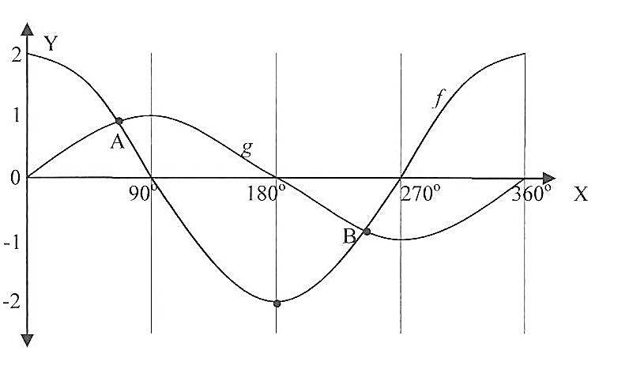

5.3.1. | Gee die vergelyking van $f.$ | 5.3.1. | Give the equation of $f.$ | (2)
5.3.2. | Gee die vergelyking van $g.$ | 5.3.2. | Give the equation of $g$. | (1)
5.3.3. | Gee die waardeversameling van $f.$ | 5.3.3. | Give the range of $f$. | (2)
5.3.4. | Gee die amplitude van $g$ | 5.3.4. | Give the amplitude of $g$. | (1)
5.3.5. | Skryf die koördinate van B neer. | 5.3.5. | Write down the coordinates of B. | (2)
5.3.6. | Vir watter waardes van $x$ is $g\left(x\right).f\left(x\right)<0$? | 5.3.6. | For what values of $x$ will $\left(x\right).f\left(x\right)<0$ ? | (2)
TOTAAL: 100 |  | TOTAL: 100

