Graad 11 Wiskunde  Vraestel 2 | Grade 11 Mathematics  Paper 2
Eksaminator: C du Toit  Moderator: M Retief  Totaal : 80  Tyd: 1 uur 30 min | Examiner: C du Toit  Moderator: M Retief  Total: 80  Time: 1 hour 30 min
19 JUNIE 2017


Hierdie vraestel bestaan uit 6 vrae en 7 bladsye waarvan een ‘n antwoordblad is. | This paper consists of 6 questions and 7 pages of which one is a answer sheet.
INSTRUKSIES EN INLIGTING  - Lees die volgende instruksies aandagtig deur voordat die vrae beantwoord word.  - Beantwoord AL die vrae.  - Kram die antwoordblad agteraan jou antwoordstel vas.  - Dui ALLE berekeninge, diagramme, grafieke, ensovoorts wat jy in die bepaling van jou antwoorde gebruik het, duidelik aan.  - Volpunte sal NIE noodwendig aan antwoorde alleen toegeken word NIE.  - Jy mag 'n goedgekeurde, wetenskaplike sakrekenaar (nie-programmeerbaar en niegrafies) gebruik, tensy anders vermeld.  - Indien nodig, rond antwoorde tot TWEE desimale plekke af, tensy anders vermeld.  - Diagramme is NIE noodwendig volgens skaal geteken NIE.  - Nommer die antwoorde korrek volgens die nommeringstelsel wat in hierdie vraestel gebruik is.  - Skryf netjies en leesbaar | INSTRUCTIONS AND INFORMATION  - Read the following instructions carefully before answering the questions.  - Answer ALL the questions.  - Staple the answer sheet to the back of your set of answers.  - Clearly show ALL calculations, diagrams, graphs, et cetera that you have used in determining your answers.  - Answers only will NOT necessarily be awarded full marks.  - You may use an approved scientific calculator (non-programmable and non-graphical), unless stated otherwise.  - If necessary, round off answers to TWO decimal places, unless stated otherwise.  - Diagrams are NOT necessarily drawn to scale.  - Number the answers correctly according to the numbering system used in this question paper.  - Write neatly and legibly.

Vraag 1 |  | Question 1
1.1. | P is die punt $(-5;2)$ en Q is die punt $(3;6)$. Bereken: | 1.1. | P is the point $(-5;2)$ and Q is the point $(3;6)$. Calculate:
1.1.1. | Die lengte van PQ. | 1.1.1. | The length of PQ. | (3)
1.1.2. | Die koördinate van M die middelpunt van PQ. | 1.1.2. | The coordinates of M the midpoint of PQ. | (3)
1.1.3. | Die vergelyking van die lyn deur P en Q. | 1.1.3. | The equation of the line going through the points P and Q. | (4)
1.1.4. | Die vergelyking van die middelloodlyn van PQ. | 1.1.4. | The equation of the perpendicular bisector of PQ. | (3)
1.2. | Bepaal die waardes van $x$ en $y$ indien  $M(1; 3)$ die middelpunt van die lynstuk is wat $A(4; 5)$ en $B(x; y)$ verbind. | 1.2. | Determine the values of $x$ and $y$ if  $M(1; 3)$ is the midpoint van the line that connects $A(4; 5)$ and $B(x; y)$. | (5)
 |  |  |  | [18]
Vraag 2 |  | Question 2
In die figuur is $A(0; 2), B(-5; -3), C(2; -2)$ en $D(x; y)$ die hoekpunte van die parallelogram ABCD. Die $x$ – afsnit van AB is $H(k; 0).$ BL sny die $x$- as by J en maak ‘n hoek $θ$, soos aangedui, met die $x$– as. |  | In the figure $A(0; 2), B(-5; -3), C(2; -2)$ and $D(x; y)$ are the vertices of the parallelogram ABCD. The $x$ – intercept of AB is $H(k; 0).$ BL cuts the $x$- axis at J and makes an angle $θ$, as indicated, with the $x$– axis.
 | 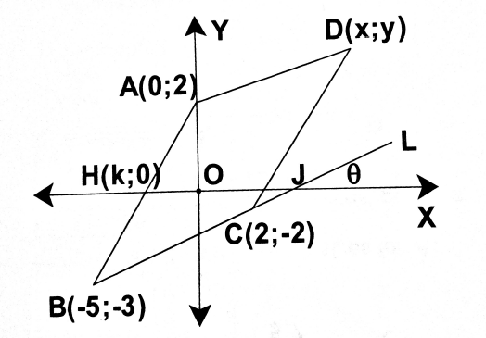
2.1. | Bepaal die gradiënt van BC. | 2.1. | Determine the gradient of BC. | (2)
2.2. | Bereken die grootte van $θ$. | 2.2. | Calculate the value of $θ$. | (2)
2.3. | Bepaal die waarde van k. | 2.3. | Determine the value of k. | (5)
2.4. | Bepaal die getalwaardes van $x$ en $y$, die koördinate van D. | 2.4. | Determine the numerical values of $x$ and $y$,the coordinates of D. | (2)
2.5. | Toon aan dat $ΔABC$ gelykbenig is. | 2.5. | Show that $ΔABC$will be isoceles. | (5)
 |  |  |  | [16]
Vraag 3 |  | Question 3
In die diagram hieronder is A(4; 3), B(2; 7),  C(-2; 5) en D(0; 1) vier punte in die kartesiese vlak. |  | In the diagram below A(4; 3), B(2; 7),  C(-2; 5) and D(0; 1) are four points on the cartesian plane.
 | 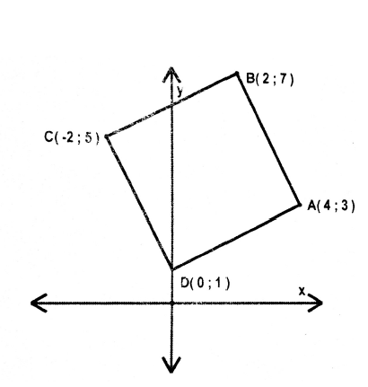
3.1. | Toon aan dat $AC⊥BD$. | 3.1. | Show that $AC⊥BD$ | (5)
3.2. | Toon aan dat AC, BD halveer. | 3.2. | Show that AC bisects BD. | (5)
3.3. | Noem, met redes, watter tipe vierhoek deur ABCD verteenwoordig word. | 3.3. | Name, with reasons, the type of quadrilateral represented by ABCD. | (1)
 |  |  |  | [11]

Vraag 4 |  | Question 4
Die grafiek van die funksies $f\left(x\right)=tan⁡(x + q)$ en $g\left(x\right)=sin⁡(px)$ vir $x ∈[-135°; 90°$] word in die onderstaande diagram geillustreer. Gebruik die skets en beantwoord die vrae wat volg. |  | The graph of the functions $f\left(x\right)=tan⁡(x + q)$ and $g\left(x\right)=sin⁡(px)$ for $x ∈[-135°; 90°$] are illustrated in the sketch below. Use the sketch to answer the following questions.
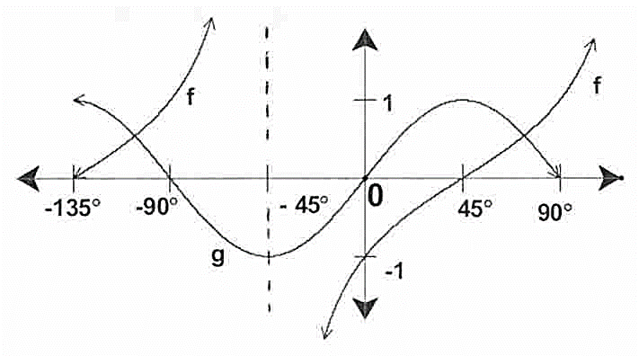
4.1. | Bepaal die waarde van $p$ en $q$. | 4.1. | Determine the value of $p$ and $q$. | (2)
4.2. | Bepaal die periode van $g$. | 4.2. | Determine the period of $g$. | (2)
4.3. | Skryf die vergelyking van $h$, as $h$ die refleksie van $g$ in die $x$-as is, neer. | 4.3. | Write down the equation of $h$, if $h$ is the reflection of $g$ in the $x$-axis | (1)
4.4. | Vir watter waarde(s) van $x$ is $f(x) ≥0$? | 4.4. | For which value(s) of $x$ is $f(x) ≥0$? | (2)
4.5. | Bepaal, met redes, die waardeversameling van die funksie $k$, as $k(x) = 2g(x)+1$ | 4.5. | Determine, with reasons, the range of the function $k$, if $k(x) = 2g(x)+1$ | (3)
 |  |  |  | [10]

Vraag 5 |  | Question 5
Bestudeer die onderstaande grafiek van die funksie $f\left(x\right)=\sin{(bx)}+c$ vir die interval  $0°≤x≤280°$. Beantwoord die vrae wat volg. |  | Study the graph below, that represents the function $f\left(x\right)=\sin{(bx)}+c$ for the interval  $0°≤x≤280°$. Answer the following questions.
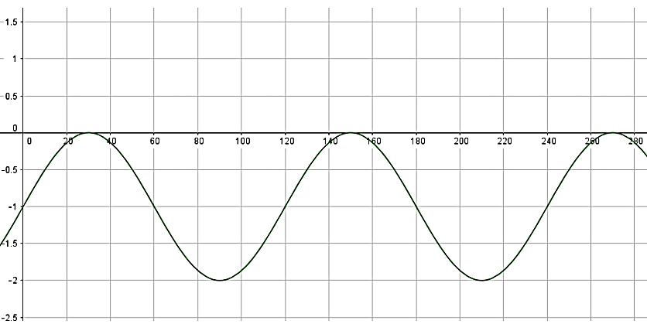
5.1. | Bepaal die waardes van b en c. | 5.1. | Determinethe values of b and c. | (2)
5.2. | Gee die waardeversameling van $f$. | 5.2. | Give the range of f. | (2)
5.3. | Vir watter waarde(s) van $x$ is $f$ stygend in die interval $0°≤x≤270°$? | 5.3. | Determine the value(s) of $x$ for which $f$is increasing for the interval  $0°≤x≤270°$. | (3)
5.4. | Vir watter waarde(s) van $x$ is $f$ dalend in die interval $0°≤x≤270°$? | 5.4. | Determine the value(s) of $x$ for which $f$is decreasing for the interval  $0°≤x≤270°$. | (2)
5.5. | Gee die amplitude van $f$. | 5.5. | Give the amplitude of $f.$ | (1)
 |  |  |  | [10]

Vraag 6 |  |  | Question 6
Gegee die funksies $f(x) = cos⁡(\frac{1}{2}x)$ en  $g(x) = - 2sinx$ vir die definisieversameling $x [-90 ; 270 ].$ |  |  | Given the functions $f(x) = cos⁡(\frac{1}{2}x)$ and  $g(x) = - 2sinx$ for the domain $x [-90 ; 270 ].$
6.1. | Skets grafieke vir die funksies op die selfde assestelsel, wat voorsien word aan die einde van hierdie vraestel. Dui alle afsnitte met alle asse, sowel as alle draaipunte duidelik aan. |  | 6.1. | Sketch the graphs of the functions on the same system of axes provided on the answer sheet provided at the back of the question paper. Clearly indicate all intercepts with axes as well as all turning points. |  | (6)
6.2. | Gee die minimum en maksimum waardes van $g.$ |  | 6.2. | Give the maximum and minimum values of $g$. |  | (2)
6.3. | Bereken die periode van $f.$ |  | 6.3. | Calculate the period of $f$. |  | (2)
6.4. | Bepaal vanaf die grafiek die waarde(s) van $x ∈[0;270]$ waarvoor $\frac{f(x)}{g(x)}$ ongedefinieerd is. |  | 6.4. | Determine from the graph the value(s) of $x ∈[0;270]$ for which $\frac{f(x)}{g(x)}$ will be undefined. |  | (2)
6.5. | Bepaal vanaf die grafiek en deur eerstens alle nodige berekeninge te wys, die waarde(s) van $x$ as  $-2\sin{x} = 1$. Dui op die grafiek (met ‘n X) aan waar die lesing(s) gemaak kan word. |  | 6.5. | Determine from the graph, by first showing any calculations needed, the value(s) of $x$, if $-2\sin{x} = 1$. Indicate on the graph (with a X) where the reading(s) were made. |  | (3)
 |  |  |  |  |  | [15]
TOTAAL: 80 |  | TOTAL: 80

ANTWOORDBLAD/ ANSWER SHEET
NAAM/ NAME _____________________________________________________________
VRAAG 6.1/ QUESTION 6.1
Y

 |  |  |  |  | 2
 |  |  |  |  | 1
 |  |  |  |  |  |  |  |  |  |  |  |  |  |  |  | X
 | -90° |  |  |  |  |  |  | 90° |  |  | 180° |  |  | 270°
 |  |  |  |  | -1
 |  |  |  |  | -2

