WISKUNDE/MATHEMATICS V2/P2 JUNIE/JUNE

GRAAD 11/GRADE 11 PUNTE/MARKS: 100
EKSAMEN/EXAMINATION TYD/TIME: 2 uur/hours
EKSAMINATOR: MODERATOR :

INSTRUKSIES EN INLIGTING

Lees die volgende instruksies aandagtig deur voordat u die vrae beantwoord:

1. Beantwoord AL die vrae in hierdie vraestel.

2. Dui AL die berekeninge, diagramme, grafieke, ensovoorts, wat u gebruik het om die antwoord te bepaal, duidelik aan.

3. ’n Goedgekeurde wetenskaplike sakrekenaar (nie-programmeerbare en nie-grafiese) mag gebruik word tensy anders vermeld.

4. Indien noodsaaklik moet antwoorde tot TWEE desimale plekke afgerond word, tensy anders vermeld.

5. Nommer die antwoorde korrek volgens die nommeringsisteem wat in hierdie vraestel gebruik word.

6. Diagramme is NIE noodwendig volgens skaal geteken nie.

7. Dit is tot u eie voordeel om leesbaar te skryf en u werk netjies aan te bied.

INSTRUCTIONS AND INFORMATION

Read the following instructions carefully before answering the questions:

1. Answer ALL the questions in this question paper.

2. Clearly show ALL calculations, diagrams, graphs, et cetera, which you have used in determining the answers.

3. An approved scientific calculator (non-programmable and non-graphical) may be used, unless stated otherwise.

4. If necessary, answers should be rounded off to TWO decimal places, unless stated otherwise.

5. Number the answers correctly according to the numbering system used in this question paper.

6. Diagrams are NOT necessarily drawn to scale.

7. It is in your own interest to write legibly and to present the work neatly.

Vraag 1/Question 1
1.1 A(3;2), B(1;a) en C(4;5) is punte in die Cartesiese vlak. Bepaal die waarde(s) van a as: A(3;2), B(1;a) and C(4;5) are points in the Cartesian plane. Determine the value(s) of a if:
1.1.1 A, B en C kolineêr is/A, B and C are collinear. (4)
1.1.2 die lengte van $AB=\sqrt{20}$ eenhede/the length of $AB=\sqrt{20}$ units. (4)

1.2 Gegee die punte A(-2;8), B(2;4), C en D, wat die hoekpunte van ‘n parallelogram is. Die vergelyking van lyn BD is $3y-x=10.$ Given the points A(-2;8), B(2;4), C and D which are the vertices of a parallelogram. The equation of BD is $3y-x=10.$

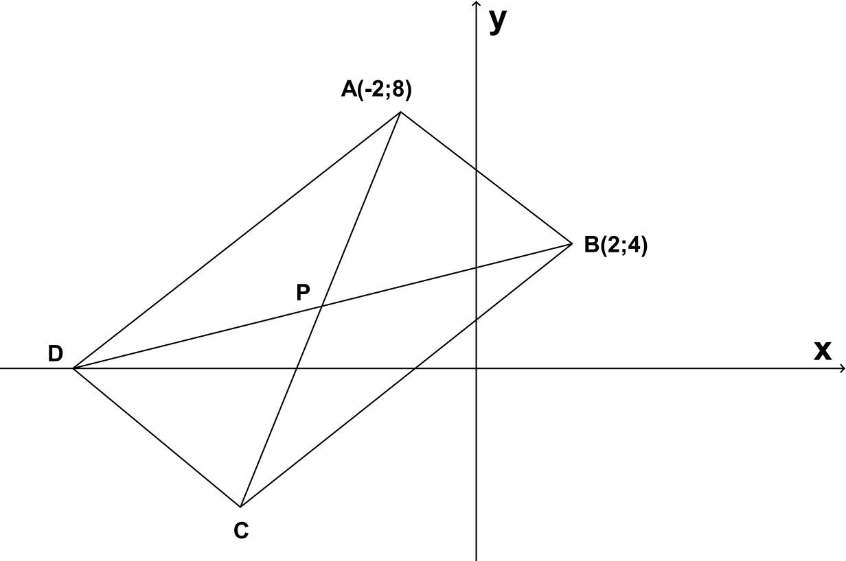

Bepaal/Determine:

1.2.1 die koördinate van D en C/the coordinates of D and C. (4)
1.2.2 die vergelyking van AC/the equation of AC. (3)
1.2.3 die koördinate van P, die snypunt van die twee hoeklyne. the coordinates of P, the intercept of the two diagonals. (2)
1.2.4 deur berekening of ABCD ‘n reghoek is/show with calculations if ABCD is a rectangle. (4)
1.2.5 die helling van AB/the inclination of AB. (2)
[23]

Vraag 2/Question 2

2.1 In die diagram hieronder is E en F onderskeidelik die x- en y-afsnit van die lyn met vergelyking $y=3x+8.$ Die lyn deur B(1;5) wat ‘n hoek van $45°$ met EF vorm, soos hieronder aangetoon, het x- en y-afsnitte by A en M onderskeidelik. In the diagram below, E and F respectively are the x-and y-intercepts of the line having equation $y=3x+8.$ The line through B(1;5) making an angle of $45°$ with EF, as shown below, has x- and y-intercepts A and M respectively.
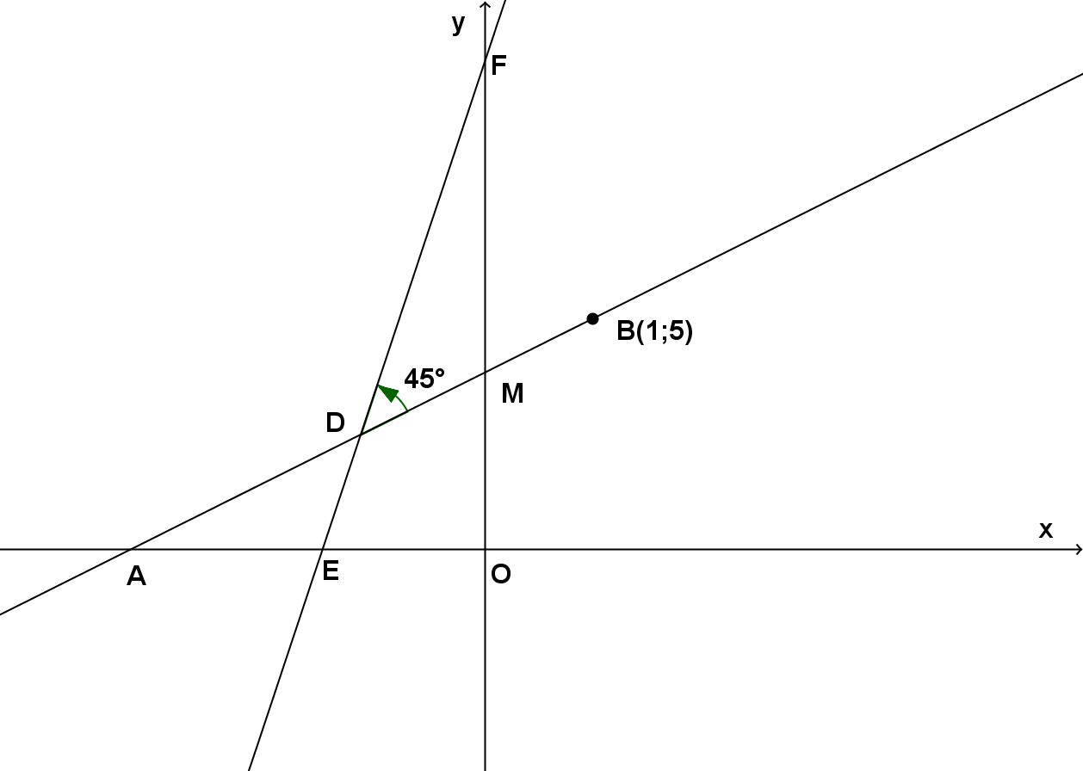

2.1.1 Bereken die grootte van $∠DAE$/Calculate the size of $∠DAE.$ (3)
2.1.2 Bepaal die vergelyking van AB in die vorm $y=mx+c.$
Determine the equation of AB in the form $y=mx+c.$ (3)

2.2 Gegee punte : A(a;b), B(a+p; b+p) en C(2a+p; 2b+p) waar a$≠$0, b$≠$0, p$≠$0 en a+p $≠$b. Given points A(a;b), B(a+p; b+p) and C(2a+p; 2b+p) where a$≠$0, b$≠$0, p$≠$0 en a+p $≠$b.

2.2.1 As AB $∥$ BC, bewys dat b = a/If AB $∥$ BC, prove that b = a. (3)
2.2.2 As B die middelpunt van AC is, bepaal die verwantskap tussen a, b en p. If B is the midpoint of AC, determine the relationship between a, b and p. (5)
[14]

Vraag 3/Question 3

3.1 As $pcos 15°=4$ , bepaal in terme van p: If $pcos 15°=4$ , determine in terms of p:

3.1.1 $\sin{165°}$ (3)
3.1.2 $\cos{75°}$ (1)
3.1.3 $tan⁡(-285°)$ (2)

3.2 Dit word gegee dat $m=\cos{α+\sin{α}}$ en $n=\cos{α-\sin{α}}$, bepaal $\cos{α}$ in terme van $m$ en $n$. It is given that $m=\cos{α+\sin{α}}$ and $n=\cos{α-\sin{α}}$, determine $\cos{α}$ in terms of $m$ and $n$. (2)

3.3 As $3\sin{θ=2}$ en $\cos{θ<0,}$ maak gebruik van ‘n skets en bepaal: If $3\sin{θ=2}$ and $\cos{θ<0,}$ use a sketch and determine:

3.3.1 $3\cos^{2}θ-1$ (4)

3.3.2 $tan⁡(-θ-180°)$ (2)

[14]

Vraag 4/Question 4

Vereenvoudig sonder ‘n sakrekenaar/Simplify without a calculator:

4.1 $\frac{\sin{110°.\cos\left(-30°\right).\tan{420°}}}{\cos^{2}\left(-135°\right).\cos{200°}}$ (8)

4.2 $\frac{\sin\left(-x\right).cos⁡(90°-x)}{\sin{450°}}-\frac{\sin\left(360°-x\right).cos⁡(x+80°)}{tan⁡(180°+x)}$ (8)

4.3 $\sqrt{4^{\sin{150°}}×2^{2\tan{225°}}}$ (4)

4.4 $\sin^{2}23°+\sin^{2}67°$ (2)
[22]

Vraag 5/Question 5

Bewys die volgende identiteite/Prove the following identities:

5.1 $\left[1-\cos^{2}x\right]\left[1+\frac{1}{\tan^{2}x}\right]=1$ (4)

5.2 $\tan^{2}x-\sin^{2}x=\tan^{2}x.\sin^{2}x$ (5)

[9]

Vraag 6/Question 6

6.1 Gegee: $h\left(x\right)=cos⁡(x+30°)$ en $g\left(x\right)=-2\sin{x}$. Given: $h\left(x\right)=cos⁡(x+30°)$.

6.1.1 Teken sketsgrafieke van die krommes van $h$en $g$ vir $xϵ\left[-120°;180°\right].$ Dui die snypunte met die asse aan asook die koördinate van die draaipunt en endpunte. Draw sketch graphs of the curves $h$ and $g$ for $xϵ\left[-120°;180°\right].$ Show all intercepts with the axes and the coordinates of the turning points and end points. (6)
6.1.2 Gebruik die grafieke geteken in 6.1.1 om te bepaal vir watter waardes van $x$ $\cos\left(x+30°\right)≥-2\sin{x }$ en $xϵ\left[-120°;180°\right].$ Use the graphs drawn in 6.1.1 to determine for which values of $x$ $\cos\left(x+30°\right)≥-2\sin{x }$ and $xϵ\left[-120°;180°\right].$ (2)
6.1.3 As kromme h afgeskuif word met $\frac{\sqrt{3}}{2}$ eenhede, bepaal die gevolglike $y$-afsnit. If the curve is shifted $\frac{\sqrt{3}}{2}$ units downwards, determine the resulting $y$-intercept. (1)
6.1.4 bepaal vir watter waardes van $x$ is $x.h\left(x\right)≥0?$ For which values of $x$ is $x.h\left(x\right)≥0?$ (3)

6.2
f
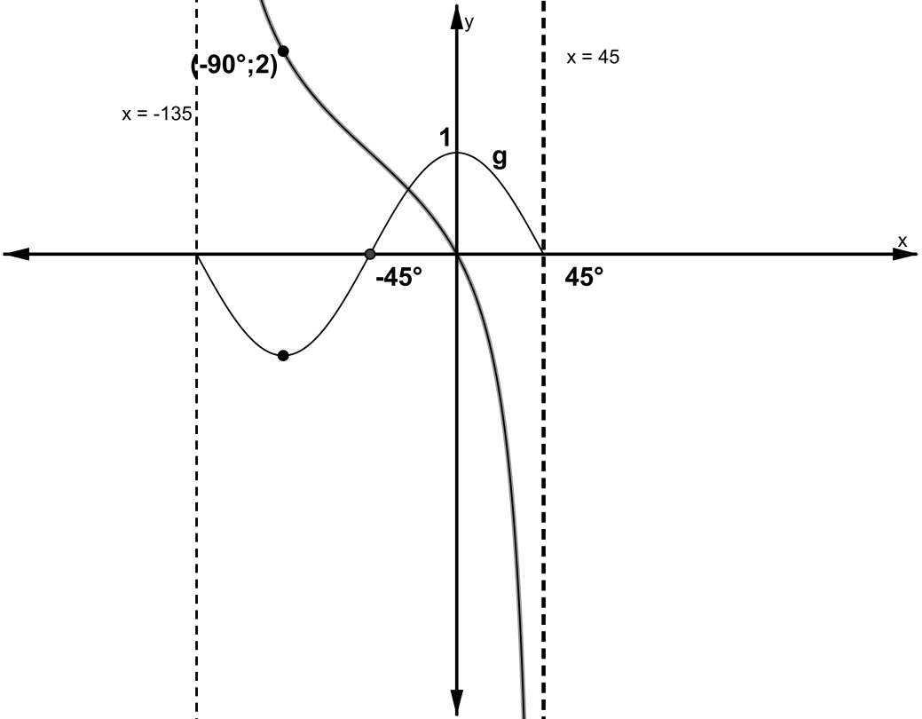

6.2.1 Noem die periode van $f$ en die amplitude van $g$. State the period of $f$ and the amplitude of $g$. (2)
6.2.2 Bepaal die waardes van a, b, c en m as: $f\left(x\right)=a tan\left(x-b\right)+c$ en $g\left(x\right)=\cos{mx.}$ Determine the values of a, b, c and m if $f\left(x\right)=a tan\left(x-b\right)+c$ and $g\left(x\right)=\cos{mx.}$ (4) [18]

