WISKUNDE/MATHEMATICS V2/P2 NOVEMBER

GRAAD 11/GRADE 11 PUNTE/MARKS: 150

EKSAMEN/EXAMINATION TYD/TIME: 3 uur/hours

EKSAMINATOR: MODERATOR :

INSTRUKSIES EN INLIGTING

Lees die volgende instruksies aandagtig deur voordat u die vrae beantwoord:

1. Beantwoord AL die vrae in hierdie vraestel.
2. Dui AL die berekeninge, diagramme, grafieke, ensovoorts, wat u gebruik het om die antwoord te bepaal, duidelik aan.
3. ’n Goedgekeurde wetenskaplike sakrekenaar (nie-programmeerbare en nie-grafiese) mag gebruik word tensy anders vermeld.
4. Indien noodsaaklik moet antwoorde tot TWEE desimale plekke afgerond word, tensy anders vermeld.
5. Nommer die antwoorde korrek volgens die nommeringsisteem wat in hierdie vraestel gebruik word.
6. Diagramme is NIE noodwendig volgens skaal geteken nie.
7. Dit is tot u eie voordeel om leesbaar te skryf en u werk netjies aan te bied.
8. Fokus nou vir 3 uur en geniet dan die volgende 6 weke sonder enige sorge.

INSTRUCTIONS AND INFORMATION

Read the following instructions carefully before answering the questions:

1. Answer ALL the questions in this question paper.
2. Clearly show ALL calculations, diagrams, graphs, et cetera, which you have used in determining the answers.
3. An approved scientific calculator (non-programmable and non-graphical) may be used, unless stated otherwise.
4. If necessary, answers should be rounded off to TWO decimal places, unless stated otherwise.
5. Number the answers correctly according to the numbering system used in this question paper.
6. Diagrams are NOT necessarily drawn to scale.
7. It is in your own interest to write legibly and to present the work neatly.
8. Focus for the next 3 hours and then you can enjoy the next 6 weeks without any worries.
VRAAG 1/QUESTION 1

Die tabel toon die persentasie vrouens wat in Julie 2011 in sekere lande in die senaat gedien het:
The table shows the percentage women who served in certain countries senates in July 2011.
Land Country | % vrouens in die Senaat % women in the Senate | Land Country | % vrouens in die Senaat % women in the Senate | Land Country | % vrouens in die Senaat % women in the Senate
Suid-Afrika  South Africa | 29,6 | Meksiko  Mexico | 22,7 | Switserland | 21,7
Namibi$ë$  Namibia | 26,9 | Italië  Italy | 18,4 | Bolivië | 47,2
Australië  Australia | 35,5 | Duitsland  Germany | 21,7 | Frankryk  France | 21,9
Oostenryk  Austria | 29,5 | Nigerië  Nigeria | 3,7 | Verenigde Koninkryk  United Kingdom | 20,1
Swaziland | 40,0 | Jemen | 1,8

1.1 | Bepaal vir hierdie datastel:  Determine for this set of data:
1.1.1 | die gemiddelde/the mean | (2)
1.1.2 | die standaardafwyking/the standard deviation | (2)
1.1.3 | watter lande nie binne een standaardafwyking van die gemiddelde val nie.  which countries do not lie within one standard deviation of the mean. | (3)
 |  | [7]

VRAAG 2/QUESTION 2

Die frekwensietabel toon die lengtes van 250 plante.
The frequency table show the lengths of 250 plants.
Plante se lengte (cm)  Lengths of plants (cm) | Frekwensie  Frequency | Kumulatiewe frekwensie  Cumulative frequency
$$0<x≤10$$ | 31 | (a)
$$10<x≤20$$ | 46 | (b)
$$20<x≤30$$ | 72 | (c)
$$30<x≤40$$ | 63 | (d)
$$40<x≤50$$ | 22 | (e)
$$50<x≤60$$ | 16 | (f)

2.1 | Skryf die waardes van (a) tot (f) neer.  Write down the values of (a) to (f). | (2)
2.2 | Gebruik die diagramblad om ‘n ogief vir die gegewe data te teken.  Draw an ogive for the given data on the diagramsheet. | (4)
2.3 | Bepaal ‘n benaderde waarde vir die interkwartielvariasiewydte deur die ogief te gebruik. Wys alle bewerkings.  Determine an estimated value for the interquartile range by using the ogive. Show all calculations. | (3)
2.4 | Die langste 10% van die plante moet na ‘n ander gebied verskuif word. Wat sou die afsnylengte wees om te bepaal of ‘n plant verskuif word of nie? Wys waar jy aflesing op ogief maak.  The longest 10% of the plants must be moved to another site. What would the cut of length be to decide whether the plants should be moved or not. Show where you read the value from the ogive. | (2)
 |  | [11]
VRAAG 3/QUESTION 3

A(2; -3), B(p; 3), C(-4; -1) en F(3; -2) is punte in ‘n Cartesiese vlak soos getoon.
A(2; -3), B(p; 3), C(-4; -1) and F(3; -2) are points in a Cartesian plane as shown.

A(2; -3)
C(-4; -1)
F(3; -2)
y
x
0
B(p; 3)

3.1 | Toon aan dat die numeriese waarde van p gelyk is aan 4 as die gradiënt van BC gelyk is aan $\frac{1}{2}.$  Show that the numerical value of p is equal to 4 if the gradient of BC is equal to $\frac{1}{2}.$ | (2)
3.2 | Bereken die koördinate van T, die middelpunt van AC.  Calculate the coordinates of T, the midpoint of AC. | (2)
3.3 | Bereken die vergelyking van AE, die mediaan (swaartelyn) van $∆ABC$met E op BC.  Calculate the equation of AE, the median of $∆ABC$ with E on BC. | (5)
3.4 | Bepaal of punte A, B en D(3; 0) kollineêr is.  Determine whether points A, B and D(3; 0) are collinear. | (3)
3.5 | Bepaal of punt C op die reguitlyn met vergelyking $y=2x+6$ lê.  Determine whether point C lies on the straight line with equation $y=2x+6$ . | (3)
 |  | [15]
VRAAG 4/QUESTION 4

In die diagram hieronder is P, Q, R(4; 2) en S(2; 1) die hoekpunte van ‘n vierhoek met PS||QR. M(0; 4) en N is die y-afsnitte van QR en PS onderskeidelik. PS verleng sny die x-as by T.
In the diagram below P, Q, R(4; 2) and S(2; 1) are the vertices of a quadrilateral with PS||QR. M(0; 4) and N are the y-intercepts of QR and PS respectively. PS produced cuts the x-axis at T.
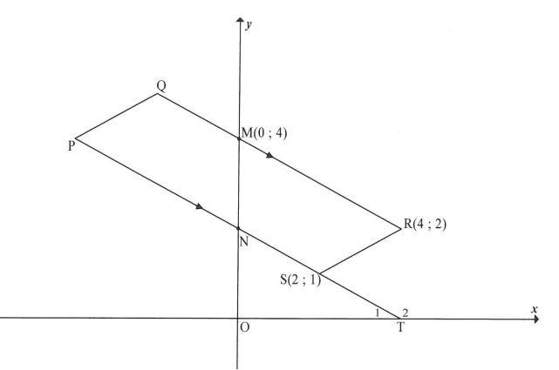

4.1 | Bereken die gradiënt van RS.  Calculate the gradient of RS. | (2)
4.2 | Gegee dat die vergelyking van PQ, $2y=x+12$ is, bereken, met redes, die lengte van PQ.  Given that the equation of PQ is $2y=x+12$, calculate, with reasons, the length of PQ. | (4)
4.3 | Bepaal die vergelyking van PT in die vorm $y=mx+c$.  Determine the equation of PT in the form $y=mx+c.$ | (4)
4.4 | Skryf vervolgens die koördinate van N neer.  Hence, write down the coordinates of N. | (2)
4.5 | Bereken, met redes, die grootte van $∠RNS$, afgerond tot EEN desimale plek.  Calculate, with reasons, the size of $∠RNS$, rounded to ONE decimal place. | (4)
 |  | [16]
VRAAG 5/QUESTION 5

5.1 | Vereenvoudig/Simplify:  $$\frac{\cos\left(180°-x\right).\sin\left(x-90°\right)-1}{\tan^{2}\left(540°-x\right).\sin\left(90°+x\right).cos⁡(-x)}$$ | (8)
5.2 | Bewys die identiteit/Prove the identity:  $$2-\cos^{2}x\left(2+\tan^{2}x\right)=\sin^{2}x$$ | (4)
5.3 | Vir watter waarde van $θ$, as $θϵ\left[-180°;180°\right],$ sal die identiteit  $1-\frac{\cos{θ}}{\sin{θ}}=\frac{\sin{θ}}{1+\cos{θ}}$ ongedefinieerd wees?  For which value of $θ$, if $θϵ\left[-180°;180°\right]$, will the identity  $1-\frac{\cos{θ}}{\sin{θ}}=\frac{\sin{θ}}{1+\cos{θ}}$ be undefined? | (3)
5.4 | Bepaal die algemene oplossing van $6\cos{x-4=\frac{2}{\cos{x}}} ,\cos{x≠0.}$  Determine the general solution of $6\cos{x-4=\frac{2}{\cos{x}}} ,\cos{x≠0.}$ | (6)
5.5 | As $\sin{42°=\sqrt{1-p^{2}}}$ bepaal, sonder om ‘n sakrekenaar te gebruik,  $\tan{135°+\tan^{2}138°+\frac{\sin{168°}}{\cos{78°}}}$ in terme van p.  If $\sin{42°=\sqrt{1-p^{2} }}$ determine, without using a calculator,  $\tan{135°+\tan^{2}138°+\frac{\sin{168°}}{\cos{78°}}}$ in terms of p. | (7)
5.6 | As die afstand tussen die koördinate $(\cos{θ;\sin{θ) en \left(2;3\right) }}$gelyk aan $\sqrt{14}$ is, bepaal die numeriese waarde van $\tan{θ.}$  If the distance between the coordinates $(\cos{θ;\sin{θ) and \left(2;3\right) is \sqrt{14}}}$, determine the numerical values of $\tan{θ.}$ | (4)
 |  | [32]

VRAAG 6/QUESTION 6

6.1 | Bepaal die algemene oplossing van $\sin\left(x+30°\right)=\cos{3x}$.  Determine the general solution of $\sin\left(x+30°\right)=\cos{3x}.$ | (6)
6.2 | In die diagram hieronder is die grafiek $f\left(x\right)=sin⁡(x+30°)$ geteken vir die interval $x∈\left[-30°;150°\right].$  In the diagram below, the graph of $f\left(x\right)=sin⁡(x+30°)$ is drawn for the interval $x∈\left[-30°;150°\right].$  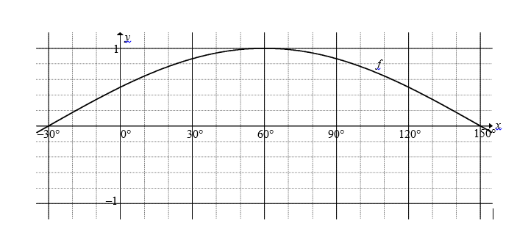
6.2.1 | Op dieselfde assestelsel, teken die grafiek van g, waar $g\left(x\right)=\cos{3x,}$ vir die interval $x∈\left[-30°;150°\right].$  On the same system of axes sketch the graph of g, where $g\left(x\right)=\cos{3x,}$ for the interval $x∈\left[-30°;150°\right].$ | (3)
6.2.2 | Skryf neer die periode van $h\left(x\right) as h\left(x\right)=g\left(x-30°\right).$  Write down the period of $h\left(x\right) if h\left(x\right)=g\left(x-30°\right).$ | (1)
6.2.3 | Vir watter waardes van x sal $f(x)≥g(x)$ in die interval $x∈[-30°;150°]?$  For which values of x will $f(x)≥g(x)$ in the interval $x∈[-30°;150°]?$ | (3)
 |  | [13]

VRAAG 7/QUESTION 7

Driehoek PQS stel ‘n sekere oppervlakte van ‘n park voor. R is ‘n punt op PS en QR verdeel die oppervlakte van die park vir ‘n feestelike geleentheid, in twee driehoekige dele. PQ = PR = $x$ eenhede, $RS=\frac{3x}{2}$ eenhede en $RQ=\sqrt{3}x$ eenhede.
Triangle PQS forms a certain area of a park. R is a point on PS and QR divides the area of the park into two triangular parts, as shown below, for a festive event. PQ = PR = $x$ units, $RS=\frac{3x}{2}$ units and $RQ=\sqrt{3}x$ units.
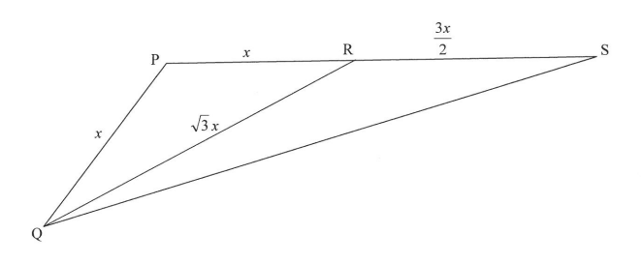
7.1 | Bereken die grootte van $∠P.$  Calculate the size of $∠P.$ | (4)
7.2 | Bereken vervolgens die oppervlakte van driehoek QRS in terme van $x$ in sy eenvoudigste vorm.  Hence, calculate the area of triangle QRS in terms of $x$ in its simplest form. | (4)
 |  | [8]

VRAAG 8/QUESTION 8

8.1 | Voltooi die volgende stellings deur slegs die ontbrekende woord(e) in elke geval neer te skryf.  Complete the following theorems by writing down only the missing word(s) in each case.
8.1.1 | ‘n Lyn vanuit die middelpunt van ‘n sirkel na die middelpunt van ‘n koord, is …….op die koord.  A line from the centre of a circle to the centre of a chord, is …….to the chord. | (1)
8.1.2 | Die hoek tussen die raaklyn en ‘n koord is…….  The angle between a tangent and a chord is…….. | (1)
8.1.3 | Die teenoorstaande hoeke van ‘n koordevierhoek is…….  The opposite angles of a cyclic quadrilateral are…….. | (1)
8.2 | In die onderstaande figuur is BD ‘n middellyn van die sirkel. BA || CD, AE = ED en $∠BDC=60°$. Bereken, met redes, die groottes van die volgende hoeke:  In the diagram below BD is the diameter of the circle. BA || CD, AE = ED and $∠BDC=60°$. Calculate, with reasons, the sizes of the following angles.  A  B  C  D  E  1  2  60°  1  1  2  2  1
8.2.1 | $$∠C_{1}$$ | (2)
8.2.2 | $$∠B_{1}$$ | (2)
8.2.3 | $$∠E$$ | (2)
8.2.4 | $$∠D_{1}$$ | (2)
8.3 | In die diagram is O die middelpunt van die sirkel, AS = SB, AB = 20 eenhede, ST = 4 eenhede en OS = $x$. Bereken die waarde van $x$.  In the diagram O is the midpoint of the circle, AS = SB, AB = 20 units, ST = 4 units and OS = $x$. Calculate the value of $x$.  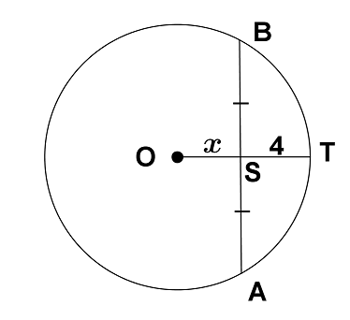 | (5)
8.4 | A, B, C en DS lê op die omtrek van sirkel O. $∠C_{1}=∠C_{2}.$ Stel $∠OAB=x.$ Bewys dat $∠DAB=2x.$  A, B, C and D are on the circumference of circle O. $∠C_{1}=∠C_{2}$. If $∠OAB=x,$ prove that $∠DAB=2x.$  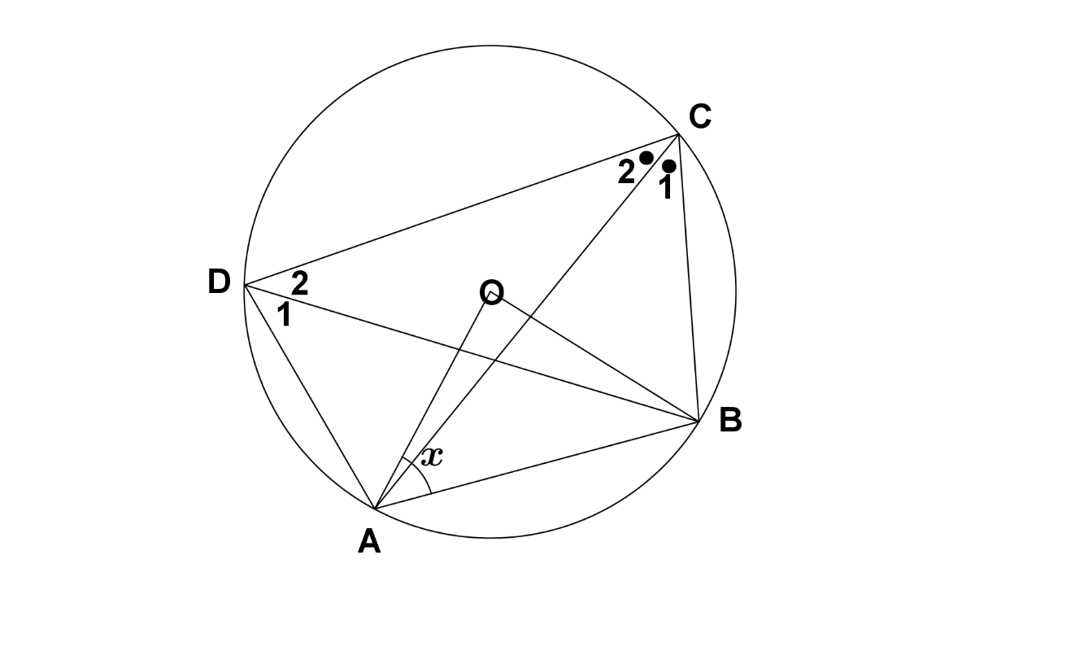 | (5)
 |  | [21]
VRAAG 9/QUESTION 9

9.1 | In die diagram hieronder is O die middelpunt van sirkel EBD. Gebruik die diagram op die DIAGRAMBLAD om die stelling te bewys wat beweer dat:  As BC ‘n raaklyn aan die sirkel is, dan is $∠DBC=∠E.$  In the diagram below O is the midpoint of the circle EBD. Use the diagram on the DIAGRAMSHEET to prove the theorem which states that:  If BC is a tangent to the circle, then $∠DBC=∠E.$  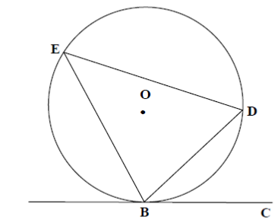 | (5)
9.2 | In die diagram hieronder is ABCF ‘n koordevierhoek met AB = BF en AF en BC, beide verleng, ontmoet in E. $∠F_{1}=x$ en die raaklyn by F ontmoet BE in D.  In the diagram below ABCF is a cyclic quadrilateral with AB = BF and AF and BC, both extended, meet in E. $∠F_{1}=x$ and the tangent to the circle at F meets BE in D.  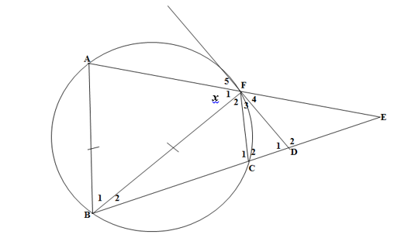  x
9.2.1 | Noem, met redes, TWEE ander hoeke wat gelyk is aan $x$.  Name, with reasons, two other angles equal to$x.$ | (4)
9.2.2 | Druk $∠F_{4}$ uit in terme van x.  Express $∠F_{4}$ in terms of x. | (5)
9.2.3 | Bewys dat FB ‘n raaklyn by F aan die sirkel deur die punte F, C en E is.  Prove that FB is a tangent to the circle at F through points F, C and E. | (5)
9.3 | In die diagram hieronder is RS die middellyn van die halfsirkel met middelpunt O. VP is ‘n raaklyn aan die halfsirkel en $OV⊥PR.$  In the diagram below RS is the diameter of the semi-circle with midpoint O. VP is a tangent to the halfcircle and $OV⊥PR.$  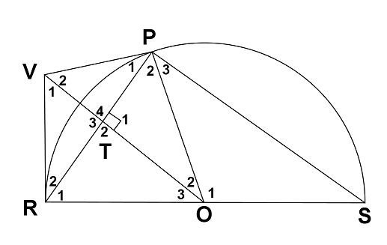  Bewys dat/Prove that:
9.3.1 | $$VO∥PS$$ | (3)
9.3.2 | PORV ‘n koordevierhoek is.(Wenk : maak $∠P_{1}=x)$  PORV is a cyclic quadrilateral.(Hint : make $∠P_{1}=x)$ | (5)
 |  | [27]

