Graad 12 Wiskunde  Vraestel 2 | Grade 12 Mathematics  Paper 2
Eksaminator: C du Toit  Moderator: M Retief  Totaal : 150  Tyd: 3 ure | Examiner: C du Toit  Moderator: M Retief  Total: 150  Time: 3 hours
11.06.2018


Hierdie vraestel bestaan uit 11 bladsye. | This paper consists of 11 pages.
INSTRUKSIES EN INLIGTING  - Lees die volgende instruksies aandagtig deur voordat die vrae beantwoord word.  - Hierdie vraestel bestaan uit 9 vrae.  - Beantwoord AL die vrae.  - KRAM DIAGRAMVELLE AGTERAAN ANTWOORDSTEL VAS.  - Dui ALLE berekeninge, diagramme, grafieke, ensovoorts wat jy in die bepaling van jou antwoorde gebruik het, duidelik aan.  - Volpunte sal NIE noodwendig aan antwoorde alleen toegeken word NIE.  - Jy mag 'n goedgekeurde, wetenskaplike sakrekenaar (nie-programmeerbaar en nie-grafies) gebruik, tensy anders vermeld.  - Indien nodig, rond antwoorde tot TWEE desimale plekke af, tensy anders vermeld.  - Diagramme is NIE noodwendig volgens skaal geteken NIE.  - Nommer die antwoorde korrek volgens die nommeringstelsel wat in hierdie vraestel gebruik is.  - Skryf netjies en leesbaar | INSTRUCTIONS AND INFORMATION  - Read the following instructions carefully before answering the questions.  - This question paper consists of 9 questions.  - Answer ALL the questions.  - STAPLE DIAGRAM SHEETS TO THE BACK OF SET OF ANSWERS.  - Clearly show ALL calculations, diagrams, graphs, et cetera that you have used in determining your answers.  - Answers only will NOT necessarily be awarded full marks.  - You may use an approved scientific calculator (non-programmable and non-graphical), unless stated otherwise.  - If necessary, round off answers to TWO decimal places, unless stated otherwise.  - Diagrams are NOT necessarily drawn to scale.  - Number the answers correctly according to the numbering system used in this question paper.  - Write neatly and legibly.

Vraag 1 |  | Question 1
Hieronder is die punte van 30 leerders in `n Wiskunde eksamen (uit 150):  59 63 66 66 67 67  68 69 72 72 74 74  75 75 78 79 80 84  84 85 85 86 89 92  92 98 99 101 104  108 |  | Below are the marks of 30 learners in a Mathematics examination (out of 150):  59 63 66 66 67 67  68 69 72 72 74 74  75 75 78 79 80 84  84 85 85 86 89 92  92 98 99 101 104  108
1.1. | Voltooi die onderstaande tabel op DIAGRAMVEL 1. | 1.1. | Complete the table on DIAGRAM SHEET 1. | (4)
Punte/ Marks | Frekwensie/ Frequency | Kumulatiewe frekwensie/  Cumulative Frequency
$$50 ≤ x < 60$$
$$60 ≤ x < 70$$
$$70 ≤ x < 80$$
$$80 ≤ x < 90$$
$$90 ≤ x < 100$$
$$100 ≤ x < 110$$

1.2. | Teken ‘n ogief op DIAGRAMVEL 1 om die inligting in die tabel voor te stel. | 1.2. | Draw an ogive on DIAGRAM SHEET 1 to represent the information in the table. | (4)
1.3. | Gebruik die ogief om die mediaan te bepaal en aan te dui. | 1.3. | Use the ogive to determine and indicate the median mark. | (2)
1.4. | Bereken die standaardafwyking van die oorspronklike data. | 1.4. | Calculate the standard deviation of the original data. | (2)
 |  |  |  | [12]
Vraag 2 |  | Question 2
Die vyf syfer opsomming van die hoogte van tamatie plantjiess in sentimeters is as volg:  (25, 40, 50, 55, 75) |  | The five number summary of the heights of the heights of tomato plants in centimeters is  given as (25, 40, 50, 55, 75)
2.1. | Gebruik die data en teken ‘n mond-en-snor ( houer en stippel) diagram. | 2.1. | Use the data and draw a box and whisker diagram. | (3)
2.2. | Watter persentasie van plantjies se hoogte oorskry 55 cm. | 2.2. | What percentage of plants has a height in excess of 55 cm. | (1)
2.3. | Bepaal die interkwartiel omvang. | 2.3. | Determine the inter-quartile range. | (2)
2.4. | Tussen watter kwartiele sal die hoogte van die plantjies die minste variasie toon? | 2.4. | Between which quartiles does the height of the plants show the least variation? | (1)
2.5. | Lewer kommentaar oor die skeefheid van die data. | 2.5. | Comment on the skewness of the data. | (1)
 |  |  |  | [8]

Vraag 3 |  | Question 3
Die diagram hieronder toon die punte $P(0 ; 2)$ en $Q(4 ; 0)$. Punt $A$ is die middelpunt van $PQ$. Die lyn $AB$ is loodreg op $PQ$ en sny die $x$-as by $G$ en die $y$-as by $B$. |  | The diagram below shows the points $P(0 ; 2)$ and $Q(4 ; 0).$Point $A$ is the midpoint of $PQ$. The line $AB$ is perpendicular to $PQ$ and intersects the $x$-axis at $G$ and the $y$-axis at $B$.
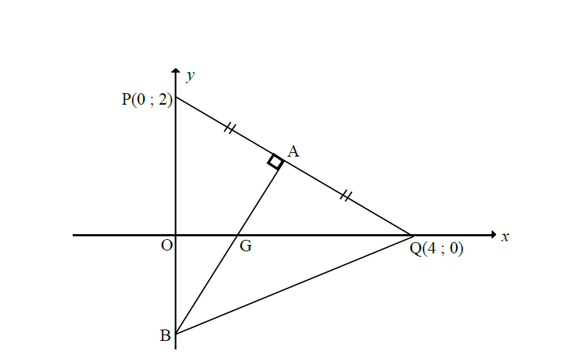
3.1. | Toon aan dat die gradient van PQ gelyk is aan $-\frac{1}{2}$. | 3.1. | Show that the gradient of PQ is equal to $-\frac{1}{2}.$ | (1)
3.2. | Bepaal die koördinate van A. | 3.2. | Determine the coordinates of A. | (2)
3.3. | Bepaal die vergelyking van die lyn AB. | 3.3. | Determine the equation of the line AB. | (5)
3.4. | Bereken die lengte van BQ. | 3.4. | Calculate the length of BQ. | (3)
3.5. | Toon aan dat $∆BPQ$ ‘n gelykbenige driehoek is. | 3.5. | Show that $∆BPQ$ is an isosceles triangle. | (2)
3.6. | Indien PBQR ‘n ruit is, bepaal die koördinate van R. | 3.6. | If PBQR is a rhombus, determine the coordinates of R. | (2)
 |  |  |  | [15]

Vraag 4 |  | Question 4
4.1. | Die onderstaande diagram toon vierhoek ABCE, met hoekpunte $A\left(1;7\right), B\left(3;y\right), C\left(5;-9\right)$ en $E(-3;3)$ en $AB∥EC$. $D$ is die middelpunt van $CE$. | 4.1. | The diagram below show quadrilateral ABCE, with vertices $A\left(1;7\right), B\left(3;y\right), C\left(5;-9\right)$ and $E(-3;3)$ and $AB∥EC$. $D$ is the midpoint of $CE$.
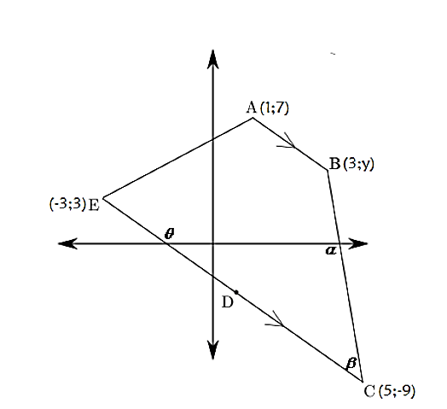
4.1.1. | Bereken die waarde van $y$. | 4.1.1. | Determine the value of $y$. | (4)
4.1.2. | Bepaal die koördinate van D. | 4.1.2. | Determine the coordinates of D. | (2)
4.1.3. | Bereken die grootte van $θ$, die inklinasie hoek van $EC$. | 4.1.3. | Calculate the size of $θ$, the inclination angle of $EC$. | (3)
4.1.4. | Bereken die grootte van $β.$ | 4.1.4. | Calculate the size of $β.$ | (5)
4.2. | Parallelogram ABCD het hoekpunte $A\left(2;5\right), B\left(7;0\right), C(x;y)$ en $D\left(-3;1\right).$ | 4.2. | Parallelogram ABCD has vertices $\left(2;5\right), B\left(7;0\right), C(x;y)$ and $D\left(-3;1\right).$
 | 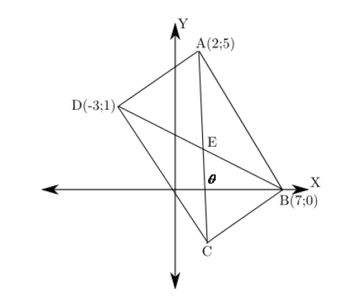
4.2.1. | Bereken die koördinate van $C$. | 4.2.1. | Calculate the coordinates of $C$. | (2)
4.2.2. | Bereken die grootte van $θ$. | 4.2.2. | Calculate the size of $θ$. | (3)
4.2.3. | Is ABCD ‘n reghoek? Motiveer jou antwoord met gepaste berekeninge. | 4.2.3. | Is ABCD a rectangle? Motivate your answer with appropriate calculations. | (5)
 |  |  |  | [24]

Vraag 5 |  | Question 5
5.1. | As $24tanβ = 7$ en $β∈[180°;360°]$ , bepaal die waarde van $sin 2β$ sonder die gebruik van 'n sakrekenaar. Maak gebruik van 'n skets om die berekeninge te staaf en wys alle berekeninge. | 5.1. |  |  | If $24tanβ = 7$ and $β∈[180°;360°]$, determine the value of $sin 2β$ without using a calculator. Make use of a sketch to substantiate your calculations. Show all calculations. | (6)
5.2. | Bewys die volgende identiteit: | 5.2. |  |  | Prove the following identity: | (4)
 | 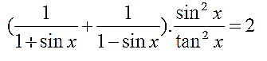
5.3.1. | Bewys: $\cos{2x}=1-2\sin^{2}{x}$ |  | 5.3.1. | Prove: $\cos{2x}=1-2\sin^{2}{x}$ |  | (4)
5.3.2. | Vereenvoudig die volgende uitdrukking sonder 'n sakrekenaar. | 5.3.2. |  |  | Simplify the following expression without using a calculator. | (7)
 | 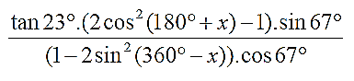
5.4. | Beskou die onderstaande vegelyking. Los op vir $x, x∈\left[0°;360°\right],$ sonder die gebruik van 'n sakrekenaar.  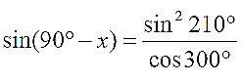 | 5.4. |  |  | Consider the equation below. Solve for $x, x∈\left[0°;360°\right],$ without using a calculator.  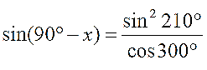 | (6)
5.5. | Bereken die algemene oplossing vir:  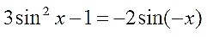 | 5.5. |  |  | Calculate the general solution for: | (4)
 |  |  |  |  |  | [31]

Vraag 6 |  |  | Question 6
Die diagram verteenwoordig $f \left(x\right)=\sin{ax}$ en $g\left(x\right)= b\cos{x}$ vir $x∈[-180°;180°]$ |  |  | The diagram represents $f \left(x\right)=\sin{ax}$ and $g\left(x\right)= b\cos{x}$ for $x∈[-180°;180°]$.
 |  | 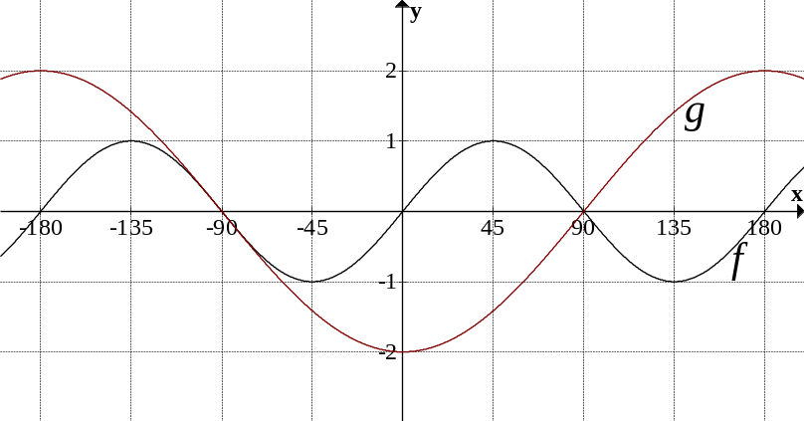
6.1. |  | Bepaal die waardes vir $a$ en $b$ . | 6.1. | Determine the values for $a$ and $b$ . | (2)
6.2. |  | Vir watter waarde(s) van $x$ sal  $f\left(x\right)=g(x)$? | 6.2. | For what value(s) of $x$ will $f\left(x\right)=g(x)$? | (2)
6.3. |  | Vir watter waarde(s) van $x$ sal  $f (x) = g(x) + 2$ ? | 6.3. | For what value(s) of $x$ will  $f (x) = g(x) + 2$ ? | (2)
6.4. |  | Gee die vergelyking van $h$ as  $h(x) = 2g(x) + 2$ | 6.4. | Give the equation of $h$ if  $h(x)=2g(x)+2$ | (3)
6.5. |  | Gee die waardeversameling van $h(x)$ | 6.5. | Give the range of $h(x)$. | (2)
 |  |  |  |  | [11]
Vraag 7 |  |  | Question 7
'n Reghoekige verjaarsdagkaartjie word met 'n lint by die middelpunte, $G$ en $H$, van die langer kante vasgemaak.  Die kaartjie word oopgemaak om die boodskap binne te lees en dan so op 'n tafel geplaas dat die hoek $E\hat{F}A$ tussen die voorblad en die agterblad van die kaartjie $90°$ is. Die punte $G$ en $H$ word met reguit lyne verbind tot by punt $C$ binne in die kaartjie, soos in die skets getoon.  Laat die korter kant van die kaartjie, $BC = x$, en die langer kant,$CF = 2y$. |  |  | A rectangular birthday card is tied with a ribbon at the midpoints, $G$ and $H$, of the longer sides.  The card is opened to read the message inside and then placed on a table in such a way that the angle $E\hat{F}A$ between the front cover and the back cover of the card is $90°$ . The points $G$ and $H$ are joined by straight lines to the point $C$ inside the card, as shown in the sketch.  Let the shorter side of the card, $BC = x$, and the longer side, $CF = 2y$.
 | 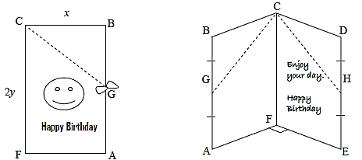
Bewys dat :$\cos{G\hat{C}H}=\frac{y^{2}}{x^{2}+y^{2}}$ |  |  | Prove that: $\cos{G\hat{C}H}=\frac{y^{2}}{x^{2}+y^{2}}$ |  | [8]

VOLLEDIGE REDES MOET VIR DIE VOLGENDE VRAE VERSKAF WORD. |  | COMPLETE REASONS MUST BE GIVEN FOR THE FOLLOWING QUESTIONS.
Vraag 8 |  | Question 8
8.1. | In die diagram hieronder is $AB$ ŉ koord van ŉ sirkel met middelpunt $O$.  $D$ is ’n punt op die sirkel. $OD$ is loodreg op $AB$. $OA=25 cm$ en  $CD=18 cm.$ | 8.1. | In the diagram below $AB$ is a chord of the circle with center $O$. $D$ is a point an the circle. $OD$ is perpendicular on $AB$. $OA=25 cm$ and $CD=18 cm.$
 | 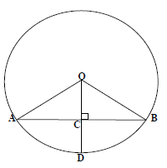
 | Bereken, met redes, die lengte van $AB$. |  | Calculate, with reasons, the length of $AB$. | (5)
8.2. | In die diagram hieronder is $QOB$ die middellyn van sirkel $O$. $PR||QB$,  $QB⊥RS$ en $∠PBQ=25°$. $P, R$ en $S$ is punte op die sirkel. | 8.2. | In the diagram below $QOB$ is the diameter of circle $O$. $PR||QB$,  $QB⊥RS$ and $∠PBQ=25°$. $P, R$ and $S$ are points on the circle.
 | 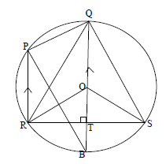
8.2.1. | Bepaal, met redes, drie ander hoeke wat elk gelyk is aan $25°$. | 8.2.1. | Calculate, with reasons, three other angles that is each equal to $25°$. | (6)
8.2.2. | Bepaal met redes: | 8.2.2. | Determine with reasons:
(a) | $∠ROB$ | (a) | $∠ROB$ | (2)
(b) | $∠ORT$ | (b) | $∠ORT$ | (2)
(c) | $∠ROS$ | (c) | $∠ROS$ | (2)
(d) | $∠RPQ$ | (d) | $∠RPQ$ | (2)
 |  |  |  | [19]

Vraag 9 |  | Question 9
9.1. | In die diagram sny koorde $AR$ en $CP$ mekaar binne die sirkel. $AR$ en $CP$ word onderskeidelik na $B$ en $D$ verleng sodat $AC || DB$. | 9.1. | In the diagram chords $AR$ and $CP$ intersect at the inside of the circle. $AR$ and $CP$ is produced to $B$ and $D$ respectively in such a way that $AC || DB$.
 | 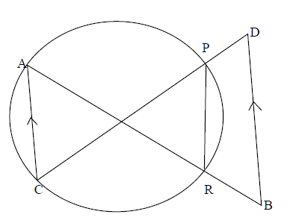
 | 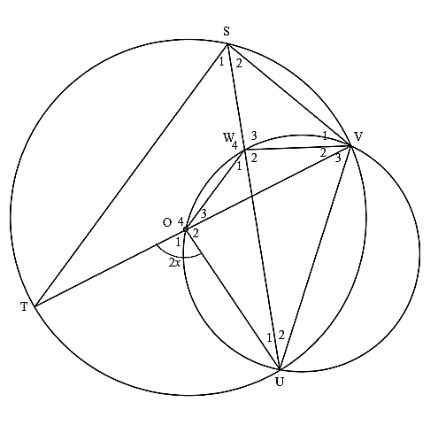  Bewys dat $PDBR$ ŉ koordevierhoek is. |  | Prove that $PDBR$ is a cyclic quadrilateral. |  | (7)
9.2. | $O$ is die middelpunt van die groter sirkel. $O$ lê op die omtrek van die kleiner sirkel. $O, W, V$ en $U$ is punte op die omtrek van die kleiner sirkel. $T$, $S, V$ en $U$ is punte op die omtrek van die groter sirkel. $∠O_{1}=2x.$ | 9.2. | $O$ is the center of the bigger circle. $O$ lies on the circumference of the smaller circle. $O, W, V$ and $U$ is points on the circumference of the smaller circle. $T$, $S, V$ and $U$ is points on the circumference of the bigger circle. $∠O_{1}=2x.$
9.2.1. | Noem, met redes, VIER ander hoeke elk gelyk aan . | 9.2.1. | Name, with reasons, FOUR other angles each equal to $x$. | (8)
9.2.2. | Bepaal, met redes, die grootte van $∠W_{2}$ in terme van . | 9.2.2. | Determine, with reasons, the size of $∠W_{2}$ in terms of . | (3)
9.2.3. | Bewys dat $WS = WV$. | 9.2.3. | Prove that $WS = WV$. | (4)
 |  |  |  | [22]
TOTAAL: 150 |  | TOTAL: 150

DIAGRAMVEL 1: KRAM AGTERAAN ANTWOORDSTEL VAS
DIAGRAM SHEET 1: STAPLE TO THE BACK OF YOUR SET OF ANSWERS
NAAM & VAN/
NAME & SURNAME: ________________________________________________________

VRAAG 1.1. / QUESTION 1.1.
Punte/ Marks | Frekwensie/ Frequency | Kumulatiewe frekwensie/  Cumulative Frequency
$$50 ≤ x < 60$$
$$60 ≤ x < 70$$
$$70 ≤ x < 80$$
$$80 ≤ x < 90$$
$$90 ≤ x < 100$$
$$100 ≤ x < 110$$
(4)
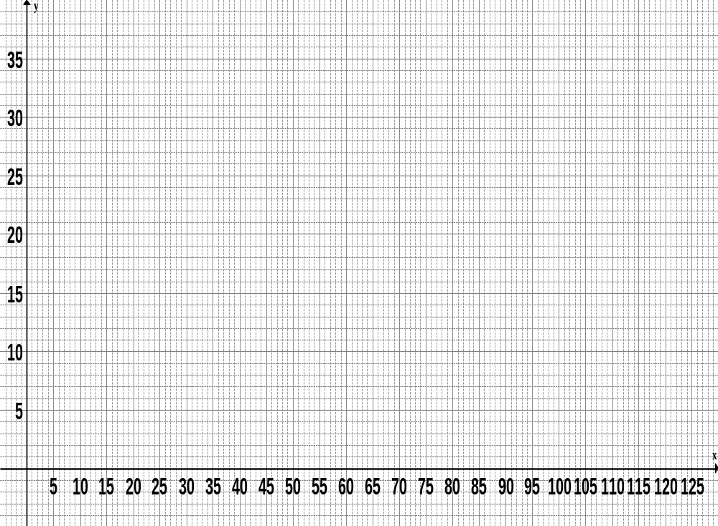
VRAAG 1.2. / QUESTION 1.2.
Punte van leerders/ Learner marks
Kumulatiewe frekwensie/ Cumulative frequency
DIAGRAMVEL 2: KRAM AGTERAAN ANTWOORDSTEL VAS
DIAGRAM SHEET 2: STAPLE TO THE BACK OF YOUR SET OF ANSWERS
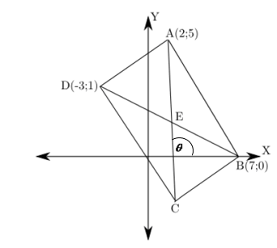
VRAAG 3 VRAAG 4.2

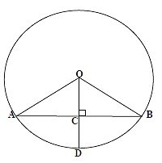
VRAAG 4.1 VRAAG 8.1

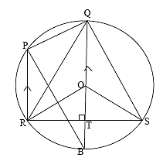
VRAAG 8.2 VRAAG 9.2

VRAAG 9.1

