WISKUNDE/MATHEMATICS V2/P2 JUNIE/JUNE

GRAAD 12/GRADE 12 PUNTE/MARKS: 150
EKSAMEN/EXAMINATION TYD/TIME: 3 uur/hours
EKSAMINATOR: MODERATOR:

INSTRUKSIES EN INLIGTING

Lees die volgende instruksies aandagtig deur voordat u die vrae beantwoord:

1. Beantwoord AL die vrae in hierdie vraestel.
2. Dui AL die berekeninge, diagramme, grafieke, ensovoorts, wat u gebruik het om die antwoord te bepaal, duidelik aan.
3. ’n Goedgekeurde wetenskaplike sakrekenaar (nie-programmeerbare en nie-grafiese) mag gebruik word tensy anders vermeld.
4. Indien noodsaaklik moet antwoorde tot TWEE desimale plekke afgerond word, tensy anders vermeld.
5. Nommer die antwoorde korrek volgens die nommeringsisteem wat in hierdie vraestel gebruik word.
6. Diagramme is NIE noodwendig volgens skaal geteken nie.
7. Dit is tot u eie voordeel om leesbaar te skryf en u werk netjies aan te bied.

INSTRUCTIONS AND INFORMATION

Read the following instructions carefully before answering the questions:

1. Answer ALL the questions in this question paper.
2. Clearly show ALL calculations, diagrams, graphs, et cetera, which you have used in determining the answers.
3. An approved scientific calculator (non-programmable and non-graphical) may be used, unless stated otherwise.
4. If necessary, answers should be rounded off to TWO decimal places, unless stated otherwise.
5. Number the answers correctly according to the numbering system used in this question paper.
6. Diagrams are NOT necessarily drawn to scale.
7. It is in your own interest to write legibly and to present the work neatly.
VRAAG 1/QUESTION 1

Beskou die volgende stel nommers:

Consider the following set of numbers:

21 23 24 25 29 33 49

1.1 | Teken ‘n mond- en snordiagram vir hierdie data op die diagramvel.  Draw a box and whiskers plot for this data on the diagram sheet. | (5)
1.2 | Lewer kommentaar op die verspreiding van die data.  Comment on the distribution of the data. | (1)
1.3 | Toon, met die nodige berekeninge, dat 49 ‘n uitskieter is.  Show, with the necessarily calculations, that 49 is an outlier. | (3)
1.4 | Bepaal die standaardafwyking van die data.  Determine the standard deviation of the data. | (2)
1.5 | As $x$by elke getal bygevoeg word, hoe sal dit die  1.5.1 gemiddelde  1.5.2 standaardafwyking van die data beïnvloed?  If $x$ is added to every number, how will it influence the  1.5.1 mean  1.5.2 standard deviation? | (1)  (1) | [13]
VRAAG 2/QUESTION 2
150 tieners besit selfone wat deur ‘n “pay as you go” pakket aangeskaf is. In die tabel hieronder word aangedui wat die bedrae geld (in rand) is wat deur groepe van hierdie tieners gebruik is om lugtyd te koop in ‘n sekere maand.

150 teenagers have cellphones bought with a “pay as you go” package. The table below indicates the amount of money (in rand) used by the teenagers to buy airtime in a specific month.

Bedrag spandeer op lugtyd (Rand)  Amount spent on airtime (Rand) | Aantal tieners  Number of teenagers
20 tot minder as 40  20 to less than 40 | 48
40 tot minder as 60  40 to less than 60 | 58
60 tot minder as 80  60 to less than 80 | 32
80 tot minder as 100  80 to less than 100 | 9
100 tot minder as 120  100 to less than 120 | 3

2.1 | Bereken die gemiddelde bedrag spandeer op lugtyd deur die tieners.  Calculate the average amount spent on airtime by the teenagers. | (3)
2.2 | Voltooi die kolom vir kumulatiewe frekwensie in die tabel op die aangehegte diagramvel.  Complete the column for cumulative frequency in the table on the attached diagram sheet. | (2)
2.3 | Trek ‘n ogief vir die data op die rooster op die aangehegte diagramvel.  Draw an ogive for the data on the grid on the attached diagram sheet. | (3)
2.4 | Lees vanaf die ogief hoeveel tieners R90 of meer op lugtyd spandeer het. Toon duidelik met ‘n pyl aan op jou ogief waar jy die antwoord afgelees het.  Read from the ogive how many teenagers spent more than R90 on airtime. Show clearly with an arrow on your ogive where you made the reading. | (2) | [10]
VRAAG 3/QUESTION 3
PQRS is ‘n parallelogram met $P\left(0;4\right), S\left(10;-1\right), R\left(a;b\right)en Q(-6;-2)$ soos hieronder aangedui.

PQRS is a parallelogram with $P\left(0;4\right), S\left(10;-1\right), R\left(a;b\right)and Q(-6;-2)$ as indicated below.
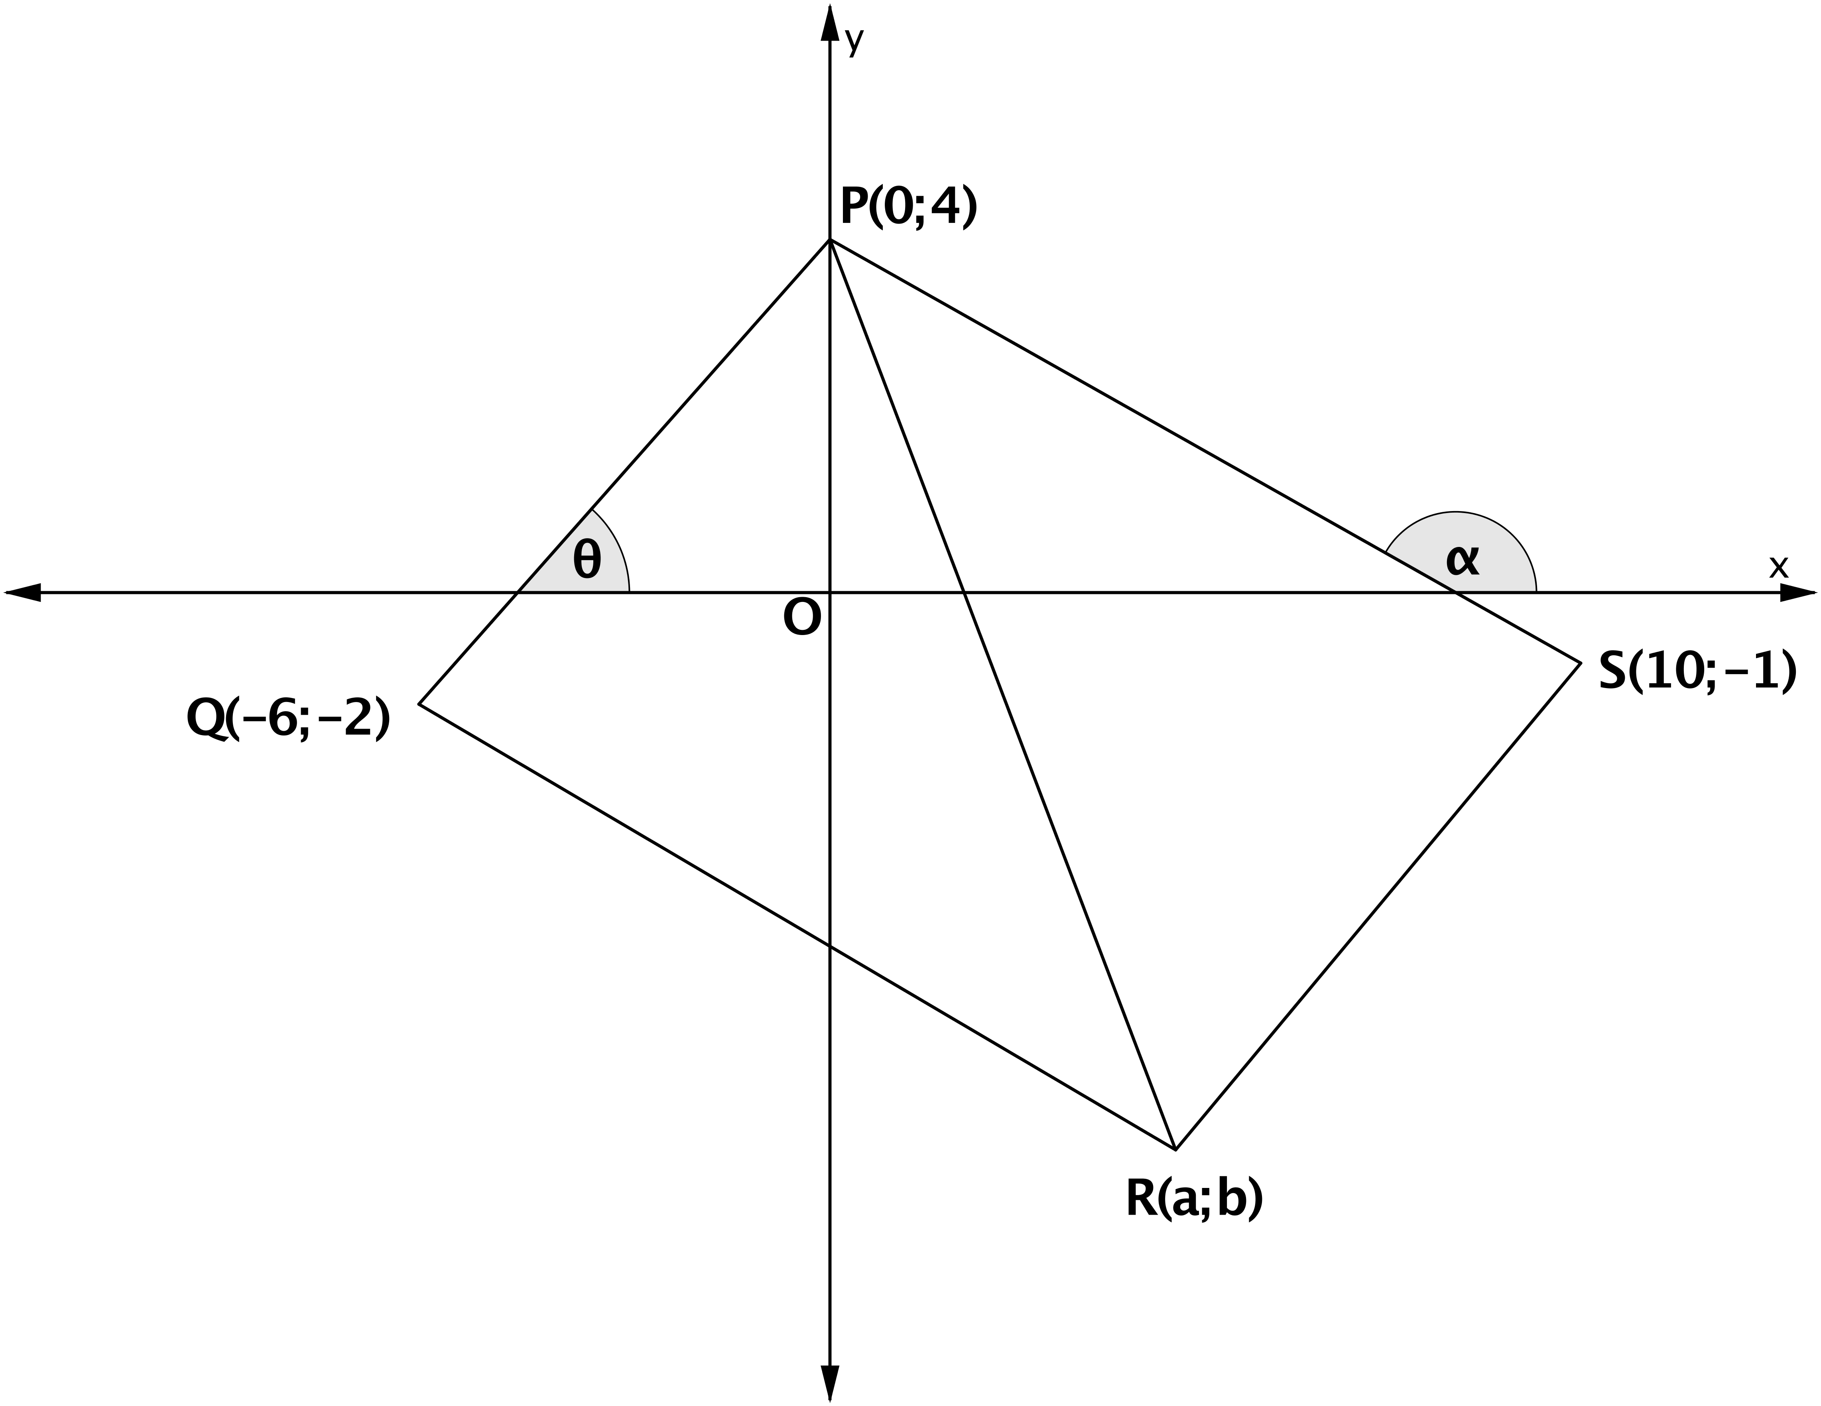

3.1 | Bereken die lengte van PS.  Calculate the length of PS. | (2)
3.2 | Bepaal die gradiënt van PQ.  Determine the gradient of PQ. | (2)
3.3 | Bepaal die vergelyking van SR.  Determine the equation of SR. | (3)
3.4 | Bepaal die waardes van $a$ en $b$.  Determine the values of $a$ and $b$. | (2)
3.5 | Bepaal die grootte van $∠QRS,$ korrek tot EEN desimale syfer.  Determine the size of $∠QRS$, correct to ONE decimal place. | (5)
3.6 | Bepaal die oppervlakte van $∆PQS.$  Determine the area of $∆PQS.$ | (4) | [18]
VRAAG 4/QUESTION 4
In die diagram is $A(-4;5), C\left(-1;-4\right) en B(4;1)$ die hoekpunte van ‘n driehoek in ‘n Cartesiese vlak. $CE⊥AB$ met E op AB. E is die middelpunt van reguit lyn CD. Bepaal:

In the diagram, $A(-4;5), C\left(-1;-4\right) and B(4;1)$ are the vertices of a triangle in a Cartesian plane. $CE⊥AB$ with E on AB. E is the midpoint of straight line CD. Determine:
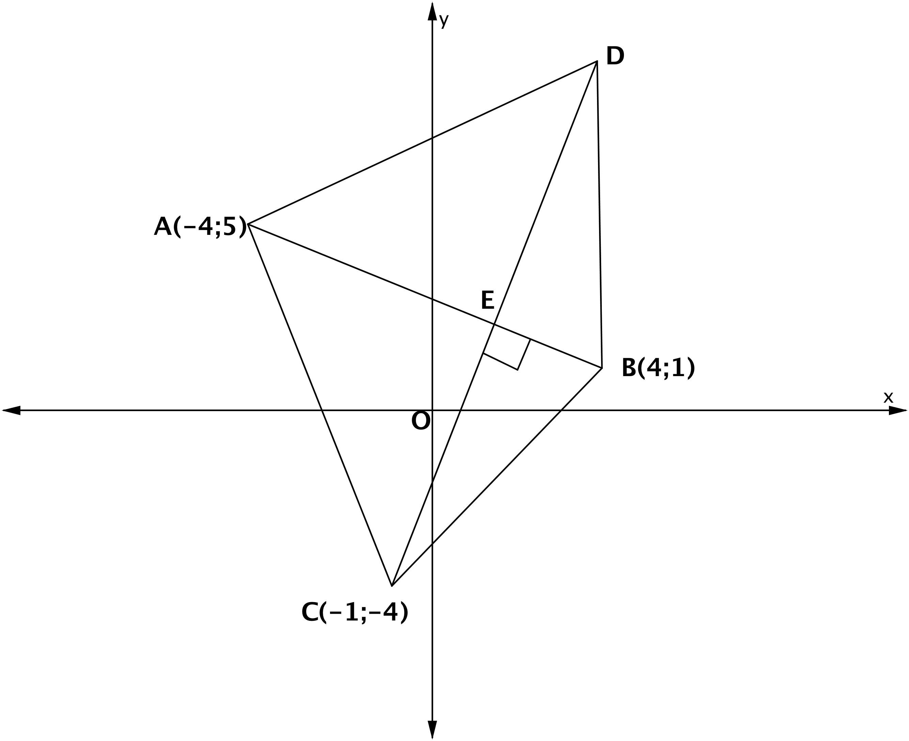

4.1 | Die vergelyking van AB.  The equation of AB. | (2)
4.2 | Die vergelyking van CD.  The equation of CD. | (2)
4.3 | Bewys dat die koördinate van E (2;2) is.  Prove that the coordinates of E are (2;2). | (3)
4.4 | Die koördinate van D.  The coordinates of D. | (2)
4.5 | Bepaal, deur alle bewerkings te toon, of die $x$-afsnit van reguit lyn CD ook op die hoogtelyn vanaf A tot BC lê.  Determine, by showing all calculations, if the x-intercept of straight line CD also lies on the altitude from A to BC. | (6) | [15]
VRAAG 5/QUESTION 5

5.1 | Vereenvoudig sonder ‘n sakrekenaar:  Simplify without a calculator:  $$\frac{\sin\left(450°-x\right).tan\left(x-180°\right).\sin{23°.\cos{23}}}{\cos{44°.sin⁡(-x)}}$$ | (7)
5.2 | As $\cos{36°=m,}$ druk die volgende in terme van $m$ uit, sonder die gebruik van ‘n sakrekenaar.  If $\cos{36°=m,}$ express the following in terms of $m$, without using a calculator.
5.2.1 | $$\sin{36°}$$ | (2)
5.2.2 | $$\sin{18°.\cos{18°-\sin\left(-54°\right).\tan{216°}}}$$ | (6)
5.3.1 | Bewys/Prove:  $$\frac{\cos{x-\sin{x.\sin{2x}}}}{\cos{2x}}=\cos{x}$$ | (3)
5.3.2 | Vir watter waardes van x is die identiteit in 5.3.1 ongedefinieerd? Gee jou antwoord in algemene vorm.  For which values of x is the identity in 5.3.1 undefined? Give your answer in general form. | (2)
5.4 | Bewys $2\sin^{2}\left(θ-45°\right)+sin2θ=1$  Prove $2\sin^{2}\left(θ-45°\right)+sin2θ=1$ | (5)
5.5 | As $\cos{x; }\cos^{2}x; \cos^{3}x$ ‘n meetkundige ry vorm, bepaal vir watter waardes van $x∈[0°;360°$] sal die ry konvergeer?  If $\cos{x; }\cos^{2}x; \cos^{3}x$ forms a geometric sequence, determine for which values of $x∈[0°;360°$] will the sequence converge? | (3)
5.6 | In die diagram is SR ‘n vertikale mas. P, Q en R is 3 punte in dieselfde horisontale vlak. PS en QS is ankerkabels om die mas regop te hou. PQ = m, QS = k en $∠PQS=α.$ Die hoogtehoek van S na P is $β.$ As k = 2m, bewys dat $SR=m\sqrt{5-4cosα}.sinβ.$  In the diagram, SR is a vertical mast. P, Q and R are three points in the same horizontal plane. PS and QS are stay ropes to hold up the mast. PQ = m, QS = k and $∠PQS=α.$ The angle of elevation of S from P is $β.$ If k = 2m, prove that $SR=m\sqrt{5-4cosα}.sinβ.$  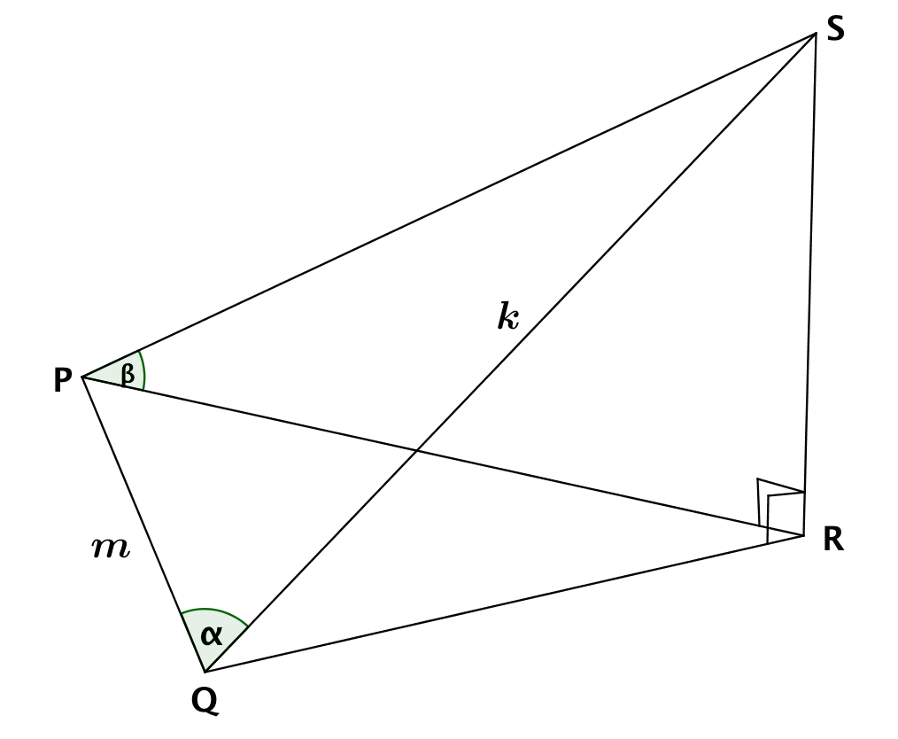 | (6) | [34]
VRAAG 6/QUESTION 6

 | Gegee/Given: $f\left(x\right)=cos 2x en g\left(x\right)=-sin x, vir x∈[-180°;180°]$
6.1 | Bereken die waardes van $x$waarvoor $f\left(x\right)=g(x)$ vir $x∈[-180°;180°]$.  Calculate the values of $x$ for which $f\left(x\right)=g(x)$ vir $x∈[-180°;180°]$. | (8)
6.2 | Skets, op dieselfde assestelsel, op die diagramvel, die grafieke van $f$ en $g$. Toon alle afsnitte met die asse, sowel as die draaipunte vir $x∈[-180°;180°]$.  On the same set of axes, on the diagram sheet, sketch the graphs of $f$ and $g$. Show all intercepts with the axes as well as the turning points for $x∈[-180°;180°]$. | (6)
6.3 | Skryf die periode van $f$ neer.  Write down the period of $f.$ | (1)
6.4.1 | Bepaal die waardes van $x$ waarvoor $f\left(x\right)-g\left(x\right)≤0 vir x∈[-180°;180°]$.  Determine the values of $x$ for which $f\left(x\right)-g\left(x\right)≤0 for x∈[-180°;180°]$. | (3)
6.4.2 | Bepaal vervolgens die minimum waarde van $cos 2x+sin x$ in die interval $[-180°;180°]$.  Hence, determine the minimum value of $cos 2x+sin x$ in the interval $[-180°;180°]$. | (2)
6.5 | Gebruik jou grafiek(e) en bepaal die waardes van $x$ waarvoor $\cos^{2}x<\sin^{2}x$ in die interval $[0°;180°]$.  Use your graph(s) to determine the values of x for which $\cos^{2}x<\sin^{2}x$ in the interval $[0°;180°]$. | (2)
6.6 | $g(x)$ word in die $x$-as gereflekteer en dan 1 eenheid af geskuif na om $h\left(x\right)) te vorm.$ Skryf die vergelyking van $h(x)$ neer.  $g(x)$ is reflected in the $x$-axis en then shifted 1 unit down to form $h(x)$. Write down the equation of $h(x).$ | (2) | [24]
VRAAG 7/QUESTION 7

7.1 | In die figuur hieronder is O die middelpunt van die sirkel en EG is ‘n raaklyn aan die sirkel by E. Bewys die STELLING wat bepaal dat die hoek tussen ‘n koord en ‘n raaklyn gelyk is aan die hoek in die teenoorstaande segment ($∠FEG=∠D)$.  In the figure below O is the centre of the circle and EG is a tangent to the circle at E. Prove the THEOREM that states that the angle between a chord and a tangent is equal to the angle in the opposite segment ($∠FEG=∠D)$.  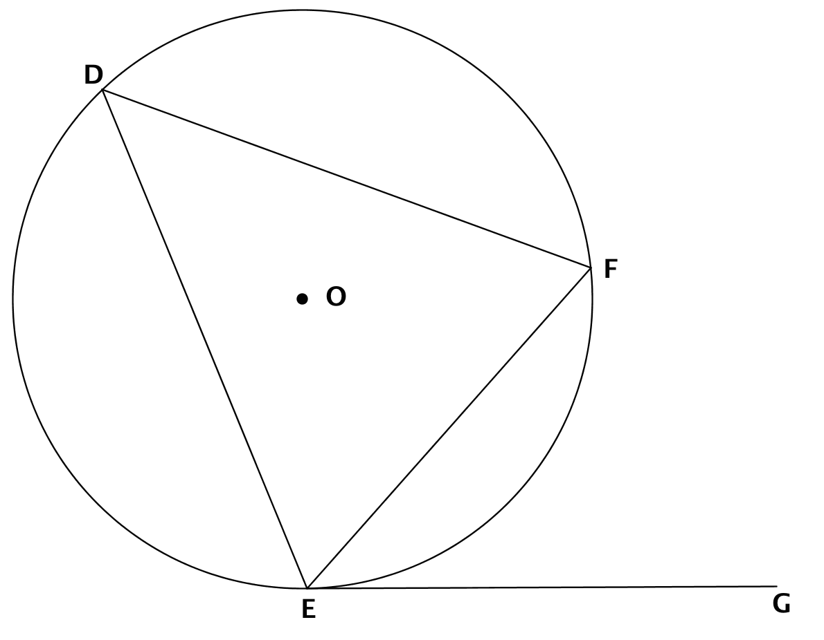 | (7)
7.2 | In die figuur ontmoet raaklyn FCE die verlengde van die middellyn van die sirkel, middelpunt O, by E. $∠ABO=38° en ∠CBD=25°.$  In the figure, tangent FCE meets the extended diameter of the circle, midpoint O, at E. $∠ABO=38° and ∠CBD=25°.$  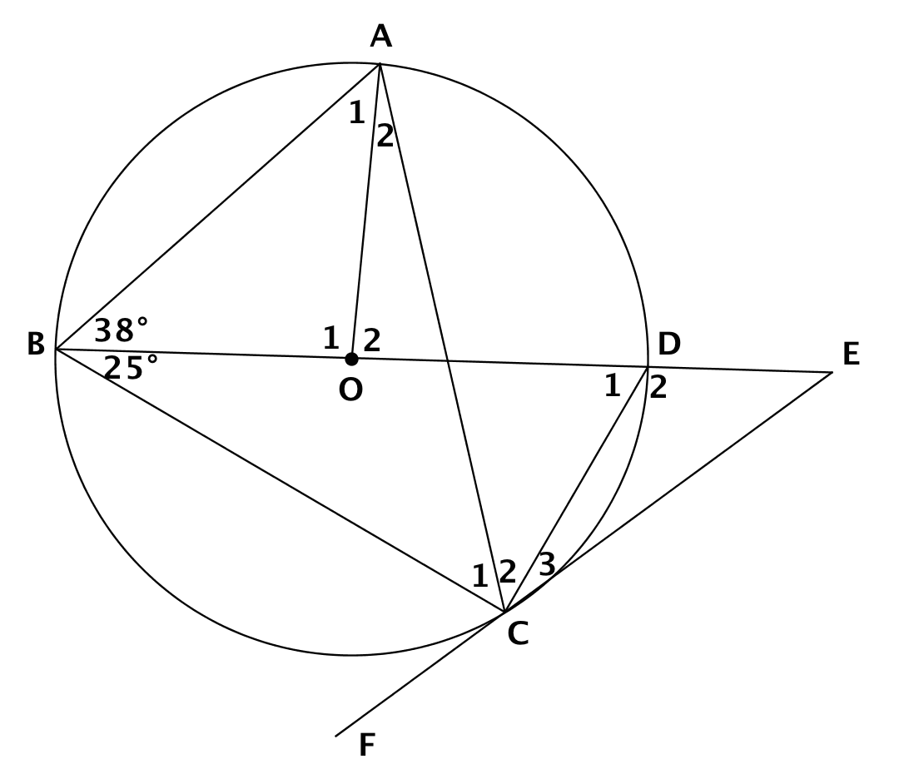
7.2.1 | Bereken die grootte van elk van die volgende:  Calculate the size of each of the following:
7.2.1.1 | $$∠A_{1}$$
7.2.1.2 | $$∠O_{2}$$
7.2.1.3 | $$∠C_{2}$$
7.2.1.4 | $$∠C_{1}$$
7.2.1.5 | $$∠C_{2+3}$$ | (5)
7.2.2 | As C ‘n punt is wat langs die boog BCD beweeg (die grootte van $∠ABD$bly $38°$, maar die grootte van $∠DBC$ verander), wat moet die grootte van $∠DBC$ dan wees vir AC om ‘n middellyn te wees?  If C is a point which moves along the arc BCD (the size of $∠ABD$ remains $38°,$ but the size of $∠DBC$ changes), what must be the size of $∠DBC$ for AC to be a diameter? | (2) | [14]
VRAAG 8/QUESTION 8

8.1 | In die figuur hieronder is RQ en RB raaklyne by die punte Q en B aan die sirkel O onderskeidelik. Die radius BO verleng ontmoet die sirkel by A en RQ verleng by P. Laat $∠Q_{1}=x.$  In the figure below, RQ and RB are tangents at the points Q and B respectively to the circle with centre O. The radius BO produced meets the circle at A and RQ produced at P. Let $∠Q_{1}=x.$  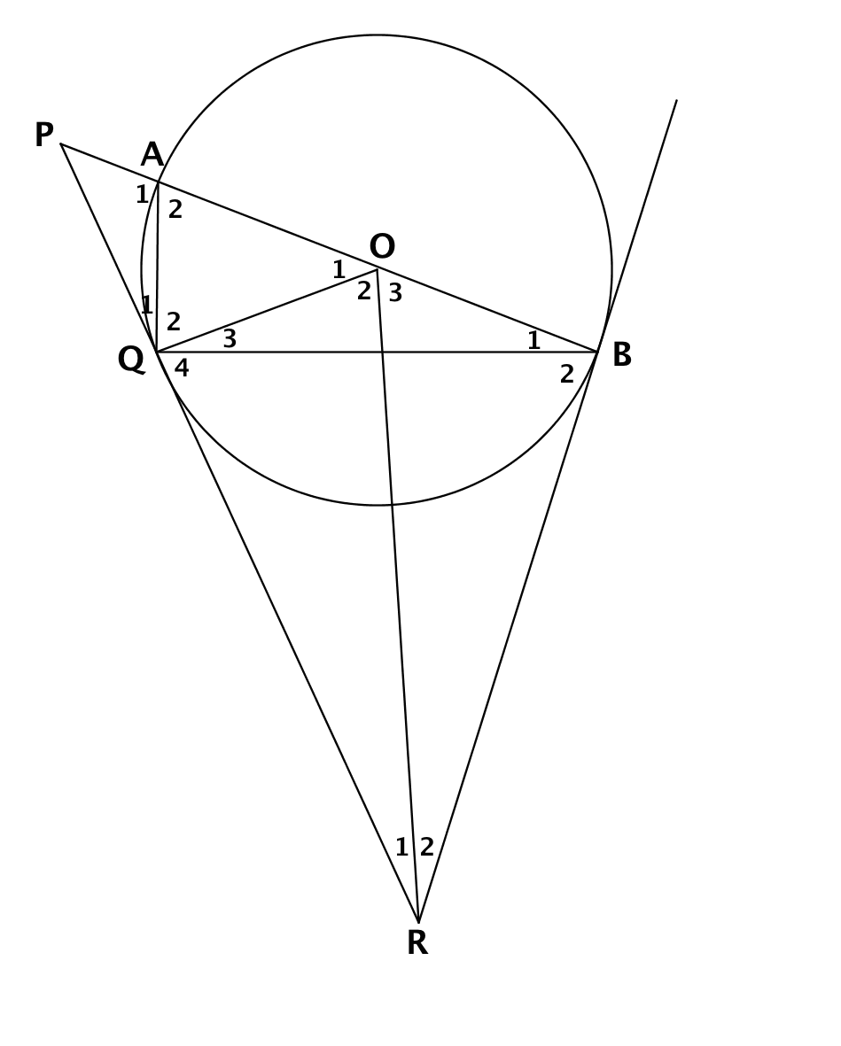
8.1.1 | Bewys dat RBOQ ‘n koordevierhoek is.  Prove that RBOQ is a cyclic quadrilateral. | (3)
8.1.2 | Noem, met redes, VIER ander hoeke in die figuur wat gelyk is aan $x$.  Name, with reasons, FOUR other angles in the figure which are equal to $x$. | (4)
8.1.3 | Druk $∠P$ uit in terme van $x$.  Express $∠P$ in terms of $x$. | (3)
8.2 | TD is ‘n raaklyn aan die sirkel ABCD. AD || BC. Die verlengdes van AB en DC ontmoet by W. TBS is ‘n reguitlyn. As $∠WBT=∠CBD,$ bewys:  TD is a tangent to circle ABCD. AD || BC. AB and DC produced meet at W. TBS is a straight line. If $∠WBT=∠CBD$, prove:  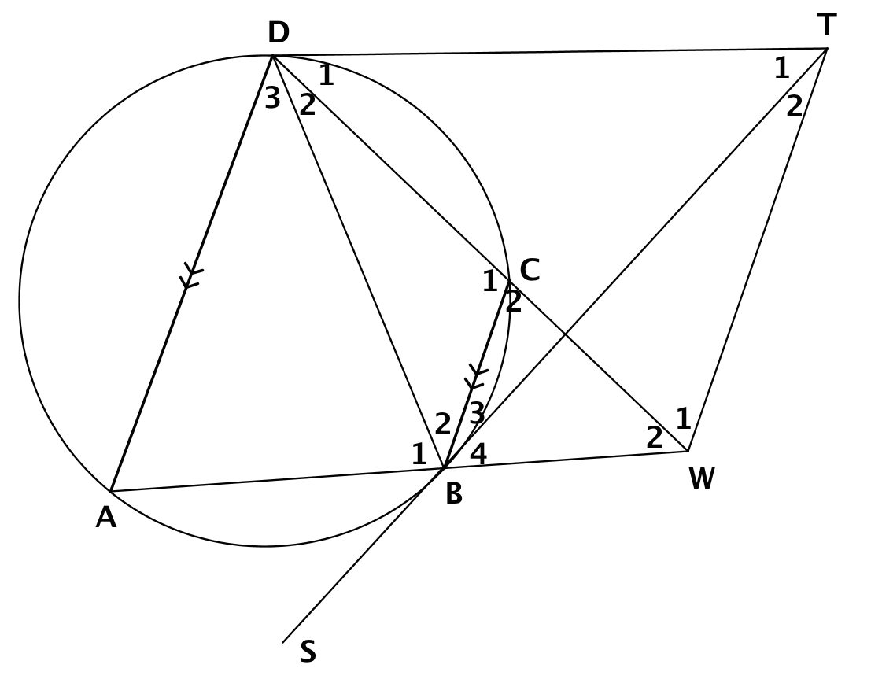
8.2.1 | BWTD is ‘n koordevierhoek.  BWTD is a cyclic quadrilateral. | (3)
8.2.2 | TBS is ‘n raaklyn aan die sirkel ABCD.  TBS is a tangent to circle ABCD. | (5)
8.2.3 | TW || BC | (2) | [20]
TOTAAL : 150

