WISKUNDE/MATHEMATICS V1/P1 JUNIE/JUNE

GRAAD 12/GRADE 12 PUNTE/MARKS: 150
EKSAMEN/EXAMINATION TYD/TIME: 3 uur/hours
EKSAMINATOR: MODERATOR:

INSTRUKSIES EN INLIGTING

Lees die volgende instruksies aandagtig deur voordat u die vrae beantwoord:

1. Beantwoord AL die vrae in hierdie vraestel.
2. Dui AL die berekeninge, diagramme, grafieke, ensovoorts, wat u gebruik het om die antwoord te bepaal, duidelik aan.
3. ’n Goedgekeurde wetenskaplike sakrekenaar (nie-programmeerbare en nie-grafiese) mag gebruik word tensy anders vermeld.
4. Indien noodsaaklik moet antwoorde tot TWEE desimale plekke afgerond word, tensy anders vermeld.
5. Nommer die antwoorde korrek volgens die nommeringsisteem wat in hierdie vraestel gebruik word.
6. Diagramme is NIE noodwendig volgens skaal geteken nie.
7. Dit is tot u eie voordeel om leesbaar te skryf en u werk netjies aan te bied.

INSTRUCTIONS AND INFORMATION

Read the following instructions carefully before answering the questions:

1. Answer ALL the questions in this question paper.
2. Clearly show ALL calculations, diagrams, graphs, et cetera, which you have used in determining the answers.
3. An approved scientific calculator (non-programmable and non-graphical) may be used, unless stated otherwise.
4. If necessary, answers should be rounded off to TWO decimal places, unless stated otherwise.
5. Number the answers correctly according to the numbering system used in this question paper.
6. Diagrams are NOT necessarily drawn to scale.
7. It is in your own interest to write legibly and to present the work neatly.

VRAAG 1/QUESTION 1

1.1.1 | Bereken die waardes van $x:$ $x^{2}-5x-24=0$  Calculate the values of $x$: $x^{2}-5x-24=0$ | (2)
1.1.2 | Gevolglik, bepaal die positiewe waardes van $x$ waarvoor $x^{2}-5x≥24.$  Hence, determine the positive values of $x$ for which $x^{2}-5x≥24.$ | (2)
1.2 | Los op vir $x$/Solve for $x$:
1.2.1 | $2x^{2}-3x-7=0$(korrek tot TWEE desimale plekke/correct to TWO decimal places) | (3)
1.2.2 | $$2^{0}+2^{x-2}+2^{x+1}+2^{x}=53$$ | (4)
1.3 | Gegee/Given:  $k=\sqrt{(x+1)^{2}-4}$ , waar $k$ ‘n reële getal is/where $k$ is a real number.
1.3.1 | Los op vir $x$ as $k = 4$ (los antwoord in eenvoudigste wortelvorm).  Solve for $x$ if $k = 4$ (leave the answer in the simplest surd form). | (4)
1.3.2 | Skryf die minimum waarde van $k$ neer.  Write down the minimum of $k$. | (1)
1.4 | Los vir $x$ en $y$ gelyktydig op/Solve for $x$ and $y$ simultaneously:  $3+x=2y$ en/and $x^{2}+4y^{2}=2xy+7$ | (6) | [22]

VRAAG 2/QUESTION 2

2.1 | Bepaal/Determine:  $$\sum_{r=4}^{12}{3(\frac{1}{2})^{r}}$$ | (4)
2.2 | Elke keer as ‘n fotokopie van ‘n oorspronklike dokument gemaak word, neem die kwaliteit met 11% af. Bepaal hoeveel keer kan voortgegaan word met die kopiëring voor die kwaliteit minder as 20% van die oorspronklike is.  Each time a photocopy is made from an original document, the quality of the print decreases by 11%. Determine how many times this photocopying can be done before the quality becomes less than 20% of the original. | (4)
2.3 | Vir watter waardes van k sal die reeks $4\left(\frac{1-k}{5}\right)+8{\left(\frac{1-k}{5}\right)}^{2}+16{\left(\frac{1-k}{5}\right)}^{3}+…$ konvergeer?  For which values of k will the series $4\left(\frac{1-k}{5}\right)+8{\left(\frac{1-k}{5}\right)}^{2}+16{\left(\frac{1-k}{5}\right)}^{3}+…$ converge? | (3)
2.4 | Die som van die eerste $n$ terme van ‘n ry is $S_{n}=3^{n-5}+2.$ Bepaal die 80ste term. Los jou antwoord in die vorm $a.b^{p}$ waar $a, b$ en $p$ almal heelgetalle is.  The sum of the first $n$ terms of a sequence is $S_{n}=3^{n-5}+2.$ Determine the 80th term. Leave your answer in the form $a.b^{p}$ where $a, b$ and $p$ are all integers. | (3) | [14]
VRAAG 3/QUESTION 3

3.1 | Gegee die rekenkundige ry: -3 ; 1 ; 5 ; … ; 393  Given the arithmetic series: -3 ; 1 ; 5 ; … ; 393
3.1.1 | Bepaal ‘n formule vir die $n$^{de} term van die ry.  Determine a formula for the $n$^{th} term of the series. | (2)
3.1.2 | Skryf die 4de, 5de, 6de en 7de term van die ry neer.  Write down the 4th, 5th, 6th and 7th term of the series. | (1)
3.1.3 | Skryf die reswaardes neer wanneer elk van die eerste sewe terme van die ry deur 3 gedeel word.  Write down the remainders when each of the first seven terms of the sequence is divided by 3. | (1)
3.1.4 | Bereken die som van die terme in die rekenkundige ry wat deur 3 deelbaar is.  Calculate the sum of the terms in the arithmetic sequence that are divisible by 3. | (5)
3.2 | Beskou die volgende patroon van punte:  Consider the following pattern of dots:  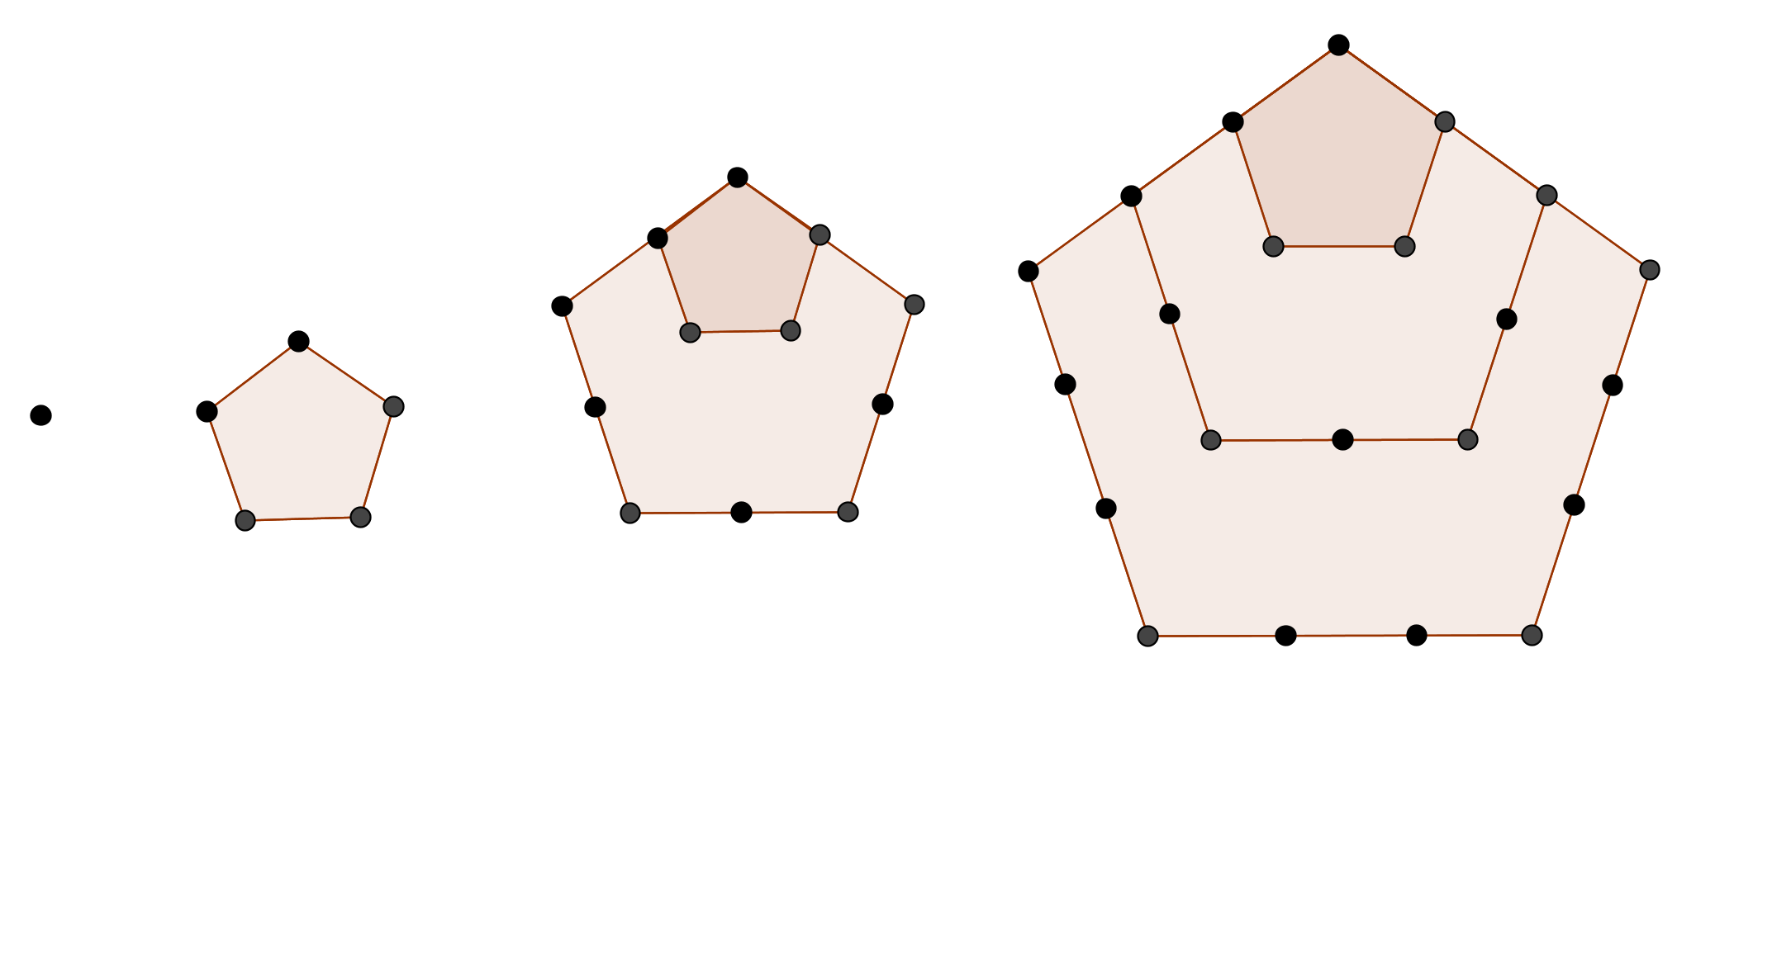  As T_{n} die totale aantal punte in FIGUUR $n$ voorstel, dan is T₁ = 1 en T₂ = 5. Indien die patroon op dieselfde wyse voortgaan, bepaal:  If T_{n} represents the total number of dots in FIGURE $n$, then T₁ = 1 and T₂ = 5. If the pattern continues in the same manner, determine:
3.2.1 | T₅ | (1)
3.2.2 | T₅₅ | (5) | [15]

VRAAG 4/QUESTION 4

4.1 | Die grafieke van $f\left(x\right)=ax^{2}+bx+c$ en $g\left(x\right)=-k^{x}+q$ is hieronder geskets.  The graphs of $\left(x\right)=ax^{2}+bx+c$ and $g\left(x\right)=-k^{x}+q$ are drawn below.  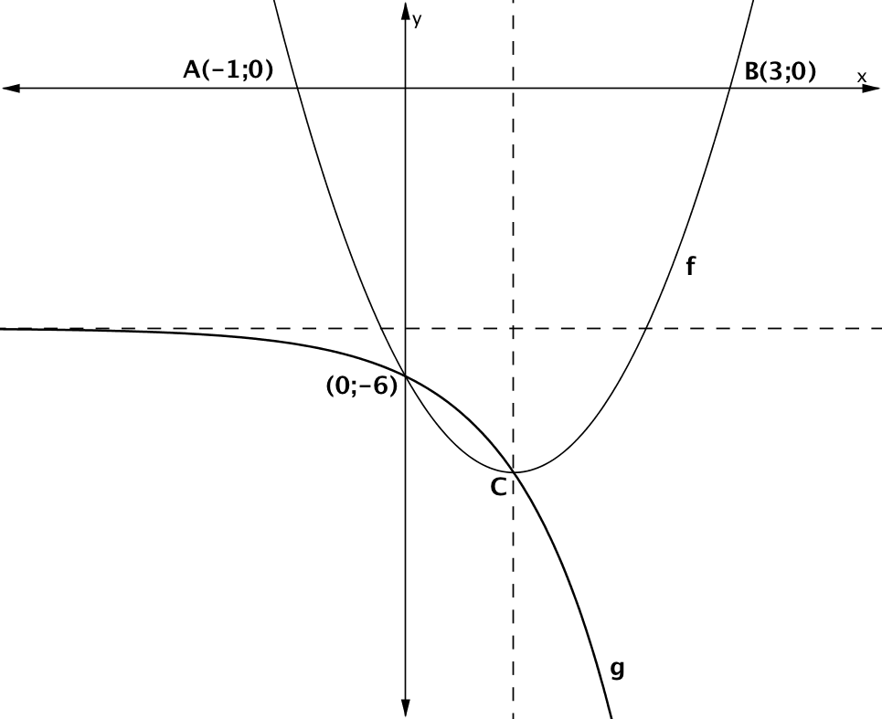
4.1.1 | Toon aan dat $a=2, b=-4 en c=-6$  Show that $a=2, b=-4 en c=-6$ | (4)
4.1.2 | Bepaal die koördinate van C, die draaipunt van die parabool.  Determine the coordinates of C, the turning point of the formula. | (2)
4.1.3 | Bepaal die vergelyking van $g$.  Determine the equation of $g$. | (4)
4.1.4 | Vir watter waarde(s) van $x$ is:  For which value(s) of $x$ is:
(a) | $$f\left(x\right)-g\left(x\right)=0$$ | (2)
(b) | $$f\left(x\right).g(x)≥0$$ | (2)
4.1.5 | Bepaal D, die koördinate van die draaipunt van $h(x)$ as $h\left(x\right)=-f\left(x\right)+4$  Determine D, the coordinates of the turning point of $h(x)$ if $h\left(x\right)=-f\left(x\right)+4$ | (2)
4.2 | Teken ‘n sketsgrafiek van $t\left(x\right)=ax^{2}+bx+c$ as die volgende gegewens bekend is:  Draw the graph of $t\left(x\right)=ax^{2}+bx+c$ if the following information is given:
- $\frac{b}{2a}=-6$

- die waardeversameling van die funksie is $y∈[-$8; $∞)$

the range of the function is $y∈[-$8; $∞)$

- die wortels van $t\left(x\right)=0$ verskil met 12

the roots of $t\left(x\right)=0$ differs with 12

 | Toon die volgende duidelik aan : die draaipunt, die simmetrie-as en die afsnitte.  Indicate the following clearly : the turning point, the axis of symmetry and the intercepts. | (4) | [20]

VRAAG 5/QUESTION 5

 | Gegee/Given: $h\left(x\right)=\log_{3}x$
5.1 | Skets die grafieke van $h(x)$ en $h^{-1}\left(x\right)$ dui alle afsnitte duidelik aan.  Draw a sketch of$h(x)$ and $h^{-1}\left(x\right)$ and show all the intercepts clearly. | (4)
5.2 | Gee die vergelyking van $h^{-1}$ in die vorm $h^{-1}\left(x\right)=$  Give the equation of $h^{-1}$ in the form $h^{-1}\left(x\right)=$ | (2)
5.3 | Skryf die definisieversameling van $h$ neer.  Give the domain of $h$. | (1)
5.4 | Vir watter waarde(s) van $x$ is $h\left(x\right)≤2?$  For which value(s) of $x$ is $h\left(x\right)≤2?$ | (2)
5.5 | Bepaal die vergelyking van $p$ as $p\left(x\right)=h^{-1}(x+2)$  Determine the equation of $p$ if $p\left(x\right)=h^{-1}(x+2)$ | (2) | [11]
VRAAG 6/QUESTION 6

‘n Skets van die hiperbool $f\left(x\right)=\frac{a}{x+p}+q$ is hieronder gegee. Die stippellyne is die asimptote. Die asimptote sny mekaar by P(-1;1) en B(2;0) is ‘n punt op $f$.

A sketch of the hyperbola $f\left(x\right)=\frac{a}{x+p}+q$ is given below. The dotted lines are the asymptotes. The asymptotes intersect at P(-1;1) and B(2;0) is a point on $f$.

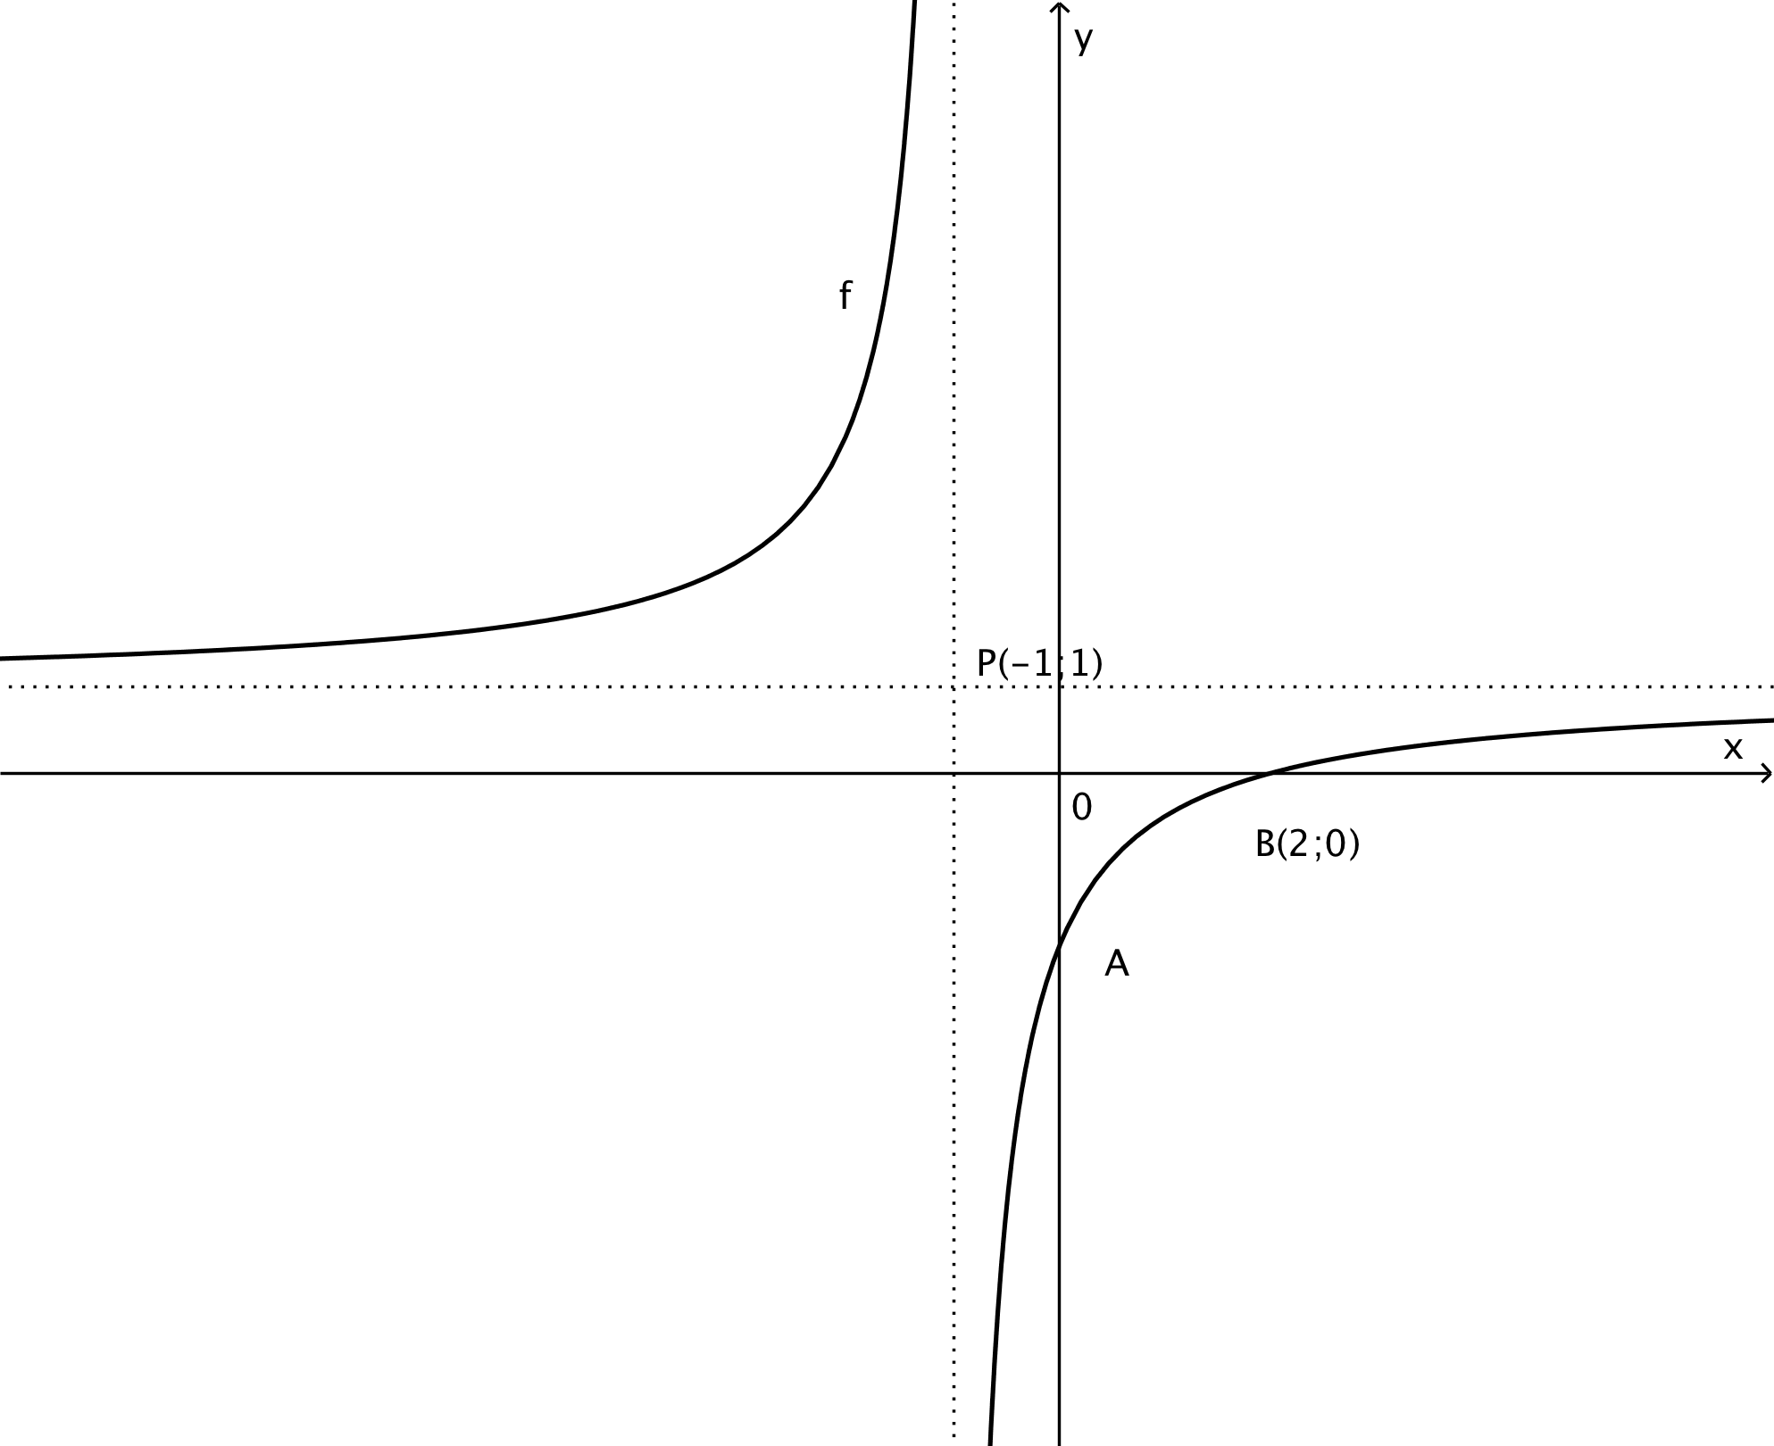

6.1 | Bepaal die vergelyking van $f.$  Determine the equation of f. | (4)
6.2 | Bepaal die koördinate van A.  Determine the coordinates of A. | (2)
6.3 | Bepaal die vergelyking van die simmetrie-as van $f$ met ‘n positiewe gradiënt.  Determine the equation of the axis of symmetry of with a positive gradient. | (2)
6.4 | Skryf die koördinate van die beeld van B(2;0) neer as B om die simmetrie-as in 6.3 gereflekteer word.  Write down the coordinates of the image of B(2;0) if B is reflected about the axis of symmetry in 6.3. | (2) | [10]
VRAAG 7/QUESTION 7

7.1 | Jade belê ‘n enkelbedrag van R5 000 vir presies 2 jaar in ‘n spaarrekening. Die belegging verdien rente teen 10% p.j., kwartaalliks saamgestel.  Jade invests a lump sum of R5 000 in a savings account for exactly 2 years. The investment earns interest at 10% p.a., compounded quarterly.
7.1.1 | Wat is die kwartaallikse renetkoers vir Jade se belegging?  What is the quarterly interest rate for Jade’s investment? | (1)
7.1.2 | Wat is die effektiewe rentekoers wat Jade verdien?  What is the effective interest rate that Jade will receive? | (3)
7.2 | Willem erf R900 000. Hy belê sy volle erfporsie in ‘n fonds wat rente verdien teen ‘n koers van 13% p.j., maandeliks saamgestel. Hy onttrek R12 000 uit die fonds aan die einde van elke maand. Sy eerste onttrekking is presies een maand na sy aanvanklike belegging.  Willem inherits R900 000. He invests all of his inheritance in a fund which earns interest at a rate of 13 % p.a, compounded monthly. At the end of each month he withdraws R12 000 from the fund. His first withdrawal is exactly one month after his initial investment.
7.2.1 | Hoeveel onttrekkings van R12 000 sal Willem uit hierdie fonds kan maak?  How many withdrawals of R12 000 will Willem be able to make from this fund? | (5)
7.2.2 | Presies vier jaar na sy aanvanklike belegging besluit Willem om al die geld wat in sy rekening oorbly, te onttrek en dit as ‘n deposito vir ‘n huis te gebruik.  Exactly four years after his initial investment Willem decides to withdraw all the remaining money in his account and to use it as a deposit towards a house.  - Wat is die waarde van Willem se deposito, tot die naaste rand?  What is the value of Willem’s deposit, to the nearest rand?  - Willem se deposito is presies 35% van die koopprys van die huis. Wat is  die koopprys van die huis, tot die naaste rand?  Willem’s deposit is exactly 35% of the purchase price of the house. What is  the purchase price of the house, to the nearest rand? | (4)  (1) | [14]
VRAAG 8/QUESTION 8

8.1 | Gegee/Given: $f\left(x\right)=3x^{2}-4$
8.1.1 | Bepaal $f^{'}(x)$ vanuit eerste beginsels.  Determine $f^{'}(x)$ from first principles. | (5)
8.1.2 | $A\left(x;23\right),$waar $x>0,$ en $B(-2;y)$ is punte op die grafiek van $f$. Bereken die numeriese waarde van die gemiddelde gradiënt van $f$ tussen A en B.  $A\left(x;23\right),$where $x>0,$ and $B(-2;y)$ are points on the graph $f$. Calculate the numeric value of the average gradient of $f$ between A and B. | (4)
8.2 | Differensieer $y=\frac{x+5}{\sqrt{x}}$ met betrekking tot $x$.  Differentiate $y=\frac{x+5}{\sqrt{x}}$ in $x$. | (3)
8.3 | Bepaal die $y$-afsnit van die raaklyn van die grafiek van $f\left(x\right)=-3x^{3}-4x+5$ by $x=-1.$  Determine the $y$-intercept of the tangent of the graph of $f\left(x\right)=-3x^{3}-4x+5$ at $x=-1.$ | (4)
8.4 | Die temperatuur T in $°C$ in die middelpunt van ‘n smeltkroes vermeerder volgens $T=t^{2}\left(45-t\right)×{10}^{-1}+25$ met tyd $t$ in minute.  The temperature T in $°C$, at the centre of a smelting pot in a blast furnace increases according to $T=t^{2}\left(45-t\right)×{10}^{-1}+25$ with time $t$ in minutes.
8.4.1 | Bepaal die temperatuur aan die begin van die eksperiment.  Determine the temperature at the beginning of the experiment. | (1)
8.4.2 | Bepaal die tempo waarteen die temperatuur verander in tyd, $t$.  Determine the rate at which the temperature is changing at time, $t$. | (2)
8.4.3 | Bepaal die tyd waartydens die tempo van verandering ‘n maksimum is.  Determine the time at which the rate of increase of temperature is maximum. | (2) | [21]
VRAAG 9/QUESTION 9

Die skets verteenwoordig die grafiek $f\left(x\right)=ax^{3}+cx.$ P(-1;-2) en R is draaipunte van $f$.

The sketch represents the graph of $f\left(x\right)=ax^{3}+cx.$ P(-1;-2) and R are turning points of $f.$

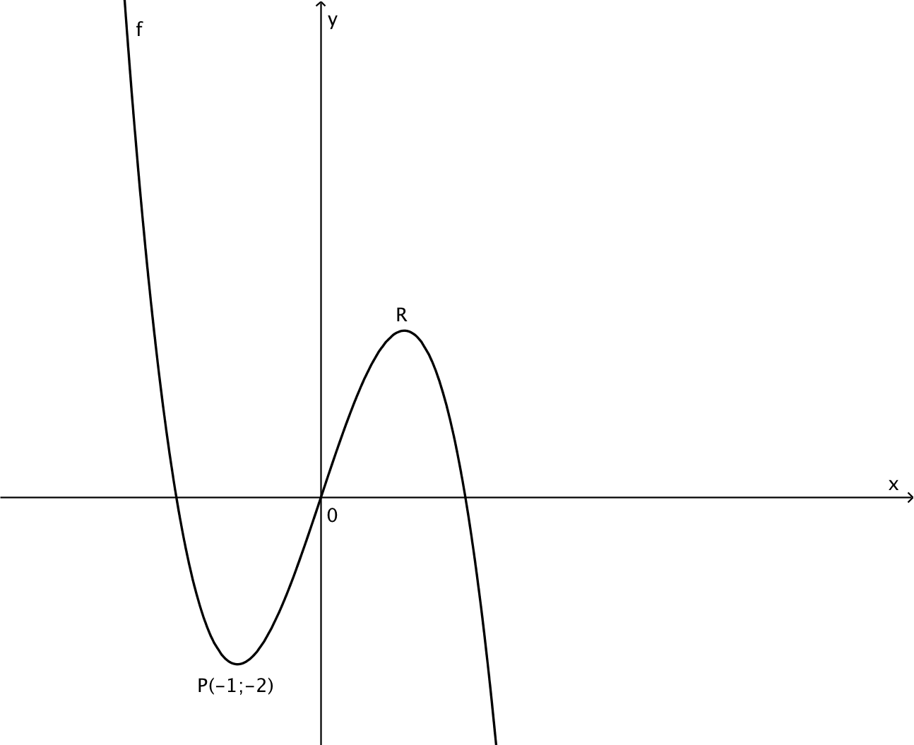

9.1 | Bewys dat $a=-1$ en $c=3$ as f ‘n minimumwaarde het by (-1;-2).  Prove that $a=-1$ and $c=3$ if $f$ has a minimum value at (-1;-2). | (5)
9.2 | Bepaal die koördinate van R waar die funksie ‘n lokale maksimumwaarde het.  Determine the coordinates of the point R where the function has a local maximum. | (3)
9.3 | Vir watter waardes van $x$ sal $f^{'}\left(x\right)≤0?$  For which values of $x$ will $f^{'}\left(x\right)≤0?$ | (2)
9.4 | Bepaal alle moontlike y-afsnitte waarvoor $f$ slegs een positiewe wortel sal hê.  Determine all possible y-intercepts for which $f$ will have only one positive root. | (2) | [12]
VRAAG 10/QUESTION 10

10.1 | Die waarskynlikheid dat ‘n tennisspeler geen beserings het nie, is 0,75. Die waarskynlikheid dat hy ‘n wedstryd sal wen as hy geen beserings het nie, is 0,95. Wanneer die speler beserings het, word die waarskynlikheid om ‘n wedstryd te wen 0,4.  The probability that a tennis player has no injuries is 0,75. The probability that he will win the match if he has no injuries is 0,95. When the tennis player has injuries the probability of him winning the match becomes 0,4.
10.1.1 | Teken ‘n boomdiagram om die gegewe situasie te illustreer.  Draw a tree diagram to illustrate the given situation. | (4)
10.1.2 | Bereken die waarskynlikheid dat die speler sy volgende wedstryd sal wen.  Calculate the probability of the tennis player winning his next match. | (3)
10.2 | Gebeurtenisse A en B is onafhanklik en gebeurtenisse B en C is onderling uitsluitend.  Events A and B are independent events and events B and C are mutually exclusive.
10.2.1 | Indien $P\left(A en B\right)=a^{2}-b^{2}$ en $P\left(B\right)=a+b,$ bepaal $P(A)$ in terme van $a$ en $b$.  If $P\left(A and B\right)=a^{2}-b^{2}$ and $P\left(B\right)=a+b,$ determine $P(A)$ in terms of $a$ and $b.$ | (2)
10.2.2 | Bepaal $P(B of C)$ in terme van $a$ en $b$ as $P\left(C\right)=3P(B)$ en $P\left(B\right)=a+b$  Determine $P(B of C)$ in terms of $a$ and $b$ if $P\left(C\right)=3P(B)$ and $P\left(B\right)=a+b$ | (2) | [11]

