GRADE 8 MATHEMATICS

TERM 2

FORMAL ASSESSMENT TASK 2.1

INVESTIGATION: Construction and Properties of Triangles

MEMORANDUM

SECTION A: INVESTIGATION [50]
QUESTION 1
 |  | Answer | Mark descriptor
1.1 |  | 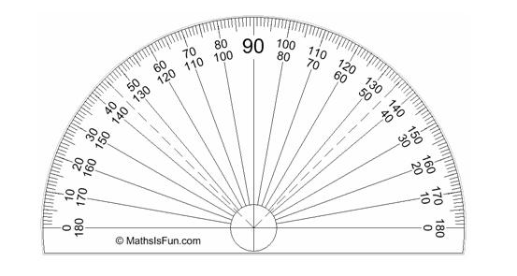30$°$  A | 1A angle of 30$°$  (1)
1.2 |  | 90$°$  A | 1A angle of 90$°$  (1)

 |  | Answer | Mark descriptor
1.3 |  | 60$°$  A | 1A angle of 60$°$  (1)
1.4 |  | 75$°$  A | 1A angle of 75$°$  (1)
1.5 |  | 135$°$  A | 1A angle of 135$°$  (1)
[5]

QUESTION 2
 |  | Answer |  | Mark descriptor
 |  | Construction | Description of Construction
2.1 |  | 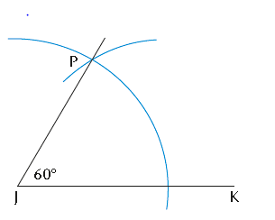  30$°$  A | A  - Draw a 60$°$angle  (isosceles triangle)  - Bisect this angle  A | 1A Construction of angle of 30$°$  (1)  Explanation:  1A isosceles triangle / angle of 60º.  1A Bisect angle of 60º. (2)
2.2 |  | 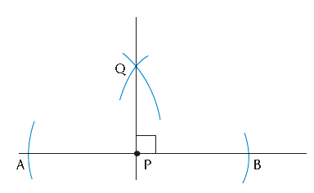  90$°$  A | Construct a perpendicular bisector  A | 1A Construction of angle of 90$°$  (1)  2A Explanation of construction of perpendicular bisector (2)
2.3 |  | 60$°$  A | A  - Draw / Construct an isosceles triangle | 1A Construction angle of 60$°$  (1)  2A Explanation of construction of 60$°$  (2)

 |  | Answer |  | Mark descriptor
 |  | Construction | Description of Construction
2.4 |  | 75$°$ = 90$°$ - 15$°$  75$°$  A  A | - Construct a right angle.  A  - On same line , construct a 60⁰ angle.  - Bisect the 30⁰ angle.  A | 1A Construction angle of 75$°$  (1)  2A Explanation of Construction of 60$°$  (2)
2.5 |  | 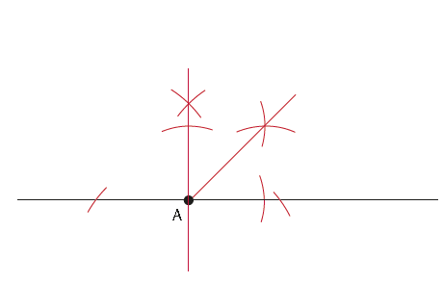  135$°$ = 90$°$ + 45$°$  A  135$°$ | - Construct a right angle.  A  - On the same line bisect one of the right angles for a 45º angle.  A | 1A Construction of angle of 135$°$  (1)  2A Explanation of construction of angle of 135$°$  (2)
[15]

QUESTION 3
 |  | Answer | Mark descriptor
3.1 |  | 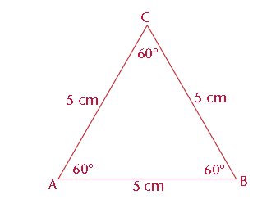  A  A | 1A : 60$°$ angle  1A: 5cm side  (2)
3.2 |  | CA  CA  CA | 1CA: angle  1CA: angle  1CA: angle  (3)
  Angle | Degrees
  A | 60$°$
  B | 60$°$
  C | 60$°$
3.3 |  |  | 1CA: angle  1CA: angle  1CA: angle  1CA: side  1CA: side  1CA: side  (6)
  Angle | Degrees  CA
  D | 60$°$  CA
  E | 60$°$  CA
  F | 60$°$
  Sy | Lengte in mm
  DE | 50mm  CA  CA
  EF | 50mm  CA
  FD | 50mm
 |  | A
3.4 | 3.4.1 | equal in length (equidistant)  A | 1 A  1 A  1 A  (3)
 | 3.4.2 | equal (in size)  A | 1 A  1 A  1 A  (3)
 | 3.4.3 | equilateral triangle | 1 A  1 A  1 A  (3)
 |  |  | [14]

QUESTION 4
 |  | Answer | Mark descriptor
4.1 | 4.1.1 | 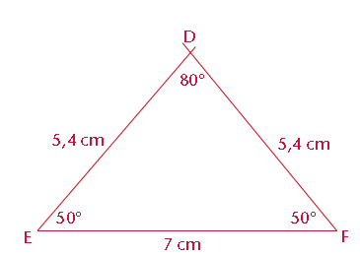  A  A  A | 1A: EF = 7cm 1A: $∠E=50°$ 1A: $∠F=50°$  (3)
 | 4.1.2 | 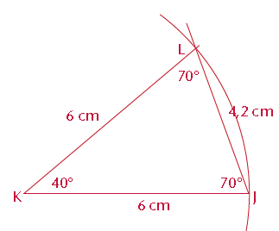  A  A  A | 1A: JK = 6cm  1A: KL = 6cm  1A: $∠J=70°$.  (3)
4.2 |  | CA  CA  CA  CA  CA  CA  A | 1CA: per angle and side  (6)
  Angle | Degrees
  K | 40º
  L | 70º
  Sy | Length in mm
  LJ | 4,2cm
  Angle | Degrees
  D | 80º
  Sy | Length in mm
  DE | 5,4cm
  FD | 5,4cm
4.3 | 4.3.1  4.3.2  4.3.3 | Two sides are equal in equal length  A  two angles are equal/equal angles opposite equal sides  A  Isosceles triangle | 1A  1A  1A  (3)
4.4 |  | $180°$  A | 1A  (1)
 |  |  | [16]
SECTION B: ASSIGNMENT [30]
QUESTION 5
 |  | Answer | Mark descriptor
5.1 |  | A  C  B  5cm  3cm  4cm  A  A  A  A | 1A per side  (3)
5.2 |  | $∠$C =90$°$  A | (1)
5.3 |  | Right angle triangle | (1)
5.4  5.5 |  | A  A  C  B  5cm  3cm  4cm  A  A  O | 1A for each bisector  (3)  1A for O point of intersection  1A for inscribed circle  (2)
 |  |  | [10]

QUESTION 6
 |  | Answer | Mark descriptor
6.1 |  | TRUE  A | 1A  (1)
6.2 |  | 180$°$ - (35$°$ + 63$°$) [ sum of the interior angles of a triangle = 180$°$ ]  = 180$°$ - (98$°$)  A  = 82$°$ | 1A  (1)
6.3 |  |  | 1A: sides equidistant  1A: interior angles = 60⁰.  1A: two sides are equal  1A: equal angles  1A: right angle  (5)
  Equilateral triangle | Isosceles triangle | Right angle triangle
  ‘n Triangle with three sides equidistant and interior angles = 60º.  A  A | ‘n Triangle where two sides are equal and equal angles are opposite equal sides.  A  A | A triangle where one angle is a right angle ( 90⁰⁾.  A
T
V
U
25$°$
3x + 5 $Type equation here.$
2x$Type equation here.$
6.4 |  | NOTE: If the statement is incorrect and the reason is correct: 0 marks. | 1A: statement  1A reason  1A answer $x=30°$  1CA final answer $∠V$  (4)
  Statement  A | Reason
  25⁰ + 2x + 3x + 5 = 180⁰ | Sum of the interior angles of a triangle = 180⁰  A
  $∴$5x + 30⁰ = 180⁰
  $∴$5x = 150⁰
  A
  $x$ = 30⁰
  CA
  $$∠V=3\left(30°\right)+5°=95°$$

 |  | Answer | Mark descriptor
6.5 |  | 35$°$  a  b  60$°$  A  B  C  D  NOTE: If the statement is incorrect and the reason is correct: 0 marks. | 1A: statement & reason  1A answer  1A: statement & reason  1A answer  (4)
  Statement | Reason
  a = 180⁰ – (60⁰ + 35⁰) | Sum of interior angles of ‘n triangle is = 180⁰  A
  = 180⁰ - 95⁰
  A
  = 85⁰
  b = 180⁰ - 95⁰  A | Supplementary angles/ angles on a straight line  A
  = 85⁰
 |  |  | [15]

QUESTION 7
 |  | Answer | Mark descriptor
 |  |  | 1 Substitution  1 Reason  1A: ED  1S Substitution  1CA answer  (or any other correct method)  (5)
  Statement  3cm  20cm | Reason  R  12cm
  AD² = AC² – CD² | Pythagoras
  AD = $\sqrt{{20}^{2}- {12}^{2}}$
  S
  = $\sqrt{16}$
  ED = AD - AE
  = 16 - 4
  A
  = 12cm
  Area BDCE = ½ (3 + 12) $⊥h$
  = ½ (3 + 12) X 12
  S
  = ½ (15) (12)
  CA
  = 90cm²
 |  |  | [5]

