Naam van leerder: / Name of learner:
………………………………………………………………………………….
Hierdie vraestel bestaan uit 7 vrae. / This paper consists of 7 questions.
Hoërskool ……………..High School Junie / June
WISKUNDE / MATHEMATICS Tyd / Time: 2 uur / hrs
Graad 9 / Grade 9 (Vraestel 2 / Paper2) Punte / Marks: 100
Eksaminator / Examiner:
Moderator:

INSTRUKSIES INSTRUCTIONS
1. Beantwoord ALLE vrae. 1. Answer ALL questions.
2. Sakrekenaars mag gebruik word. 2. Calculators may be used.
3. Dit is tot jou eie voordeel om netjies en 3. It is to your advantage to work neatly and
volledig te werk. show all workings.
4. Indien nodig, rond alle antwoorde af tot 2 4. If necessary, round off all answers to 2
desimale syfers. decimal places.
5. Trek ‘n lyn na elke vraag. 5. Draw a line after each question.

VRAAG 1 / QUESTION 1
1.1 Kies uit Kolom B die beskrywing wat die beste by Kolom A pas. Elke beskrywing mag slegs een
maal gebruik word. Skryf slegs die nommer van Kolom A en die letter in Kolom B neer. (Bv. 1 C)/
Choose from Column B the best description that fits Column A.Each description may only be used
once. Only write the number from Column A and the letter from Column B down. (Eg 1 C)

Kolom A / Column A | Kolom B / Column B
- Kongruensie / Congruency | A Een paar teenoorstaande sye ewewydig, maar ongelyk /  One pair opposite sides parallel, but unequal
- Gelykvormig / Similar | B $\frac{1}{2}$(produk hoeklyne) / $\frac{1}{2}$(product diagonals)
- Trapesium / Trapezium | C $(S ; ∠ ;S)$
- Parallelogram | D Hoeklyne halveer mekaar / Diagonals bisect each other
- Vlieër / Kite | E Binnehoeke is gelyk / Interior angles are equal
- Pythagoras | F Gelykhoekig / Equal angles
- Ruit / Rhombus | G Hoeklyne halveer reghoekig / Diagonals bisects  Perpendicular
- Reëlmatige poligoon /  Regular polygon | H ${AC}^{2}=AB^{2}{+BC}^{2}$
(8)

1.2 Sê of elk van die volgende waar of onwaar is. Gee die korrekte stelling indien onwaar. /
State whether the following statements are true or false. If false, give the correct statement.

1.2.1 Kongruente driehoeke is altyd gelykvormig. / Congruent triangles are always similar.

1.2.2 Gelykvormige driehoeke is altyd kongruent. / Similar triangles are always congruent.

1.2.3 Die supplement van $3x+10$ is $3x+170$ / The supplement of $3x+10$ is $3x+170.$

1.2.4 $(∠ ; ∠ ; ∠)$ is ‘n rede vir kongruensie / $(∠ ; ∠ ; ∠)$ is a reason for congruency (4)

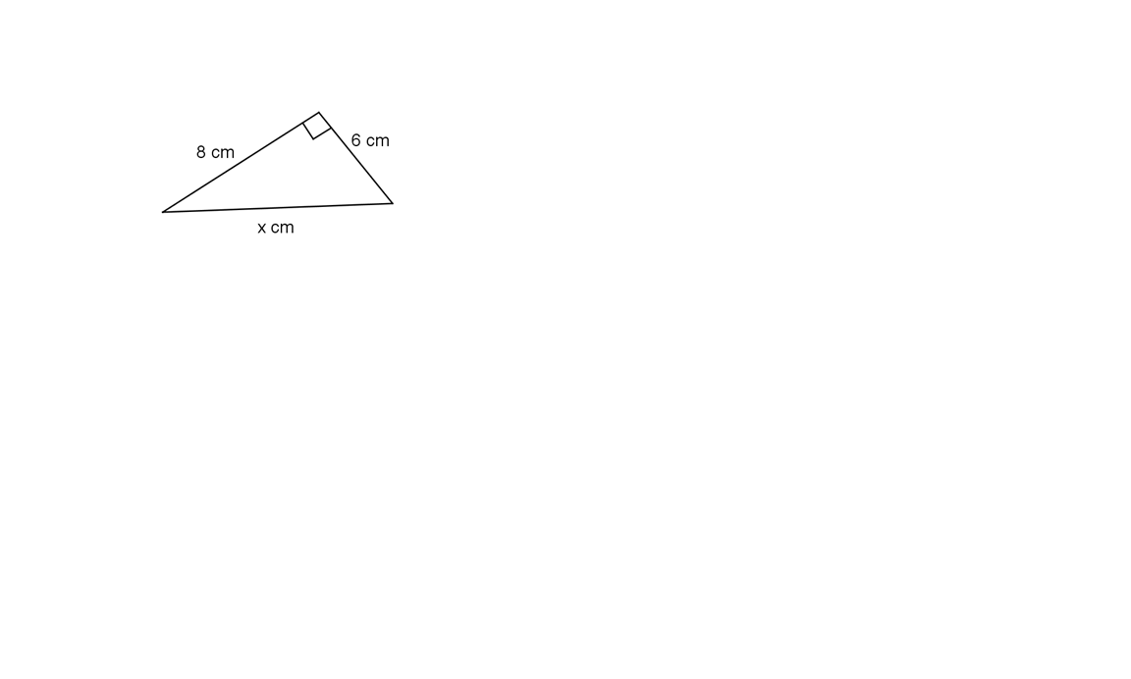
1.3 Skryf die waarde van $x$ vir elk van die volgende neer ( sonder redes) /
Write down the value of x for each of the following (without reasons)

1.3.1

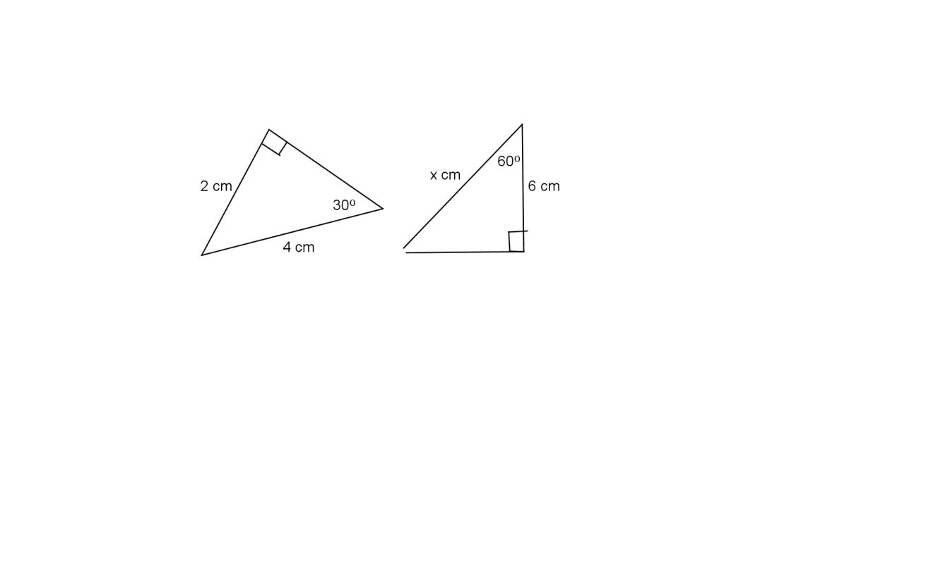

1.3.2

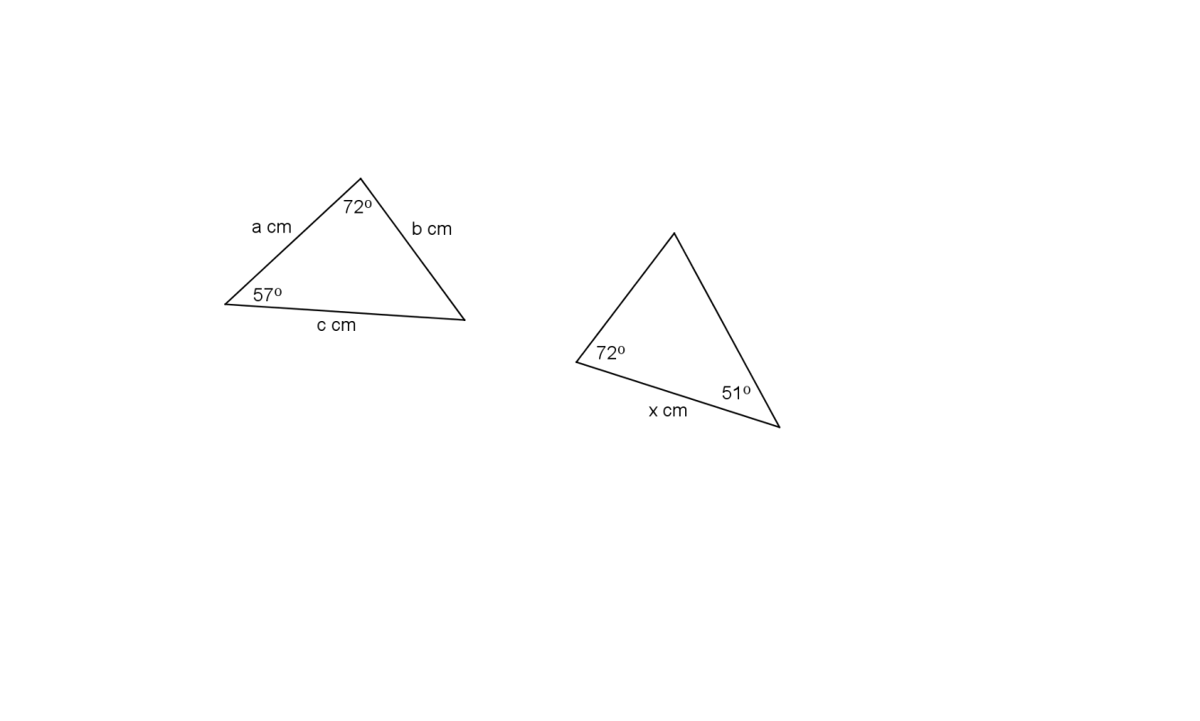

1.3.3

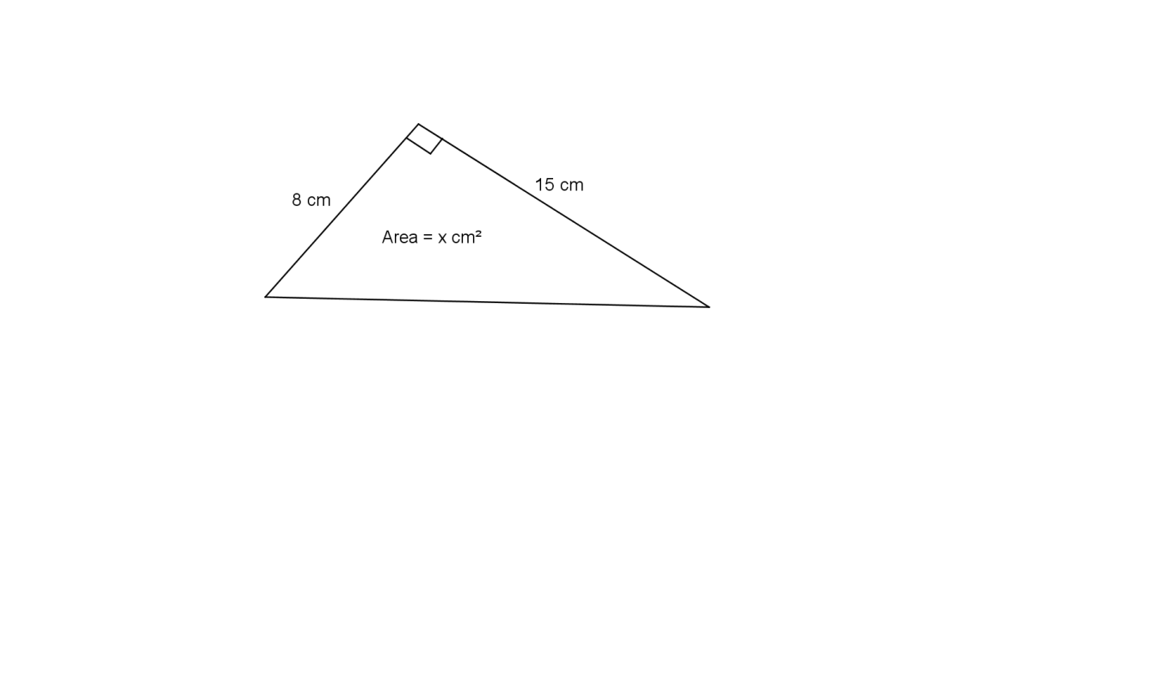

1.3.4

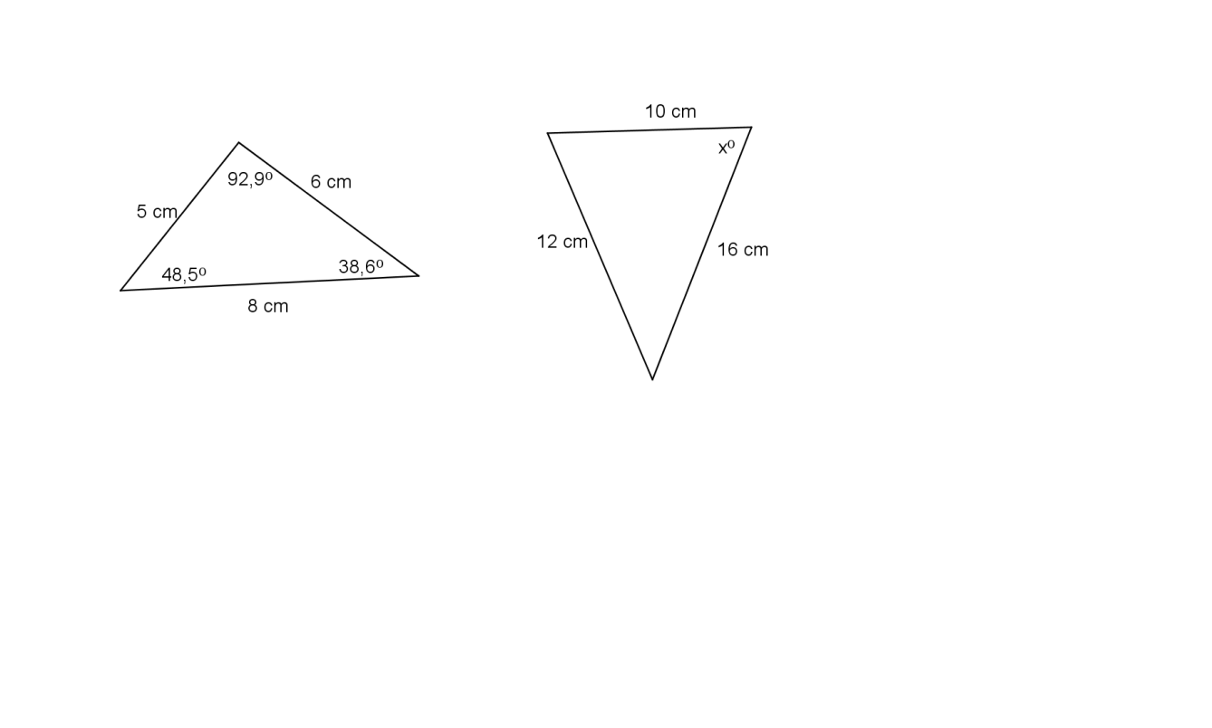

1.3.5

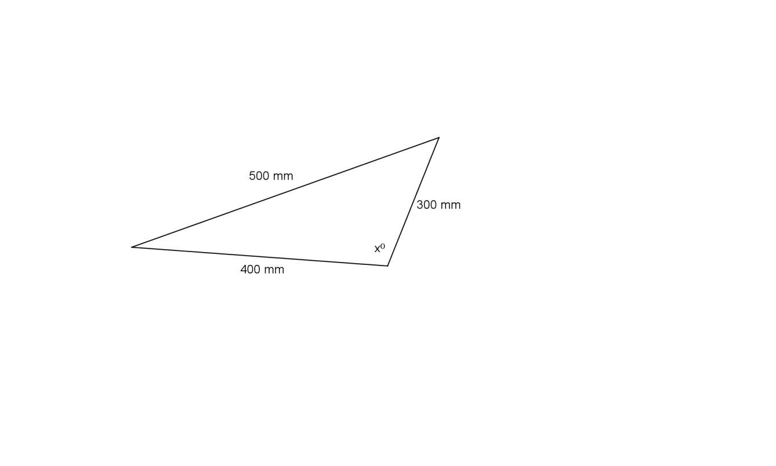

1.3.6

(6)
/18/

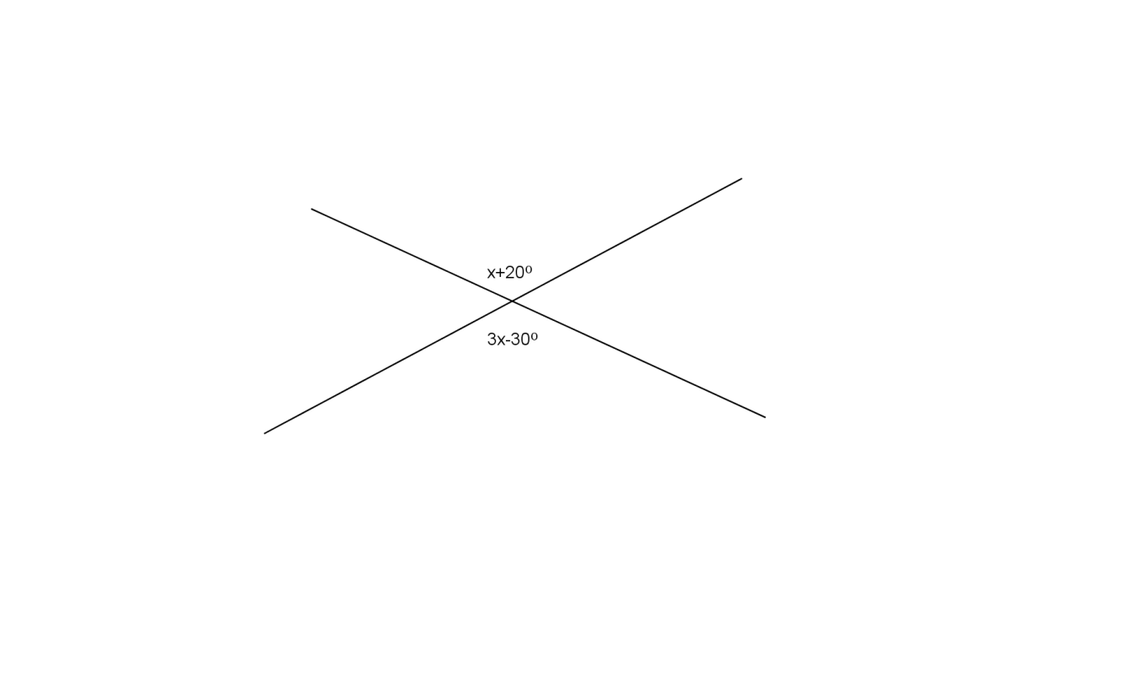
VRAAG 2 / QUESTION 2
Bepaal die groottes van die veranderlikes (a, b, c, … ens.) in elk van die volgende
met volledige redes. /
Determine sizes of the variables (a,b,c, … etc) with complete reasons.

2.1

(3)

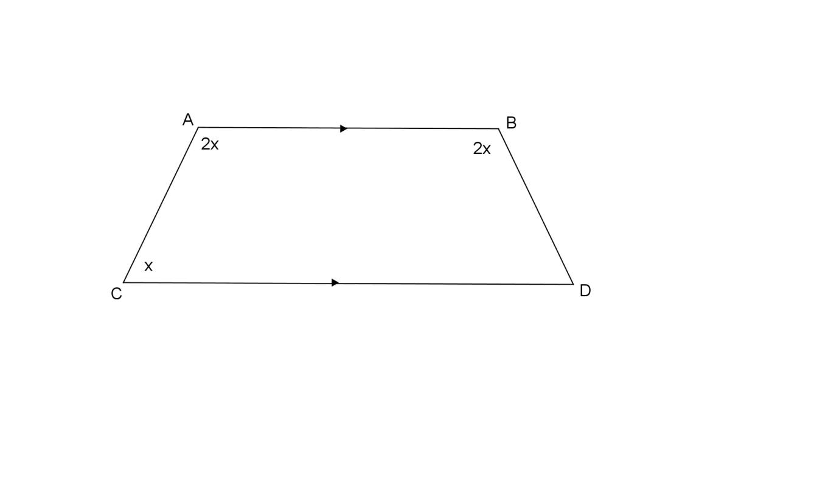
2.2

(2)

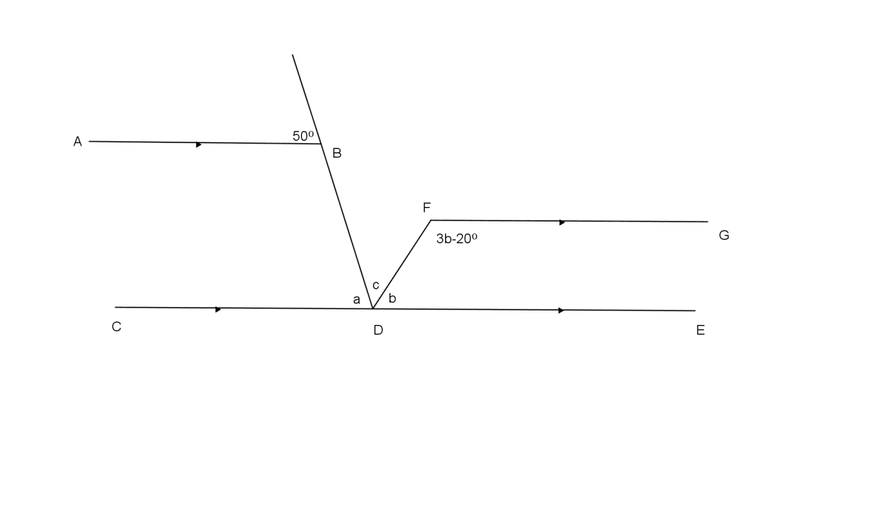
2.3

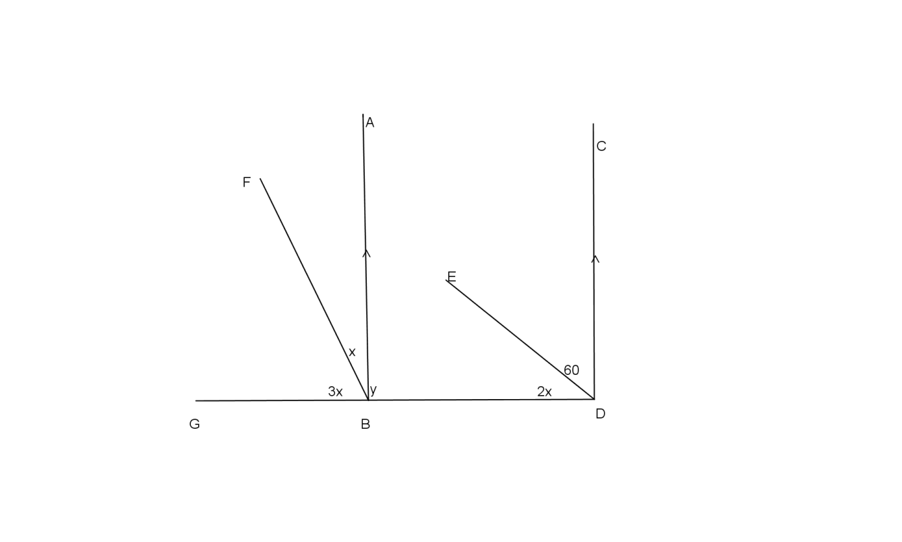
(6)

2.4

(4)
/15/

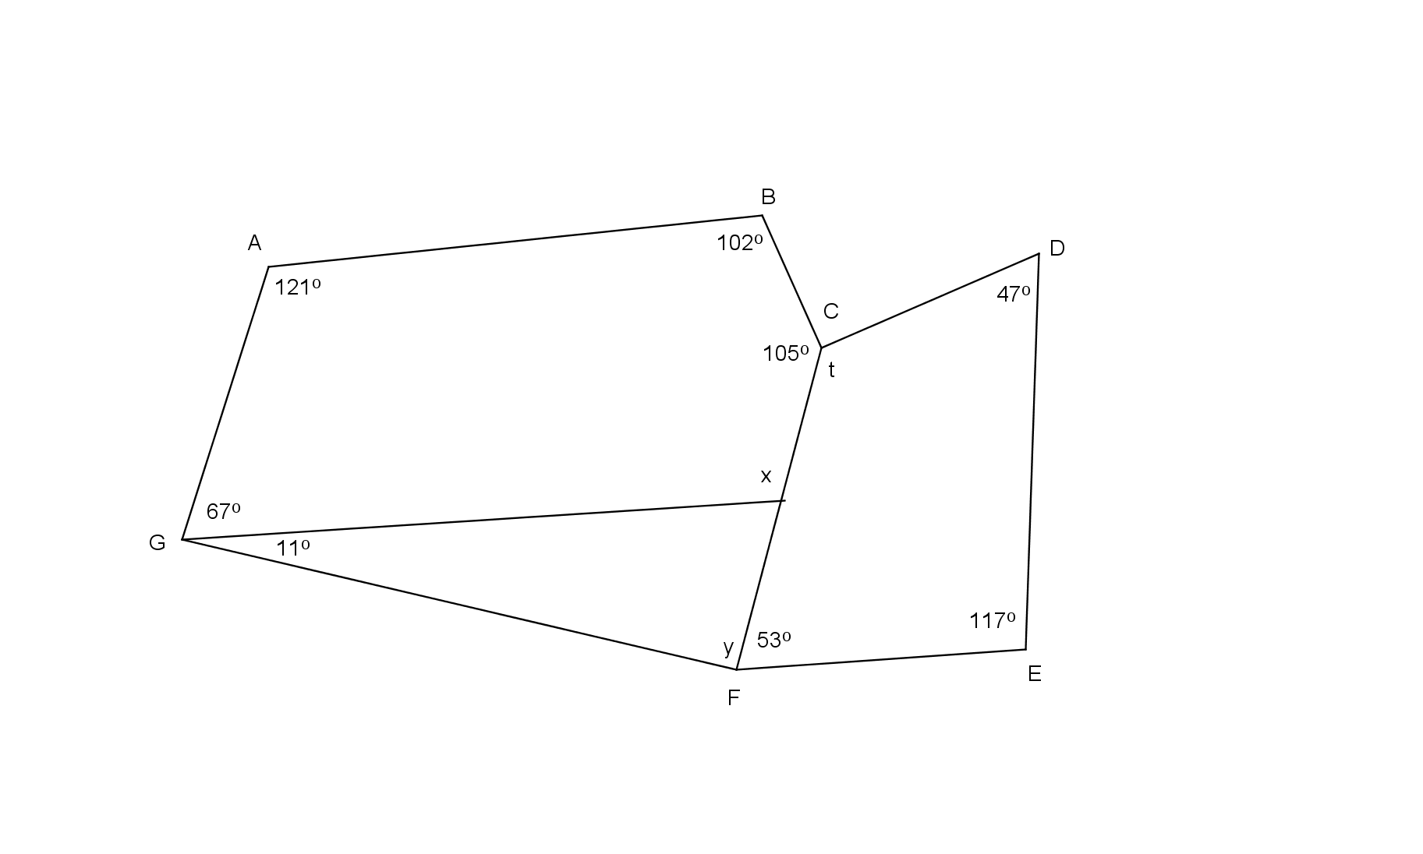
VRAAG 3 / QUESTION 3
3.1 Los op vir $x, y$en $t.$ (Geen redes nodig nie). /
Solve for x, y and t. (No reasons necessary).

(3)

3.2 Los op vir $x$ en $y$ met volledige redes. /
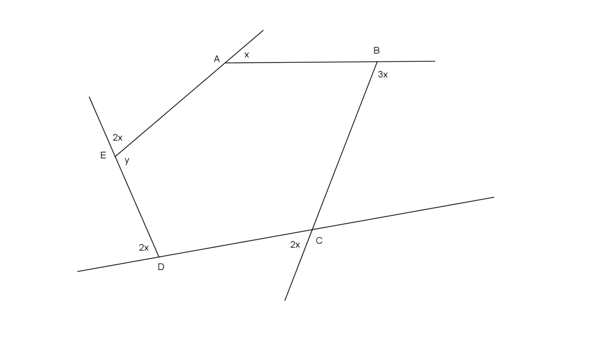
Solve for x and y with complete reasons.

(4)
/7/

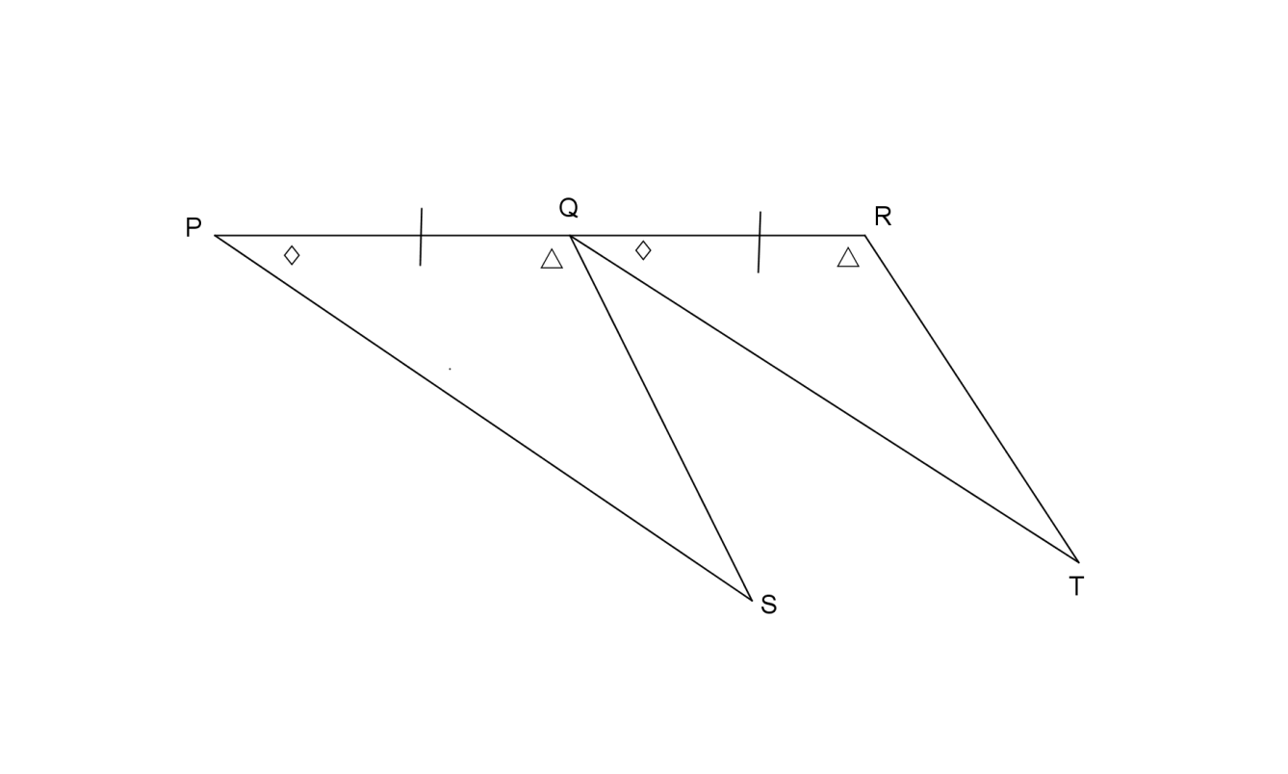
VRAAG 4 / QUESTION 4
4.1 Sê of die volgende pare driehoeke kongruent is of nie. Indien hulle kongruent is gee die
voorwaarde vir kongruensie: /
State whether the following pairs of triangles are congruent or not. If they are congruent
give the reason for congruency.

4.1.1

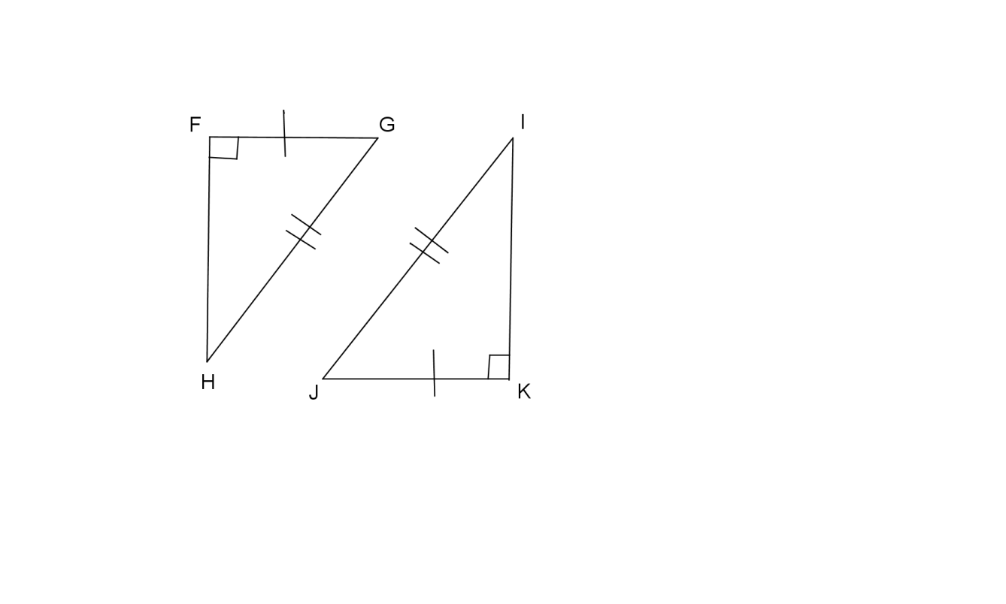

4.1.2

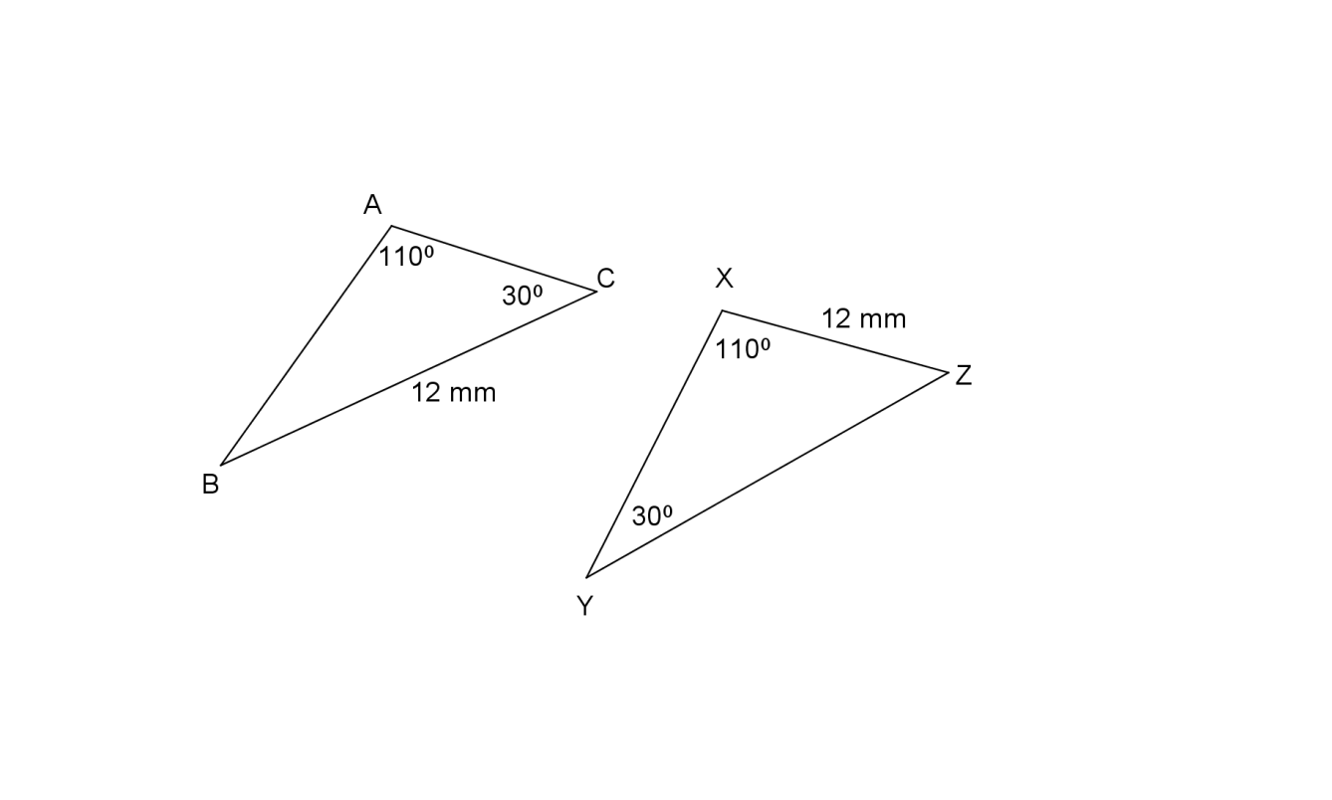

4.1.3

(5)

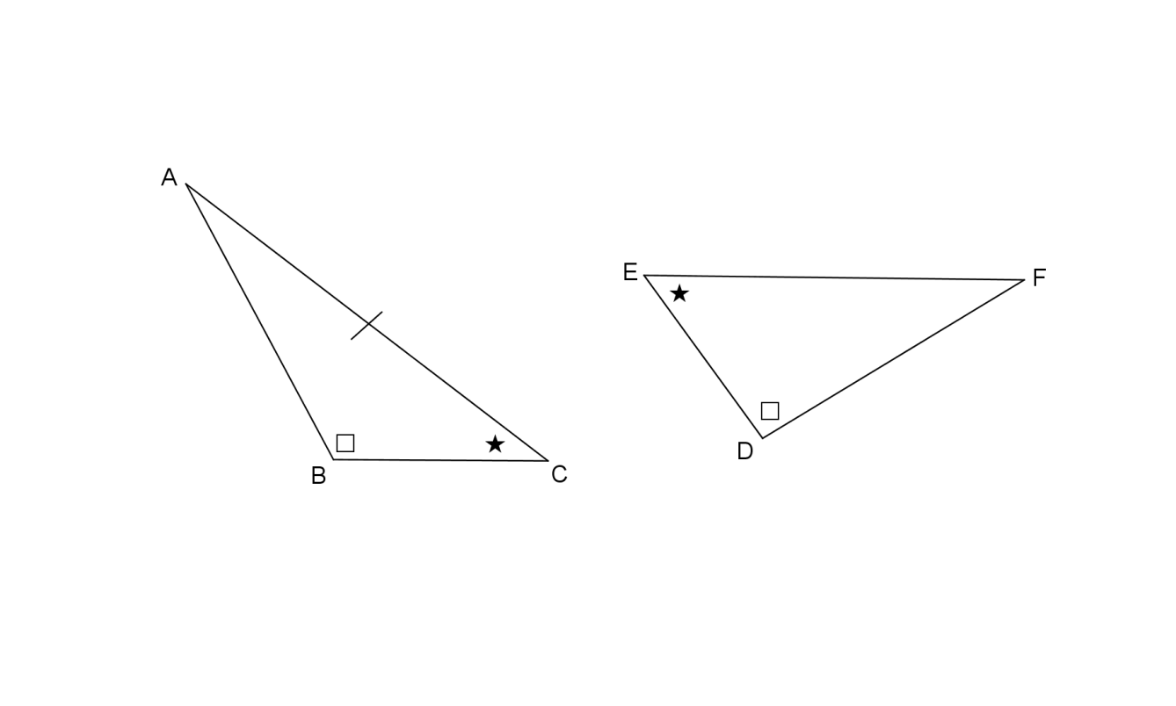

4.2 In $∆ABC$ en $∆DEF$ is $∠B=∠D$ en $∠C=∠E.$
In $∆ABC$ and $∆DEF$ $∠B=∠D$ and $∠C=∠E.$

4.2.1 Watter sy moet gelyk wees aan $AC$ vir die driehoeke om kongruent te wees? /
Which side must be equal to AC for the triangles to be congruent? (1)

4.2.2 Skryf watter voorwaarde van kongruensie geld dan. /
State which reason for congruency are used? (1)

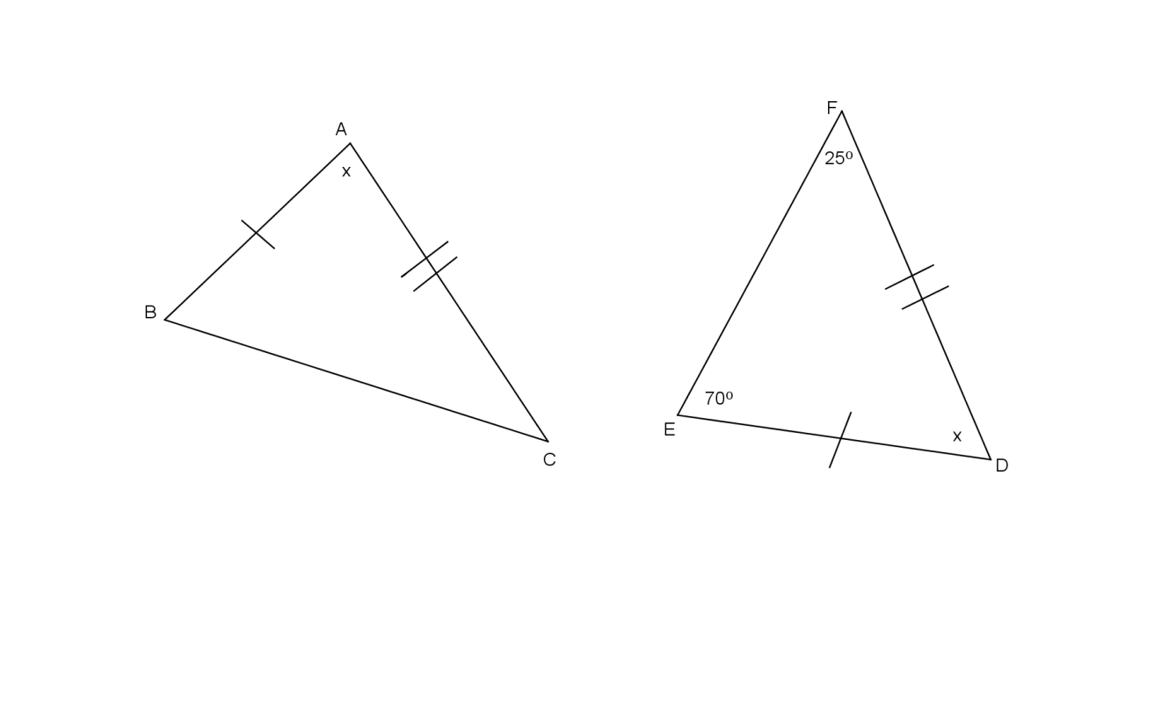

4.3 Gegee: /Given: $∆ABC≡∆DEF$

4.3.1 Gee ‘n rede waarom die 2 driehoeke kongruent is. / Give a reason why the 2 triangles
are congruent. (1)

4.3.2 Vind nou die grootte van $∠B.$ / Find the size of $∠B.$ (1)
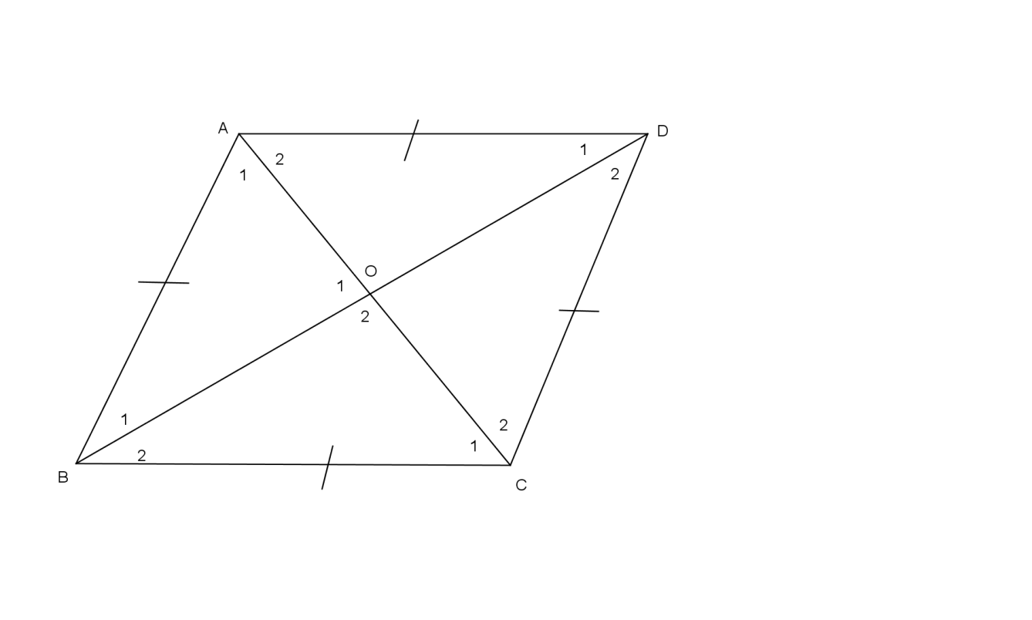

4.4 In die diagram is $AB=BC=CD=DA.$ Bewys dat: /
In the diagram $AB=BC=CD=DA.$ Prove that:

4.4.1 $∆ABD≡∆CBD$ (4)

4.4.2 $∆ABO≡∆CBO$ (4)

4.4.3 $B0⊥AC,$as / if ${∠O}_{1}{=∠O}_{2}$ (2)
/19/

VRAAG 5 / QUESTION 5
5.1 Is die volgende pare driehoeke gelykvormig? Gee redes. /
Is the following pairs of triangles similar? Give reasons.
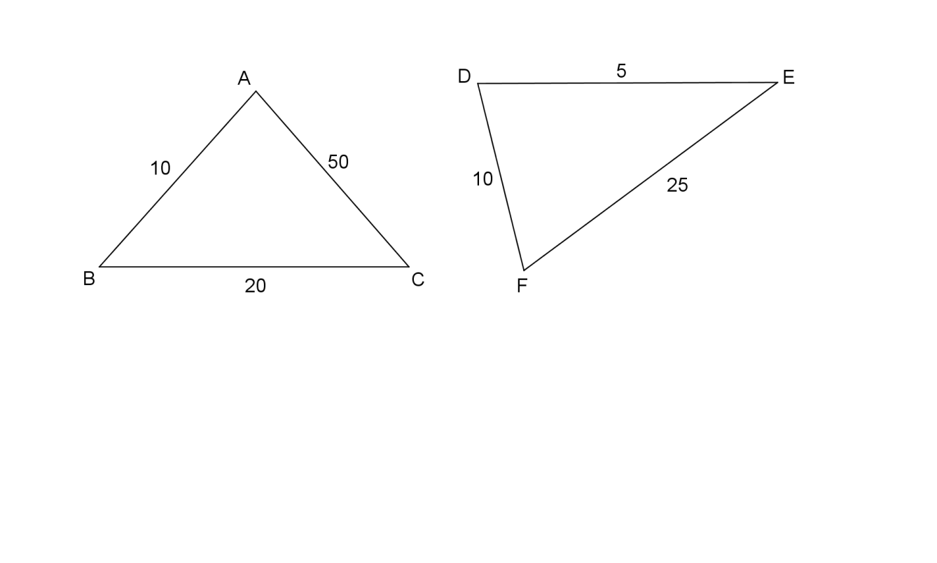
5.1.1

(2)

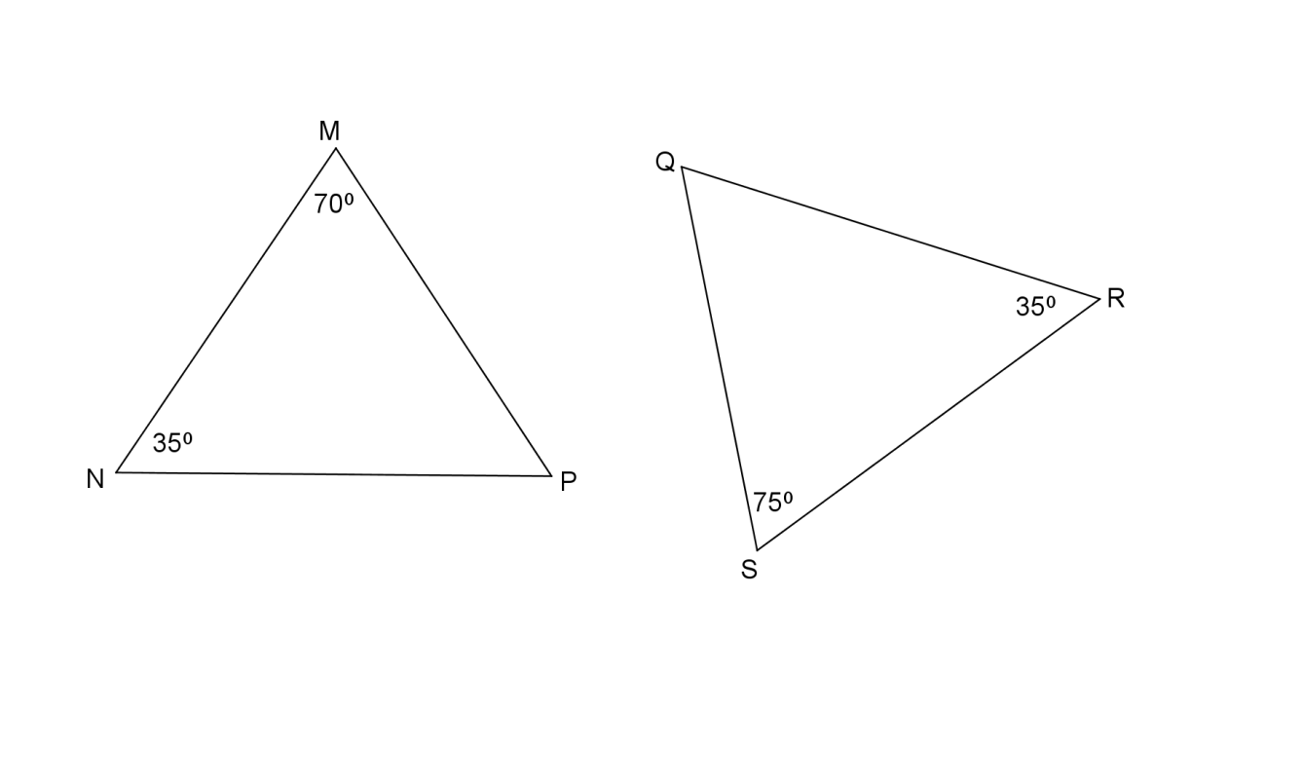
5.1.2

(2)
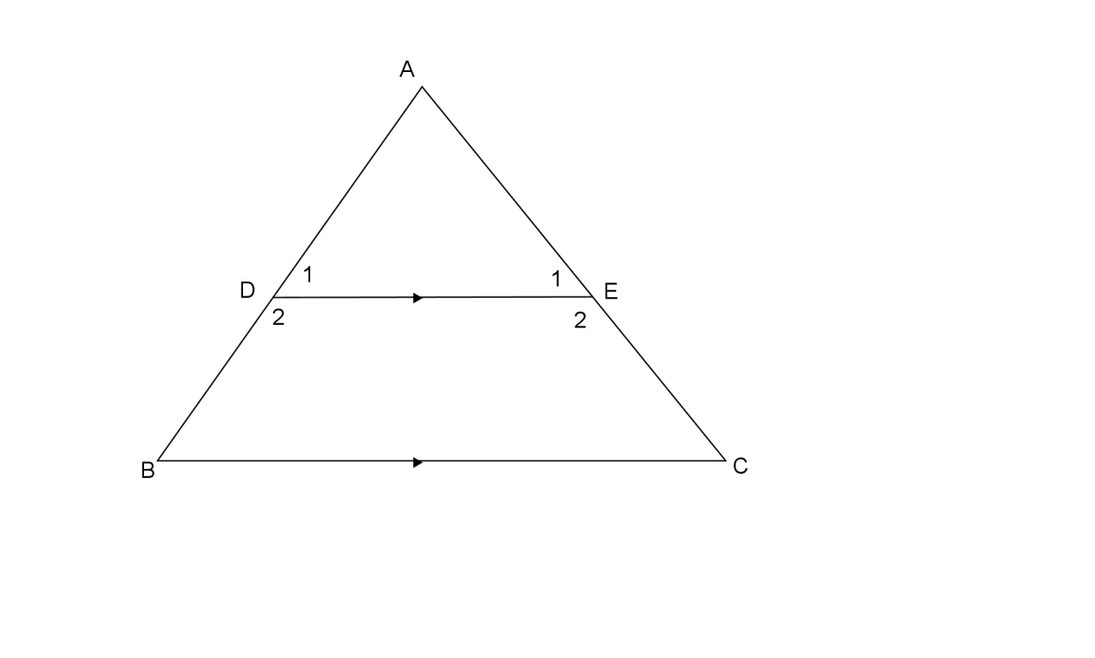
5.2 Gegee: / Given

5.2.1 Bewys volledig dat: / Prove fully that:
$∆ABC III ∆ADE$ (4)

5.2.2 As $AD=30, BD=x, DE=14, BC=21, AE=y$ en $EC=15,$
bereken $x$ en $y.$ /
If $AD=30, BD=x, DE=14, BC=21, AE=y$ en $EC=15,$
determine $x$ and $y.$ (6)

/14/

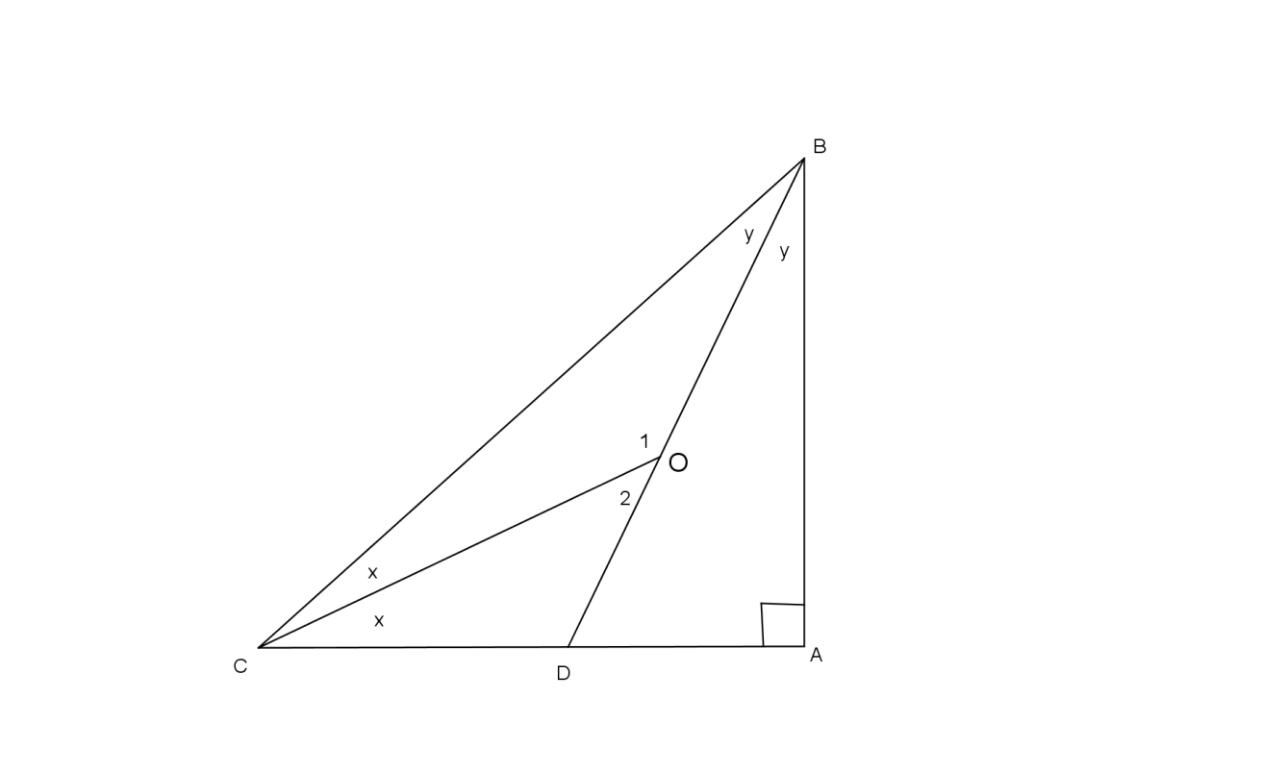
VRAAG 6 / QUESTION 6
6.1 Bereken met redes: / Determine with reasons:

6.1.1 $x+y$ (3)
6.1.2 ${∠O}_{1}$ (2)
6.2 Bereken die lengtes van $VX$, $UY$ en en $XW$ met volledige redes, as
$YX=24, UX=25$ en $YW=40$. /
Determine the lengths of VX, UY and XW with complete reasons, if
YX = 24, UX =25 and YW = 40.
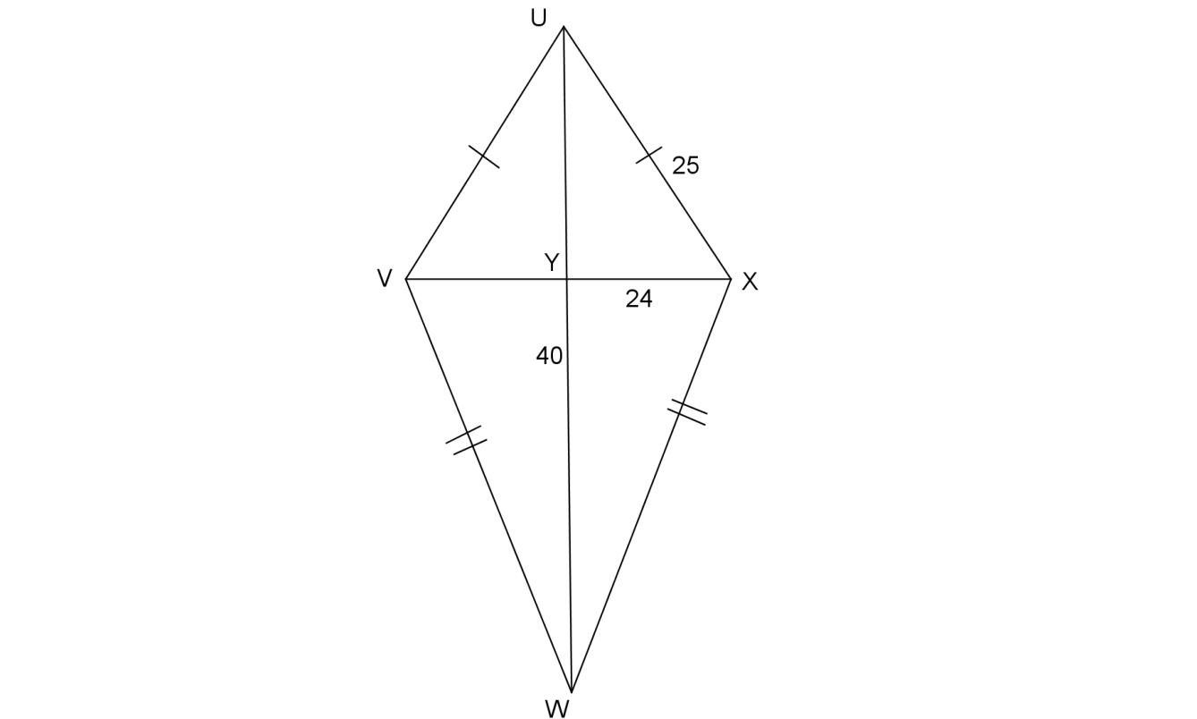

(6)

/11/

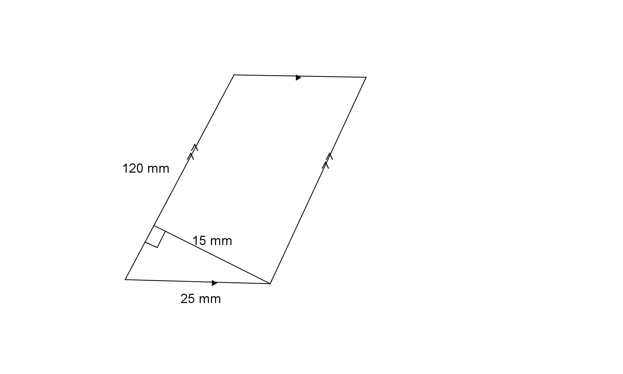
VRAAG 7 / QUESTION 7

7.1 Bereken die a) omtrek en b) oppervlakte van elk van die volgende /
Determine a) perimeter and b) area of each of the following.

7.1.1

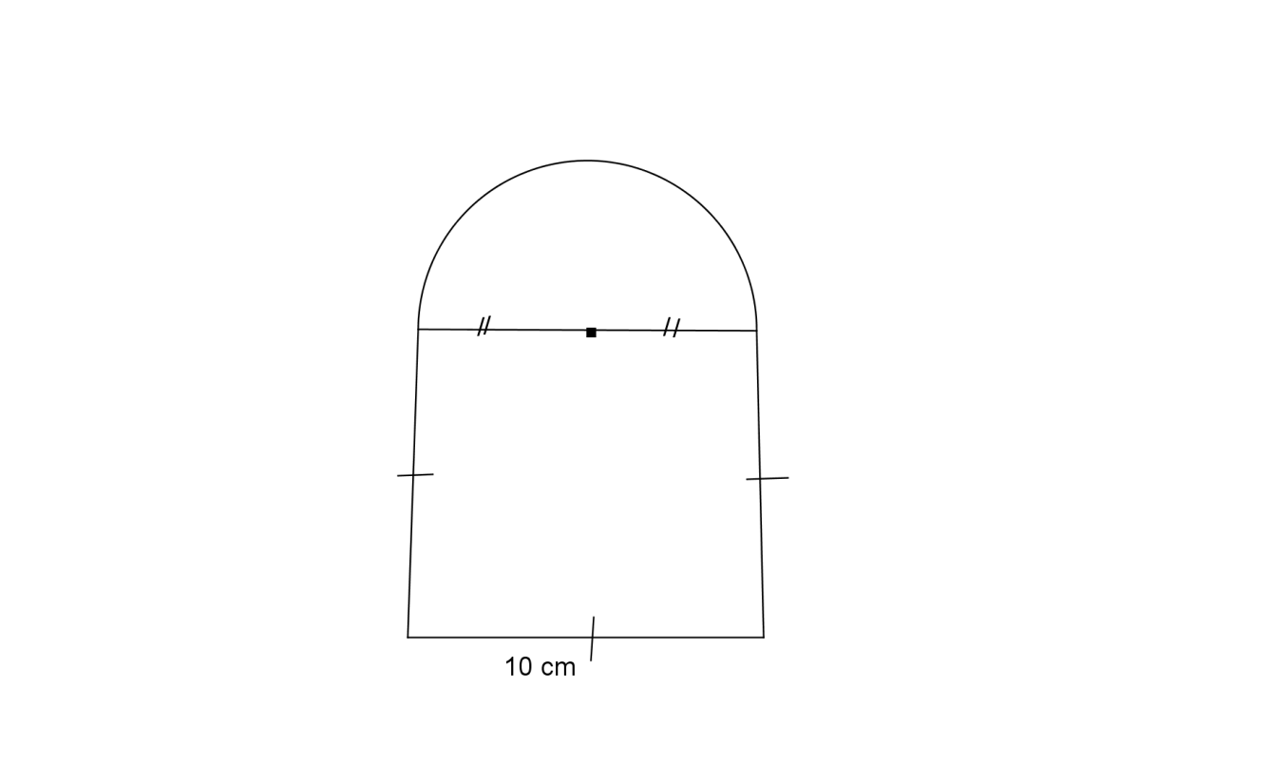
(4)

7.1.2

(8)

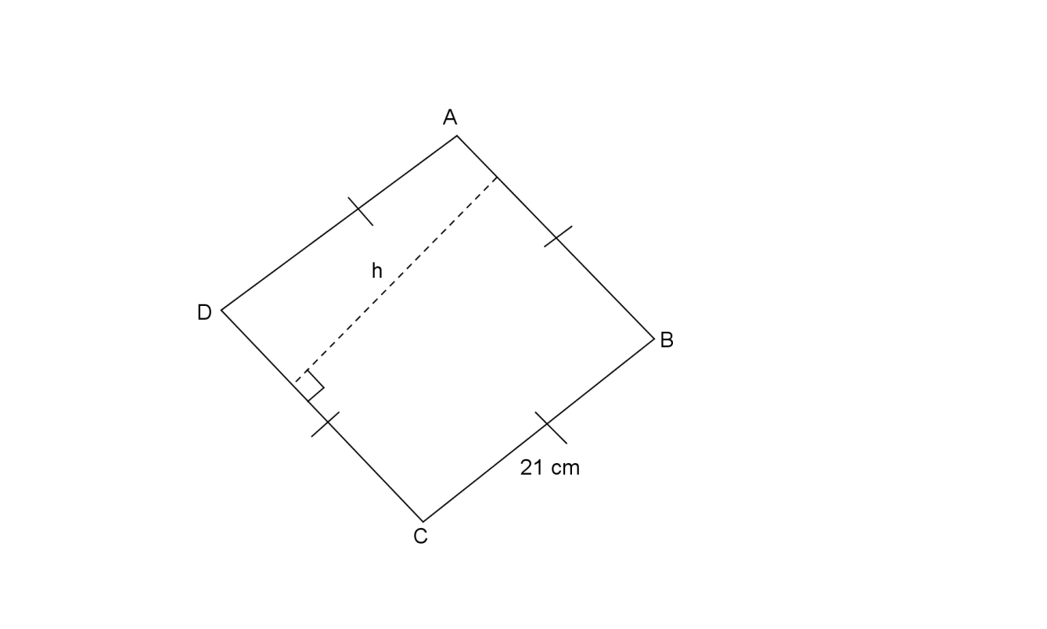
7.2 Gegee: / Given:

7.2.1 Watter tipe figuur is $ABCD$? /
What type of figure is $ABCD$? (1)

7.2.2 As die oppervlakte van die figuur ${483cm}^{2}$ is. Bereken $h.$ / If the area of the figure
iIs ${483cm}^{2}$. Determine h. (3)
/16/ [TOTAAL: 100]

