WISKUNDE/MATHEMATICS V2/P2 NOVEMBER

GRAAD 9/GRADE 9 PUNTE/MARKS: 75

EKSAMEN/EXAMINATION TYD/TIME: 1½ uur/hours

EKSAMINATOR: MODERATOR :

INSTRUKSIES EN INLIGTING

Lees die volgende instruksies aandagtig deur voordat u die vrae beantwoord:

1. Beantwoord AL die vrae in hierdie vraestel.
2. Dui AL die berekeninge, diagramme, grafieke, ensovoorts, wat u gebruik het om die antwoord te bepaal, duidelik aan.
3. ’n Goedgekeurde wetenskaplike sakrekenaar (nie-programmeerbare en nie-grafiese) mag gebruik word tensy anders vermeld.
4. Indien noodsaaklik moet antwoorde tot TWEE desimale plekke afgerond word, tensy anders vermeld.
5. Nommer die antwoorde korrek volgens die nommeringsisteem wat in hierdie vraestel gebruik word.
6. Diagramme is NIE noodwendig volgens skaal geteken nie.
7. Dit is tot u eie voordeel om leesbaar te skryf en u werk netjies aan te bied.

INSTRUCTIONS AND INFORMATION

Read the following instructions carefully before answering the questions:

1. Answer ALL the questions in this question paper.
2. Clearly show ALL calculations, diagrams, graphs, et cetera, which you have used in determining the answers.
3. An approved scientific calculator (non-programmable and non-graphical) may be used, unless stated otherwise.
4. If necessary, answers should be rounded off to TWO decimal places, unless stated otherwise.
5. Number the answers correctly according to the numbering system used in this question paper.
6. Diagrams are NOT necessarily drawn to scale.
7. It is in your own interest to write legibly and to present the work neatly.

VRAAG 1/QUESTION 1

1.1

1.1.1 | Watter tipe grafiek is hierdie?  What type of graph is this? | (1)
1.1.2 | In watter interval is die meeste leerders?  In which interval is the most learners? | (1)
1.1.3 | Watter persentasie van die leerders is in die interval 170-179?  Which percentage of learners are in the interval 170-179? | (2)
1.2 | Die skoengrootte van 16 meisies in Graad 9 is as volg:  The shoe sizes of 16 Grade 9 girls are as follow:  4, 8, 6, 3, 6, 8, 7, 6, 8, 4, 5, 6, 9, 5, 6, 7
1.2.1 | Bereken die gemiddelde skoengrootte van die meisies (korrek tot naaste heelgetal).  Calculate the mean (average) shoe sizes of the girls(correct to nearest integer). | (2)
1.2.2 | Skryf die modus van die skoengroottes neer.  Write down the mode of the shoe sizes. | (1)

1.2.3 | Bepaal die variasiewydte (omvang) van die skoengroottes.  Determine the range of the shoe sizes. | (1)
1.2.4 | Bepaal die mediaan skoengrootte.  Determine the median of the shoe sizes. | (1)
1.3 | Die eienaar van ‘n sopkombuis merk op dat die aantal koppies sop per dag verkoop en die temperatuur voorspel deur Accuweather vir die dag as volg daar uitsien:  The owner of a soup kitchen notices that the number of cups of soup that is sold every day and the temperature as predicted by Accuweather for the day, is as follows:
Dag/Day | 1 | 2 | 3 | 4 | 5 | 6 | 7 | 8 | 9 | 10
Temp in $℃$ | 12 | 10 | 8 | 5 | 8 | 4 | 1 | 0 | 4 | 2
Koppies sop/Cups of soup | 14 | 18 | 23 | 38 | 25 | 56 | 69 | 85 | 52 | 76

1.3.1 | Teken ‘n verspreidingsdiagram met die temp. op die X-as en die aantal koppies sop op die Y-as.  Draw a scattergraph with the temperature on the X-axis and the number of cups of soup on the Y-axis. | (5)
1.3.2 | Teken ‘n toepaslike paslyn.  Draw a line of best fit. | (1)
1.3.3 | Beskryf die korrelasie as positief, negatief of geen.  Describe the correlation as positive, negative or none. | (1)
1.3.4 | Merk dag 5 se punt met ‘n A.  Make an A next to the point of day 5. | (1)
1.4 | Die graad 9A klas word volgens hulle oogkleur as volg voorgestel:  The grade 9A class is represented by the colour of their eyes as follow:
 | 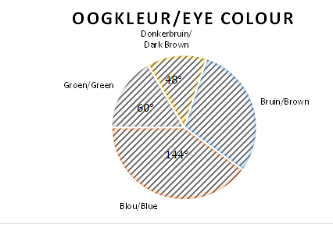
1.4.1 | Uit hoeveel grade bestaan die leerders met bruin oë?  How many degrees would be in the section with brown eyes? | (1)
1.4.2 | Watter persentasie beslaan die leerders met donker bruin oë?  Which percentage of the learners have dark brown eyes? | (1)
1.4.3 | As daar 30 leerders in die klas is, hoeveel leerders het groen oë?  If there is 30 learners in the class, how many have green eyes? | (1)
1.4.4 | In die gr 9B klas is daar 15 leerders met blou oë en as die klas in ‘n sirkeldiagram voorgestel word, beslaan dit 60% van die diagram. Hoeveel leerders is in gr 9B?  In the gr 9B class there is 15 learners with blue eyes and in a circle diagram it will take up 60% of the diagram. How many learners are there in the grade 9B class? | (2)
 |  | [22]
VRAAG 2/QUESTION 2

16 m

80 m

2.1 | Die figuur stel ‘n koringsilo voor.  The figure presents a grain silo.
2.1.1 | Bereken die volume van die silo.  Calculate the volume of the silo. | (3)
2.1.2 | Die buite - oppervlakte (insluitend bokant) moet geverf word. Bereken die totale oppervlakte wat geverf moet word.  The exterior area (including the top) must be painted. Calculate the total surface area that must be painted. | (3)
2.2 | In die figuur, bereken x en y.  In the figure, calculate x and y.  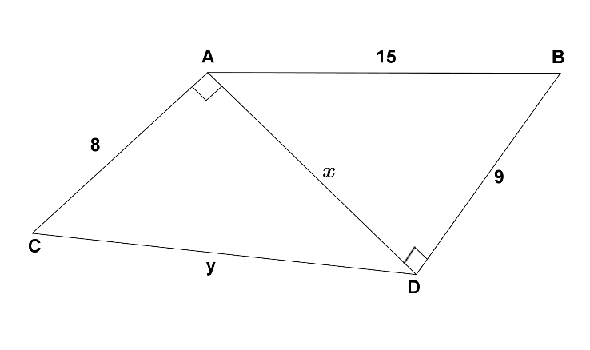 | (4)
2.3.1 | Noni ry met ‘n bus skool toe. Sy woon 45 km van die skool. As die bus gemiddeld 80 km/h per uur ry, hoeveel minute neem sy om by die skool uit te kom (rond af tot die naaste minuut).  Noni takes a bus to school. She lives 45 km from school. If the average speed of the bus is 80 km/h, how many minutes does she spend on the bus? | (3)
2.3.2 | Daar is padwerke met ‘n “stop en ry” waar die bus vanoggend 15 minute moes wag. Wat is die bus se gemiddelde spoed vandag?  During road works there is a “stop and go” where the bus had to wait 15 minutes the morning. What was the average of the bus today? | (3)
 |  | [16]
VRAAG 3/QUESTION 3

Volledige redes moet gegee word/Give full reasons.

3.1 | Bereken a, b en c.  Calculate a, b and c.  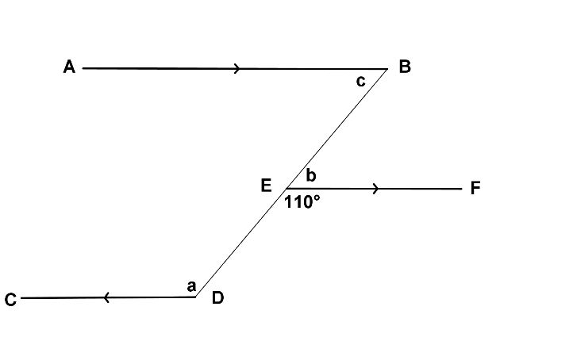 | (3)
3.2 | In die figuur is $AE∥CD, CE∥BA, ∠BCD=150°, ∠B=50° en ∠ACB=70°.$  In the figure is $AE∥CD, CE∥BA, ∠BCD=150°, ∠B=50° en ∠ACB=70°.$  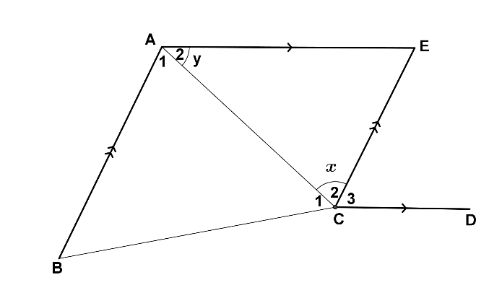
Bereken met redes:
Calculate with reasons:
3.2.1 | $$x$$
3.2.2 | $$y$$ | (4)
3.3 | Bereken $y$.  Calculate $y$.  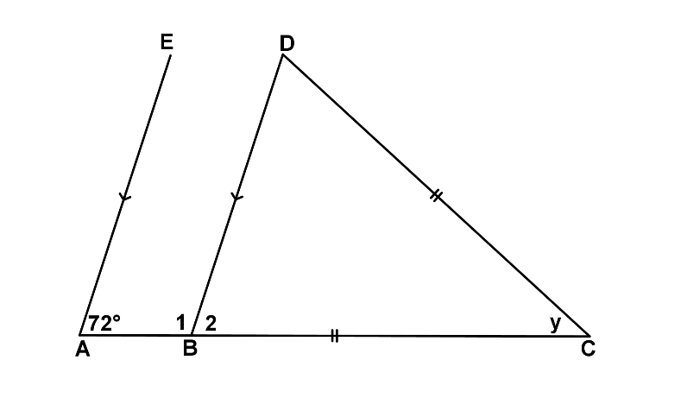 | (3)
 |  | [10]
VRAAG 4/QUESTION 4

4.1 | Gee redes waarom die volgende driehoeke kongruent is.  Give reasons why the following triangles are congruent.
4.1.1 | 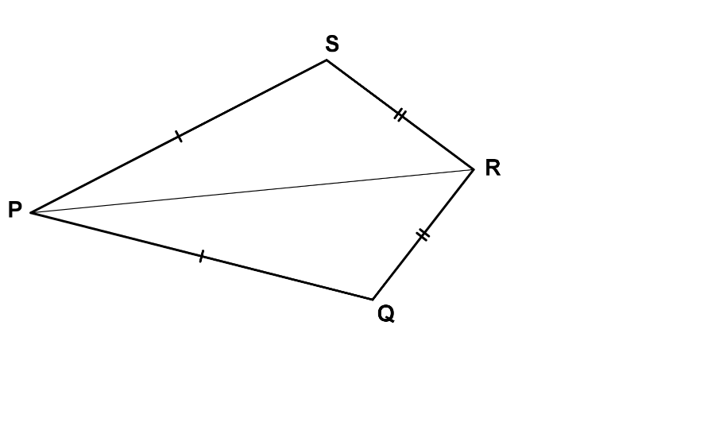
4.1.2 | 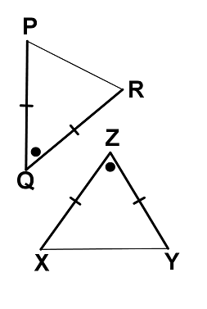
4.1.3 | 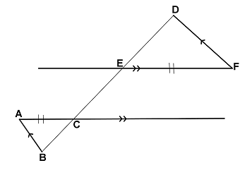 | (3)
4.2 | Bewys volledig dat $∆ABC≡∆DCB$ as AB = DC.  Prove fully that $∆ABC≡∆DCB$ if AB = DC.  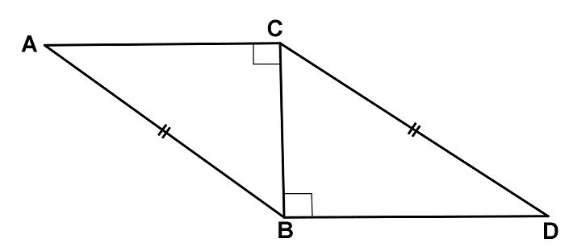 | (4)
4.3 | In die figuur is AB = AC, DC = AE en $AB∥DC.$  In the figure AB = AC, DC = AE and $AB∥DC.$  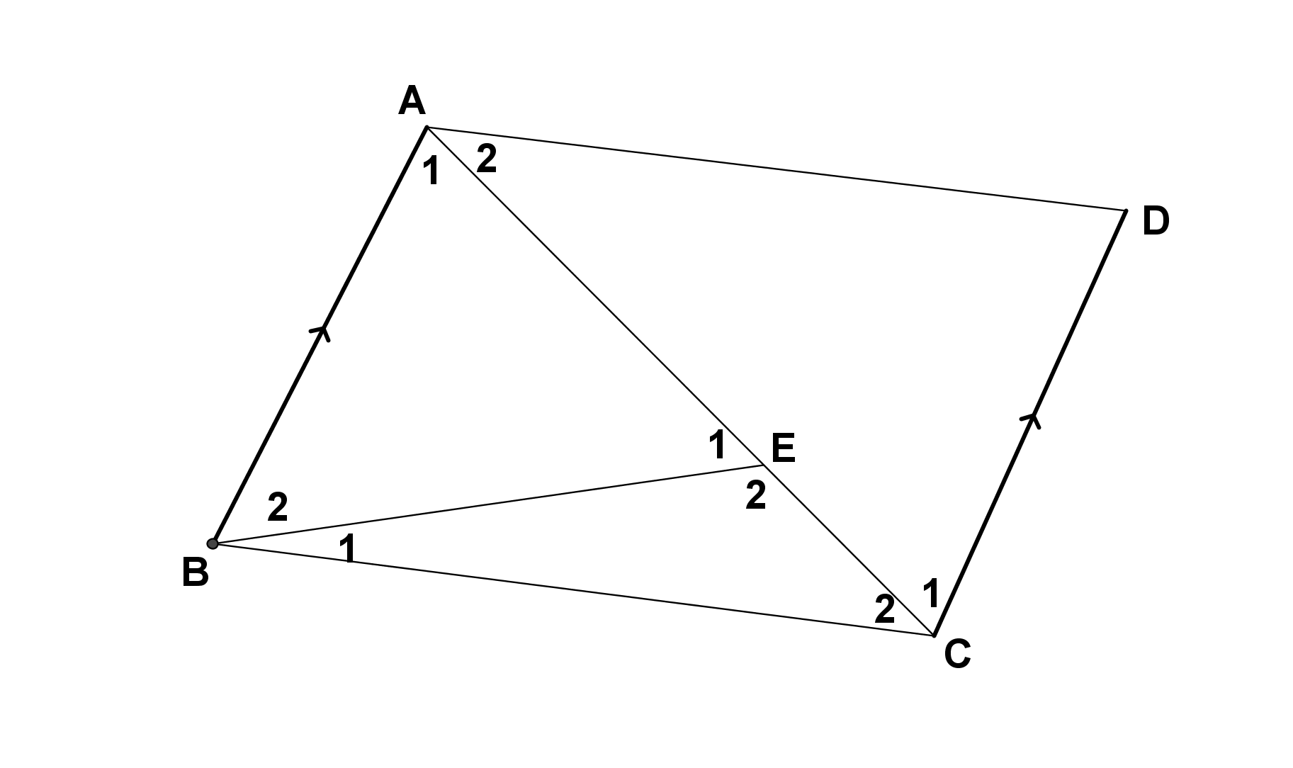  Bewys/Proof:
4.3.1 | $$∆ACD≡∆BAE$$ | (4)
4.3.2 | $$∠BAD=∠BEC$$ | (2)
 |  | [13]
VRAAG 5/QUESTION 5

5.1 | 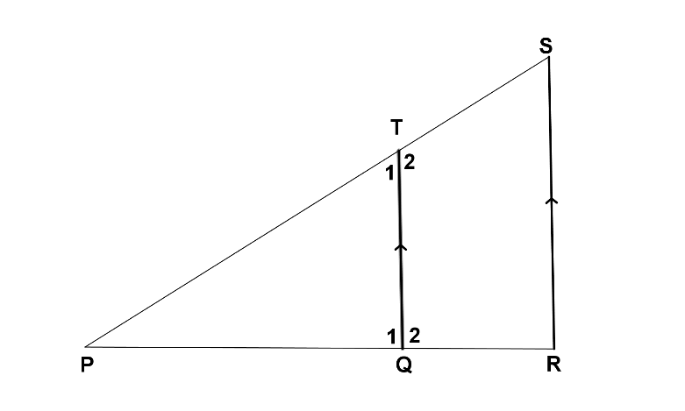
5.1.1 | Bewys dat $∆PQT|||∆PRS$.  Prove that $∆PQT|||∆PRS$. | (4)
5.1.2 | As PT = 4,5 en ST = 1,5 en PQ = 3 en QR = $x$, bereken $x$.  If PT = 4,5 and ST = 1,5 and PQ = 3 and QR = $x$, calculate $x$. | (3)
5.2 | 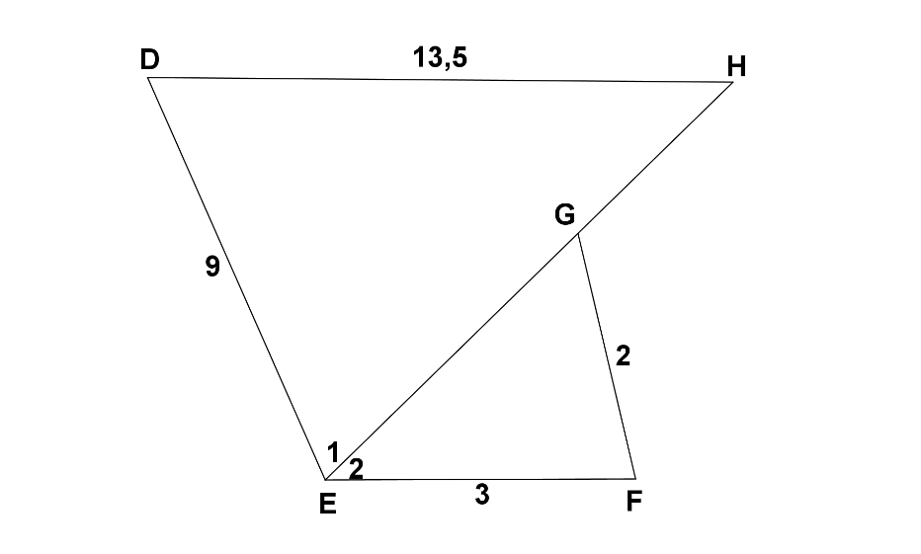  In die figuur is DH = 13,5 cm, DE = 9 cm, GE = 5 cm, GH = 17,5 cm, EF = 3 cm en GF = 2 cm.  In the figure DH = 13,5 cm, DE = 9 cm, GE = 5 cm, GH = 17,5 cm, EF = 3 cm and GF = 2 cm.
5.2.1 | Bewys dat $∆DEH|||∆FGE.$  Prove that $∆DEH|||∆FGE.$ | (4)
5.2.2 | Voltooi/Complete:  $∠E_{2}=∠$ ________ (uit gelykvormigheid/from similarity) | (1)
5.2.3 | Wat kan jy aflei van DH en EF?  What can you deduce about DH and EF? | (2)
 |  | [14]

