Naam van leerder: …………………………………………………………………………………
Hierdie vraestel bestaan uit 4 bladsye.
Hoërskool …….. November
WISKUNDE (Eerste Vraestel) Tyd/Time: 1½ uur/hrs
Graad/Grade 9 Punte/Marks: 75
Eksaminator/Examiner: Moderator:
INSTRUKSIES | INSTRUCTIONS
- Beantwoord ALLE vrae.  - Sakrekenaars mag gebruik word.  - Dit is tot jou eie voordeel om netjies en volledig te werk.  - Indien nodig, rond alle antwoorde af tot 2 desimale syfers.  - Trek ‘n lyn onderaan elke vraag.  - Geniet die vraestel. | - Answer ALL questions.  - Calculators may be used.  - It is to your advantage to work neatly and show all workings.  - If necessary, round off all answers to two decimal places.  - Draw a line after each question.  - Enjoy the paper.

Vraag 1/Question 1
1.1 Vereenvoudig/Simplify:
1.1.1 $4ab(5a^{2}b^{2}+2ab-3)$ (2)
1.1.2 ${-3(x+3)}^{2}$ (3)
1.2 Faktoriseer volledig/Factorise fully:
1.2.1 $6xy-3x$ (2)
1.2.2 $x^{2}+5x-14$ (2)
1.2.3 $p^{2}-36$ (2)
1.2.4 $t\left(x-y\right)-(y-x)$ (2)
1.2.5 $9p^{4}-36q^{2}$ (2)
[15]

Vraag 2/Question 2

2.1 Vereenvoudig/Simplify:
2.1.1 $\frac{3x-6y}{3}$ (2)
2.1.2 $\frac{{4p}^{2}-q^{2}}{6p+3q}$ (3)
2.1.3 $\frac{2a-2}{a+2}÷\frac{a^{2}+a-2}{a^{2}-4}$ (5)

2.2 Los op vir x/Solve for x:
2.2.1 $4\left(x-2\right)=15$ (2)
2.2.2 $\frac{x}{3}-\frac{x-2}{2}=4\frac{1}{2}$ (4)
2.2.3 $4x^{2}=5x$ (3)
2.2.4 $2^{x-1}=\frac{1}{32}$ (2)
2.3 Vereenvoudig/Simplify:
2.3.1 ${(3x)}^{4}+{(2x}^{2})^{2}$ (3)
2.3.2 $\frac{5a^{2}b^{-1}}{15a^{-2}b^{4}}$ (3)

2.3.3 ${4m}^{0}{-(2m)}^{0}$ (3)
[30]

Vraag 3/Question 3

3.1 Skryf die volgende 2 terme in die ry neer/Write down the next two terms in the sequence:
6; -2; -10; … (2)
3.2 Skryf die algemene term (T_{n}) van die ry neer.
Write down the general term (T_{n}) of the given sequence. (2)
3.3 Watter term in die ry is gelyk aan -154?/Which term in the sequence is equal to -154? (2)
[6]
Vraag 4/Question 4

4.1 Teken op dieselfde assestelsel, sketse van A: $y=-\frac{1}{3}x$+3 en B: $y=2x-2$. Toon duidelik aan waar die grafieke die asse sny. Gebruik enige metode en benoem ook die lyne.
Draw sketches of A: $y=-\frac{1}{3}x$+3 and B: $y=2x-2$. Show all intercepts with the axes. Use any method and label the lines. (5)

4.2 Gee die vergelykings van die volgende lyne:
Give the equations of the following lines:
4.2.1 lyn met gradiënt -4 en y-afsnit 6/line with gradient -4 and y-intercept 6. (2)

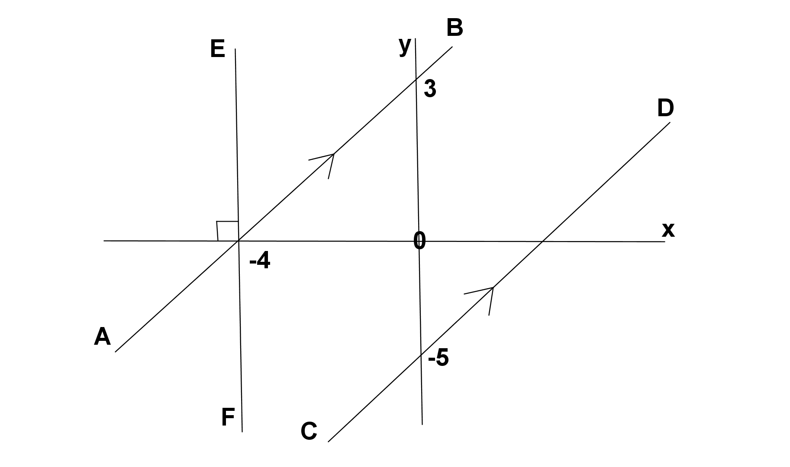
4.2.2 AB
4.2.3 CD
4.2.4 EF (5)
[12]
Vraag 5/Question 5

5.1 Vermeerder 72 in die verhouding 3 : 2 /
Increase 72 in the ratio 3 : 2 (1)
5.2 Drie studente wat ‘n woonstel deel, betaal elkeen R2 250 huur per maand. Nog 2 studente trek by hulle in. Hoeveel huur moet elkeen nou betaal?
Three students who share a flat, pay R2 250 each rent per month. If another 2 students move into the flat, how much will they each have to pay now? (2)
5.3 Dit kos R694,65 om ‘n motor se tenk van 55 liter vol brandstof te maak. Hoeveel sal dit kos om ‘n 6-liter kan met dieselfde brandstof vol te maak?
It costs R694,65 to fill up the petrol tank of 55 litre of a car. How much will it cost to fill a 6 litre can of the same petrol? (2)
5.4 Bereken die rente na 5 jaar as R13 500 teen ‘n rentekoers van 4% p.j. saamgestelde rente belê word. /
Calculate the interest after 5 years if R13 500 is invested at 4% compound interest. (3)
5.5 ‘n TV word gemerk vir R 12 500. As jy dit op huurkoop koop, moet jy 15 % deposito
betaal en die res teen $12\frac{1}{2} \%$ enkelvoudige rente oor 24 maande terugbetaal.
Bereken die maandelikse paaiement. /

A TV is marked R 12 500. If you buy it on hire purchase, you have to pay 15 % deposit
and pay $12\frac{1}{2} \%$ simple interest for 24 months.
Calculate the monthly instalment.
(4)

[12]
[Totaal: 75]

